Nineteenth Century East Meon
Contents
1. Ramsdean Farm (Manning’s Farm)/ Homelands Farm 2
2. Park Farm (tithe Free) 5
3. Hyden Farm (not mentioned on tithe map as it was tithe free) 8
4. Langrish Manor Farm 11
5. Hillhampton Farm (Oxenbourne Farm) 14
6. Lower Farm (Orchard Farm) 17
7. Tegwell (Tigwell) Farm 19
8. Westbury House 22
9. Hop kiln Farm 25
10. Whitewool Farm 29
11. Barrowhill Farm 31
12. Biden Farm 34
13. Langrish House (Langrish Farm) 36
a) Langrish Farm (Home Farm) 39
14. Lower House Farm (Oxenbourne Farm) 40
15. Leythe House Farm 43
16. Riplington Farm 45
b) Old Down Farm 48
c) Peake (Peak) Farm (part of Riplington) 50
17. Stroudbridge (Farm) (Dean’s Farm, Buriton) 52
18. Coombe Cross 54
19. Court Farm (tithe Free) 56
20. Coombe Farm 59
21. Duncoombe Farm 62
22. Bordean Farm 64
23. Rothercoombe Farm 67
24. Upper House Farm 69
25. Rookery Farm 72
d) South Field (Rookery Farm) 75
26. Lower Farm & Fairfield Farm (South Farm) (tithe Free) 76

Ramsdean Farm (Manning’s Farm)/ Homelands Farm
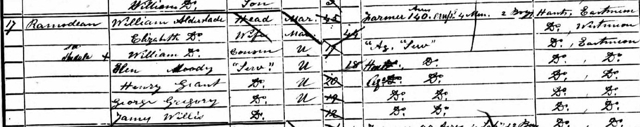
1851 Ramsdean Farm was largely owned by Charles Manning and farmed by 45 year old William Alderslade, born in East Meon, who farmed 140 acres employing 4 men and 2 boys. It is not explicitly named in the census.
Alderslade lived with his wife Elizabeth, 17 year old cousin, also William, 18 year old Elen Moody, a house servant from East Meon, and three other agricultural labours from East Meon. The tithe map showed him farming 176 acres, of which 109 were arable, 32 acres were pasture, 10 acres were woods and 22 acres were allotments on Ramsdean Down.
(The first map shows the area on the tithe map, with local current farmsteads superimposed in red to show where in the parish the map is taken from).
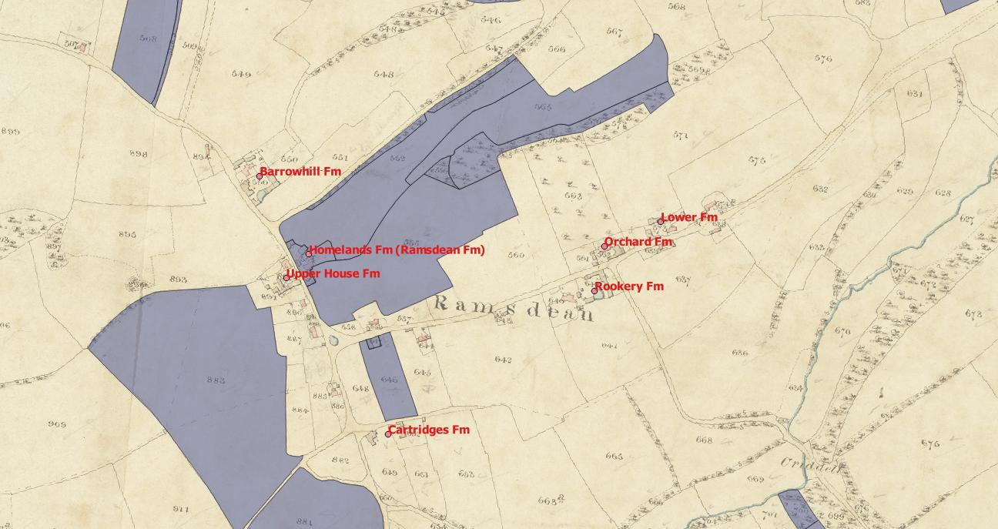
1861 44 year old Henry Vokes, from East Meon, lived at Mannings House and farmed 200 acres. He lived with his wife Mary, from Steep, and 5 children, all born in East Meon. He had been listed as a farmer of 9 acres employing 2 men in 1851, but was not listed on the tithe map as the occupier of land. The Kelly’s directory of 1855 had listed him as a drill man, but by 1865 he was listed as a farmer.
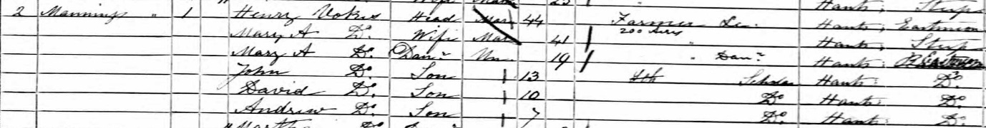
1871 Henry Vokes, 53 , was listed simply as a farmer. He continued to live at Mannings House, Chapel St, with his 51 year old wife Mary and his sons 17 year old Andrew and 9 year old Charles. He also employed 17 year old Ellen Denyers from Fernhurst as a general servant.
(The second map shows the same area on the first Ordnance Survey map from 1870, with local current farmsteads superimposed in red to show where in the parish the map is taken from).
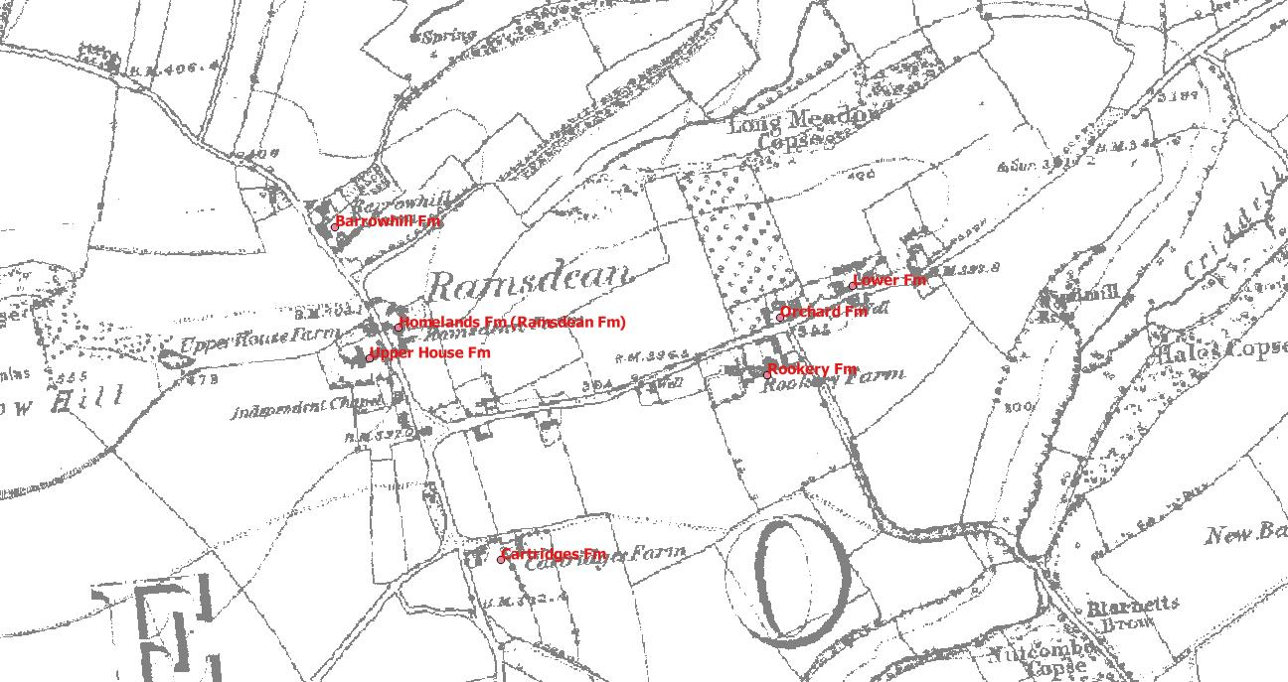
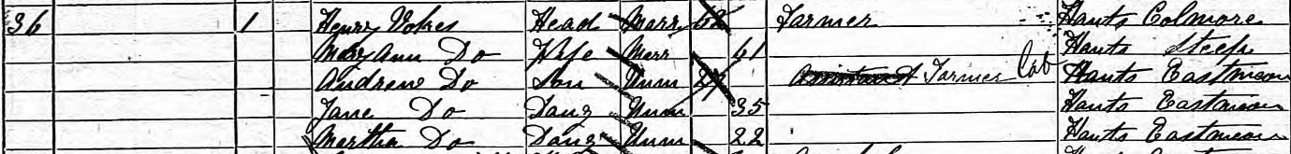
1881 Henry Vokes, 62, listed as farmer, lived next door to Richard Green (of Upper House Farm, #24). The address in the census was simply given as Ramsdean. He lived with his 61 year old wife Mary Ann, his 27 year old son Andrew worked as an agricultural labourer, and daughters Jane 35 and Martha 22 lived with them. Neither had an occupation. There were no servants. The 1880 directory listed him as farmer, threshing machine proprietor, corn & seed merchant, Ramsdean.

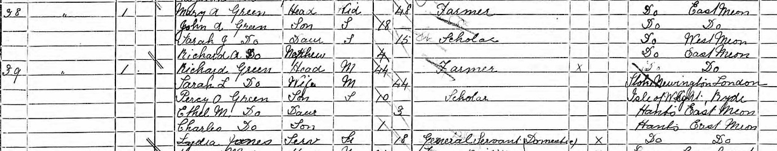
1891 48 year old widow Mary A Green, who lived with her son John 18, daughter Sarah 15 and nephew Richard, 4. Mary Ann Green was the daughter of Henry Vokes, who had appeared on the 1861 census. Her husband, George Robert Green, the eldest son of Robert Green who had farmed Rookery Farm (#25) was away on the night of the 1881 census, and she was widowed by the 1891 census. Her brother in law, Richard Green, lived next door. Her husband was the eldest of 11 children, and Richard was the fifth of these children. Another brother (John) lived with Louisa Young at Rookery Farm.

Park Farm (Tithe Free)
1851 36 year old Henry Barnard farmed 830 acres, employing 18 labourers and 8 boys. He had been born in Kilmeston, and his 38 year old wife Ann had been born in West Meon. They lived with two children (Ellen 6, Henry 1), a third child, Silvester was to die in infancy in 1855. They had three staff: 21 year old Louisa Lunn from West Dean was the governess, 14 year old Miriam Lunn was Nursery assistant and 18 year old Mary Bance from East Meon was the house maid. There were 7 in the household. An elder daughter (Fanny) was baptised in the church in 1842, and married in 1859 giving Henry Barnard as her father. She never appeared on the census. The 1855 O’Kelly directory listed Henry Barnard as farming Park Farm, and James Barnard as farming Upper Bordean. The acreage farmed included the tithe free land of Park Farm, and the land at Bordean where the Tithe map listed James Barnard as the owner and Henry Barnard as the occupier.
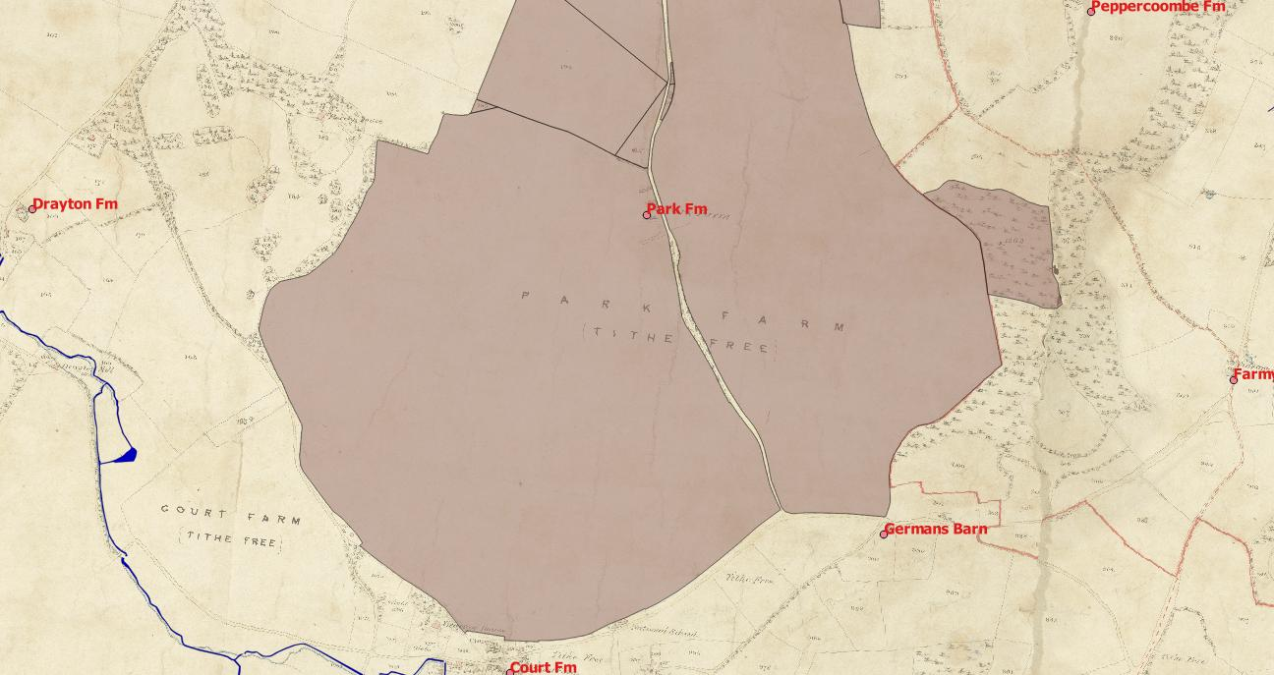
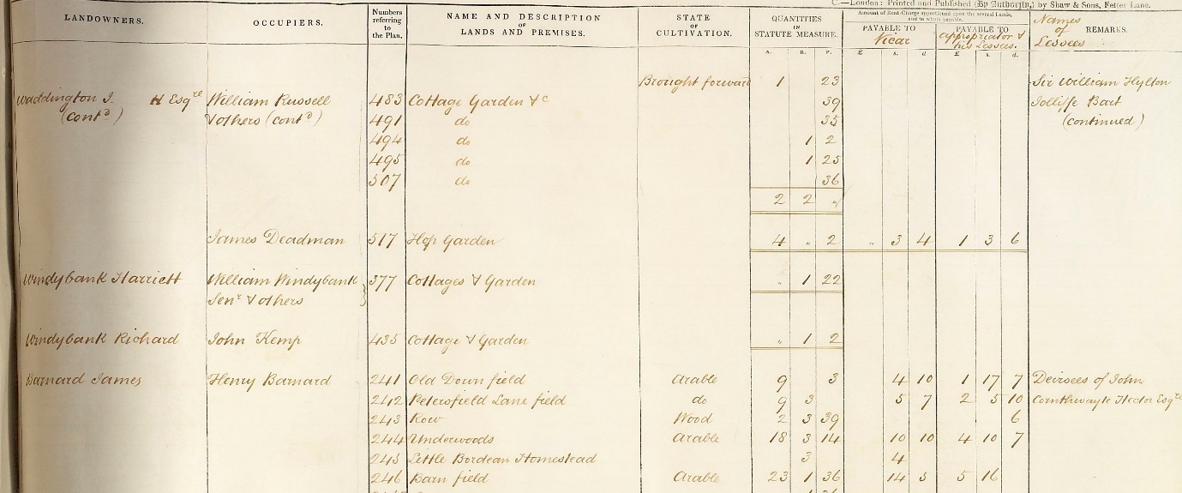1861 The address was given as Bordean Road, Park House. The farm was 830 acres, and employed 17 labourers and 7 boys. Three further children Jane, 18, Lasham, 8, and Anna Maria, 5 also lived in the house. Jane was baptised in East Meon in 1842, at which point her father was described as “yeoman”. When her younger siblings were born, he was described as “farmer”. Louise Lunn was still the governess. 20 year old Mary Ford from Silchester and 18 year old Amelia Norman from East Meon completed the household of 9. The 1865 Harrod’s directory listed Henry Barnard as farming at Park Farm and Upper Bordean. The addition of James Barnard’s Upper Bordean 60 acres (and three boys) may explain the increase in acreage from 1861 to 1871.
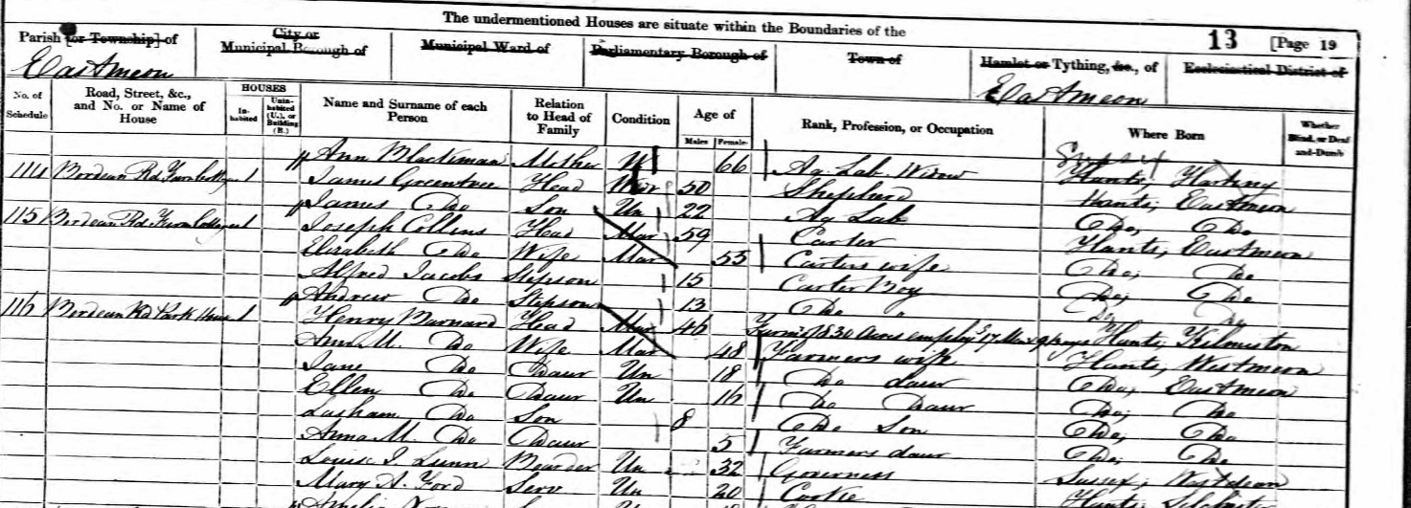

1871 The farm had expanded to 900 acres, employing 20 labourers and 7 boys. Four of the five children lived at home, the only absentee being 21 year old Henry. They had two servants, 24 Martha Withers from West Tisted and 17 year old Ann Sims from West Meon. The household was 8 people. The 1875 Harrod’s directory showed Henry Barnard at Park Farm amongst the gentry (and it noted he kept a pack of harriers) whereas previous directories had shown him as a farmer.
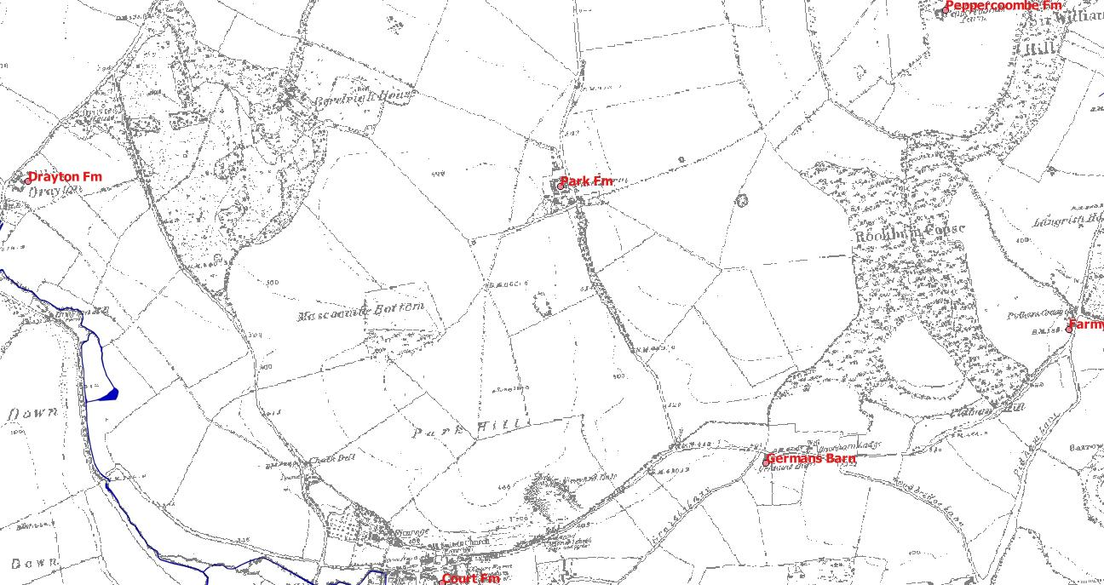

1881 Henry Barnard was 66 and his wife 62. He only farmed 600 acres employing 3 men and 5 boys. They had three servants: 22 year old Charlotte Gaiger from Terrington in Norfolk was the housekeeper, 19 year old Annie Beckingham from East Meon was the cook, and 14 year old Annie Mosely from Steadham was their domestic housemaid.
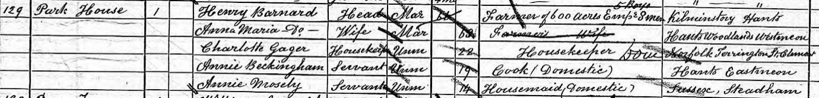
Henry Barnard died in 1887 and his wife in 1888. Neither of their sons took on the farm. Lasham Barnard was a steam tractor proprietor in Froxfield, and by 1898 was listed in the Harrod’s directory as a steam plough proprietor in Bordean. Henry, the elder son, was a brewer near Newbury. Two of his daughters had married brothers originally from Haslemere. The elder one had died soon after her marriage, and the younger daughter was living in Southampton, her husband having become a commercial traveller.
1891 Park Farm was occupied by 40 year old bailiff Edward Goodwin from Penshurst, Kent. He lived with his wife and five children. The four youngest had been born in Rotherfield, Sussex, suggesting that they had only recently moved to East Meon.

Hyden Farm (not mentioned on tithe map as it was tithe free)
1851 66 year old William Beasant farmed 760 acres at Hyden Farm and employed 7 labourers. He had been born in East Meon, and his 71 year old wife Olive was from Ropley.
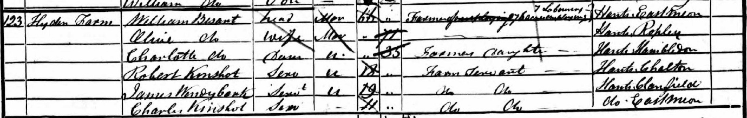
They lived with their 35 year old daughter Charlotte, and three farm servants: 18 year old Robert Kinshot from East Meon, 19 year old James Windybank from Clanfield and 11 year old Charles Kinshot from Chalton. The Beasant’s 32 year old son Henry lived in a neighbouring cottage. William Beasant was listed in the 1855 directory as a farmer at Highden Farm.
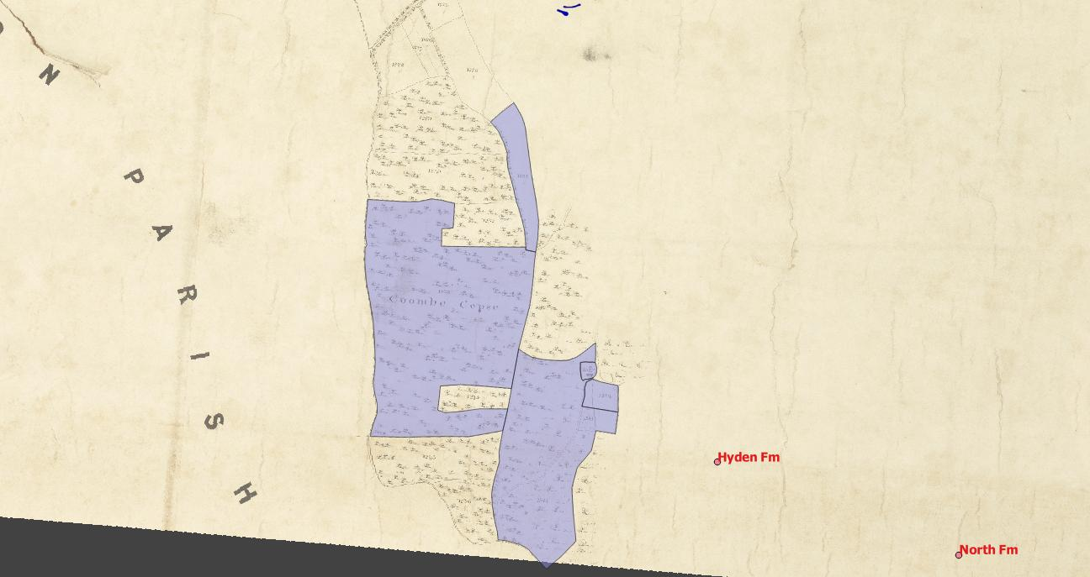
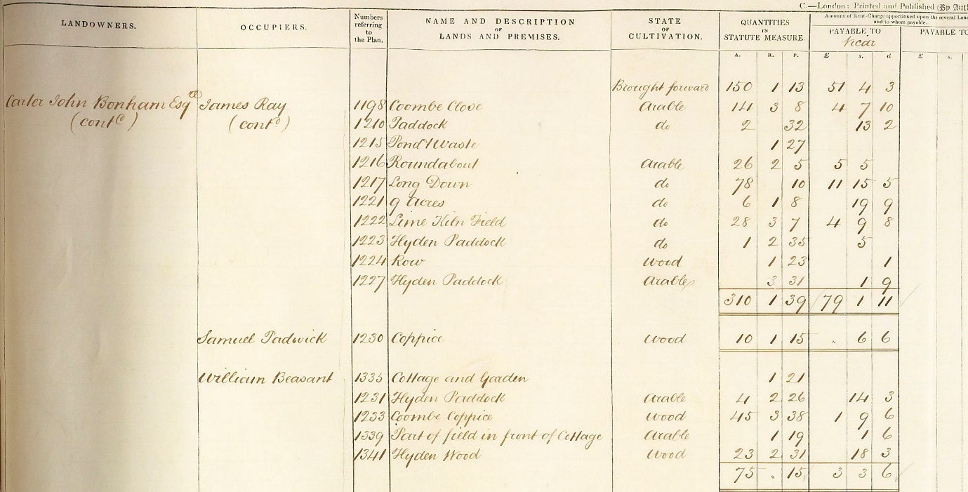
1861 William Hammond farmed 80 acres employing 2 men on Hambledon Road. He was from Hambledon, as was his 57 year old wife Rhoda and his three children. 21 year old William was a farmer’s son, and 18 year old Jane was a farmer’s daughter. However, 19 year old Harry was a grocer out of place. William Hammond was listed at the farmer at Highden (sic) Farm in the 1865 directory.
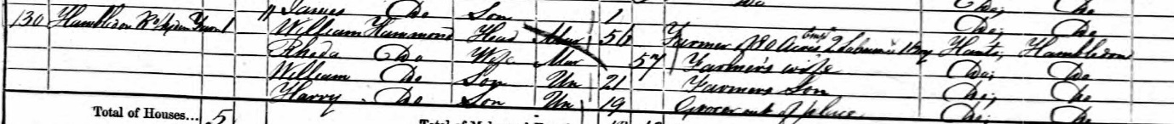
1871 Rhoda Hammond was listed as the 67 year old widow farmer at Hyden Wood Farm. She farmed 90 acres and employed 1 man and 1 boy. Her 29 year old son Harry was employed on the farm and her 28 year old daughter Jane was the housekeeper. Her 31 year old son William lived in a neighbouring cottage with his family and he worked as a carpenter. Mrs Hammond was listed in the 1875 directory as the farmer at Highdell (sic) Farm.
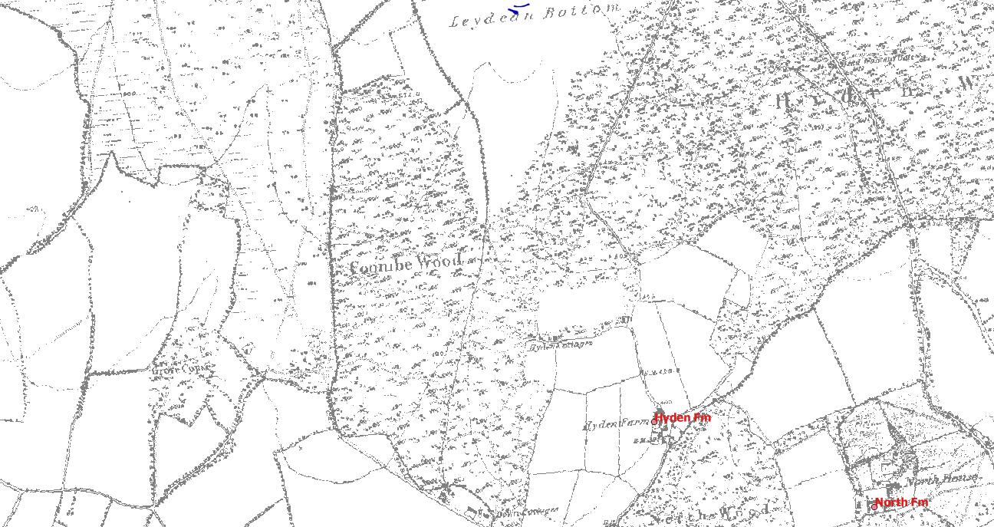
1881 77 year old Rhoda Hammond was the first person in East Meon in the 1881 census, listed at Hyden Farm. She farmed 92 acres and employed 1 man and 1 boy. Her 39 year old son Harry and 38 year old daughter Jane lived with her. Her elder son, 41 year old William, was a carpenter and wheelwright, and he also lived at the farm with his wife Eleanor and their four children. The eldest had been born in Emsworth, the three youngest in East Meon.
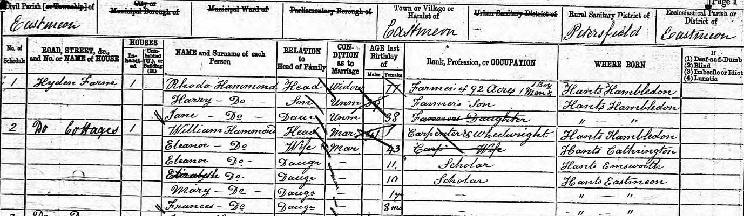
1891 Harry Hammond was 49 and listed as the farmer at Hyden Farm, living with his 36 year old wife Sarah Ann, from Hackney. His sister had married Richard Pink, the miller at Upper Mill. Another labourer, 39 year old John Allam from Hickley in Hampshire, also lived at Hyden Farm with his wife and 5 children. The two youngest of these had been born in East Meon. Harry Hammond was listed in the 1898 directory as the farmer at Highden farm.

Langrish Manor Farm
1851 Robert Berriman, 66, farmed 200 acres employing 12 labourers. He lived at “Langrish Farm”, with his 60 year old sister Elizabeth and 54 year old brother Hori, who was a farmer of 10 acres employing 1 man. Robert and Elizabeth had been born in Selborne, and Hori in Steep.
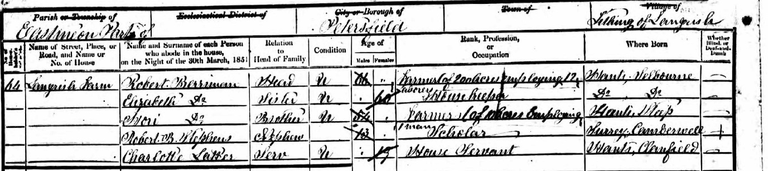
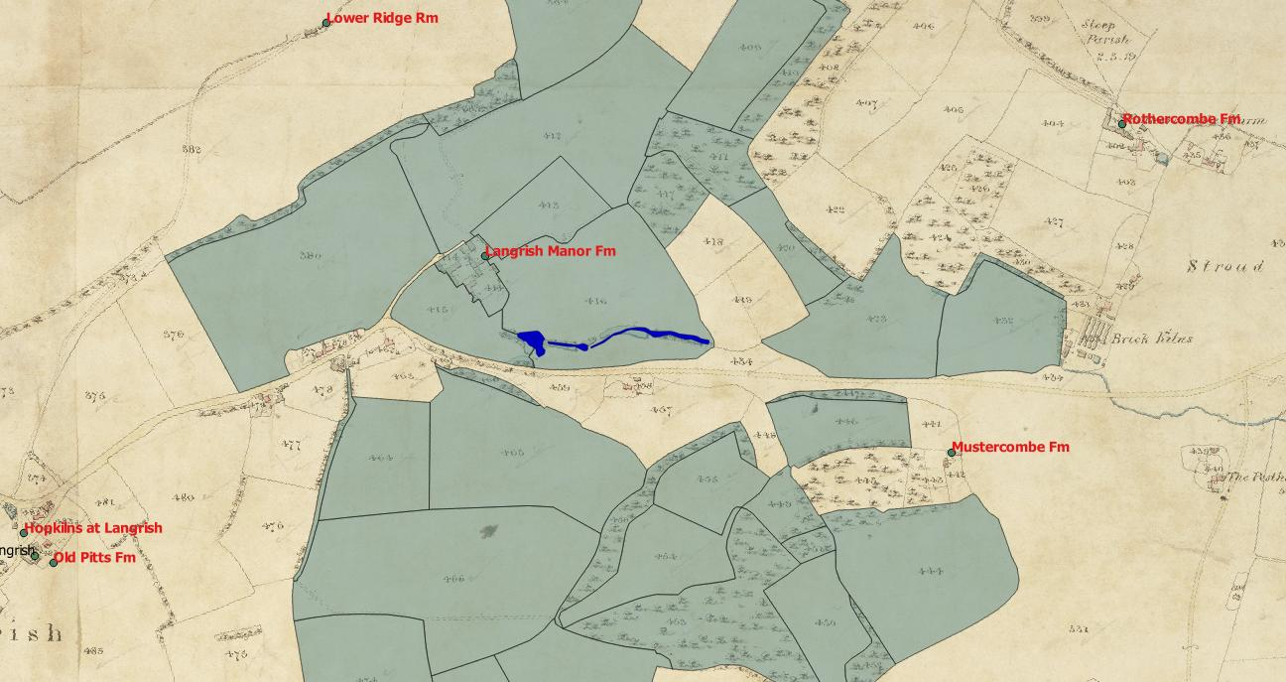
The household included their 13 year old nephew and one house servant. The tithe map showed him occupying 205 acres owned by Sir William Joliffe, of which 117 were arable, 47 acres were pasture, 30 acres were woods and 8 acres were hops. His name was spelt Berryman in the tithe map, but Berriman on the census. The 1855 Kelly’s Directory showed the spelling with an “I” and listed him as farming in Langrish.

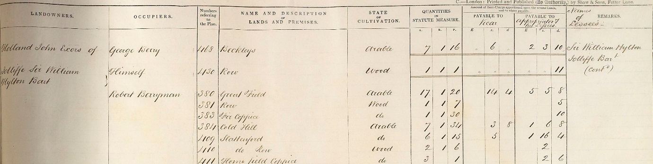
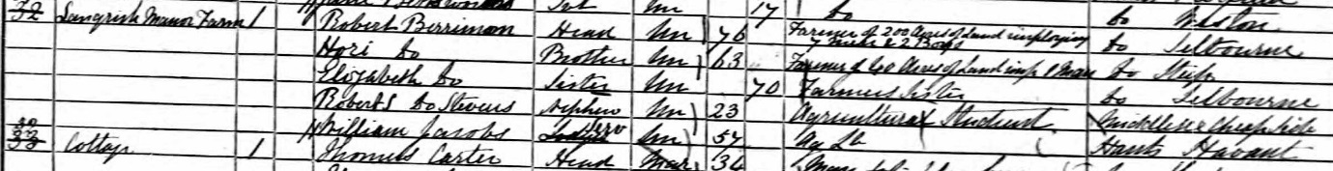
1861 Berriman farmed 200 acres employing 7 labourers and 2 boys. His brother Hori farmed 40 acres, employing 1 man. The farm was listed as Langrish Manor Farm. Their nephew ( 23) was listed as an agricultural student. The final member of the household was a 57 year old agricultural labourer from Havant. The Harrod’s 1865 directory listed Robert Berriman as farming in Langrish.
1871 The two Berriman brothers still lived in the village, and their nephew Robert Berriman Stephens, a 33 year old commercial traveller, was the head of the household. The farm had been taken on by 34 year old John Stubbs, from West Tisted, who farmed 221 acres employing 8 men and 2 boys.
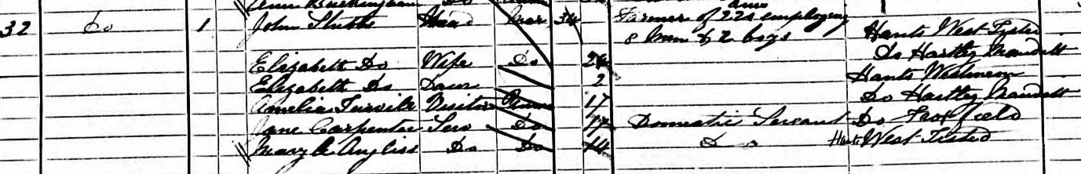
The address was simply given as Langrish. He lived with his wife and 2 year old daughter, who had been born in West Meon. They would eventually have 10 children. They had Elizabeth’s sister staying and two domestic servants, one (Jane Carpenter) from East Meon and one from West Tisted. The 1875 directory lists John Stubbs as farming at Langrish Farm, Langrish. John Stubbs was the enumerator of the 1871 census for Langrish.
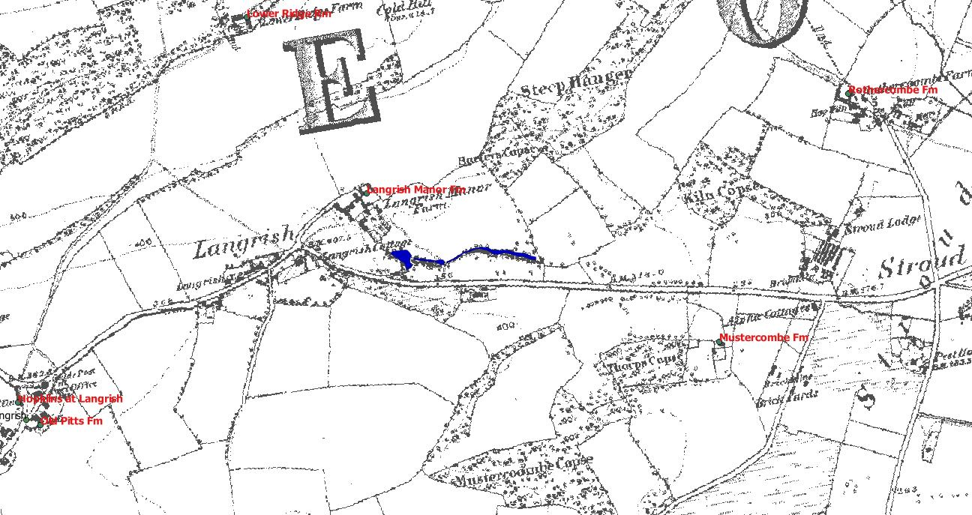
1881 John Stubbs farmed 300 acres at Langrish Farm. The census did not give employment numbers. He and his wife had 4 children under 10 living at home, and his 21 year old niece Annie Weeks was a visitor. Stubbs’ sister Ann was married to William Weeks of Oxenbourne. The family employed a governess and two domestic servants, 21 year old Alice Gregory from East Meon, and a 15 year old from West Tisted. The 1880 Harrod’s Directory lists John Stubbs as a farmer at Langrish Farm.
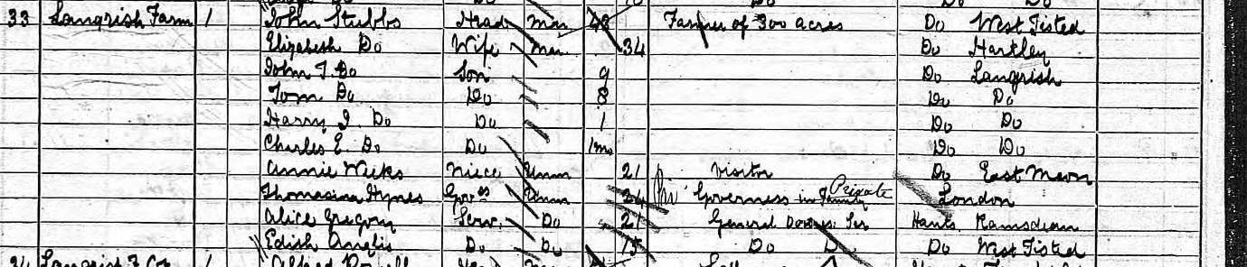
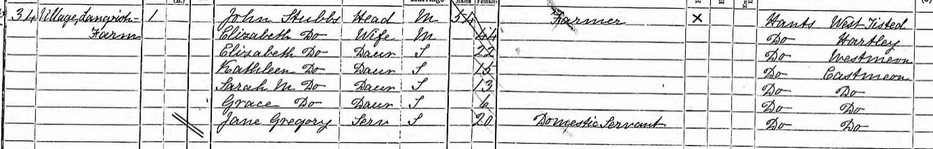
1891 John Stubbs, 54, farmed at Langrish Farm. He and his wife had four of their 10 children living at home, daughters aged from 6 to 22. They employed one domestic servant, 20 year old Jane Gregory from East Meon. The 1898 Harrod’s Directory lists him as a farmer and hop grower at Langrish Farm.

Hillhampton Farm (Oxenbourne Farm)
John Christmas, one of the six lessees of land in the parish, farmed at Oxenbourne. Christmas had the highest amount of farmland in the parish, since the vicar was the lessee of 1,968 acres, but 571 acres of these were woods, roads or common. Christmas occupied 565 acres, and but only owned 180 acres. According to the tithe map he was the occupier of both Oxenbourne Farm and Hillhampton.
1851, John Christmas was 55 years old ,living at Hillhampton, and described as a farmer of 392 acres employing 9 labourers.
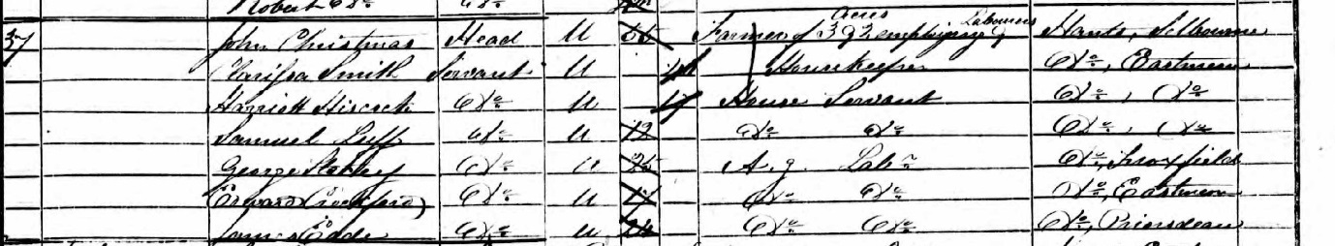
He had 40 year old Clarissa Smith, from the village, as his housekeeper, and two house servants from the village, 17 year old Harriet Hiscock and 12 year old Samuel Luff. Four agricultural labourers, two from the village, also lived at Hillhampton.
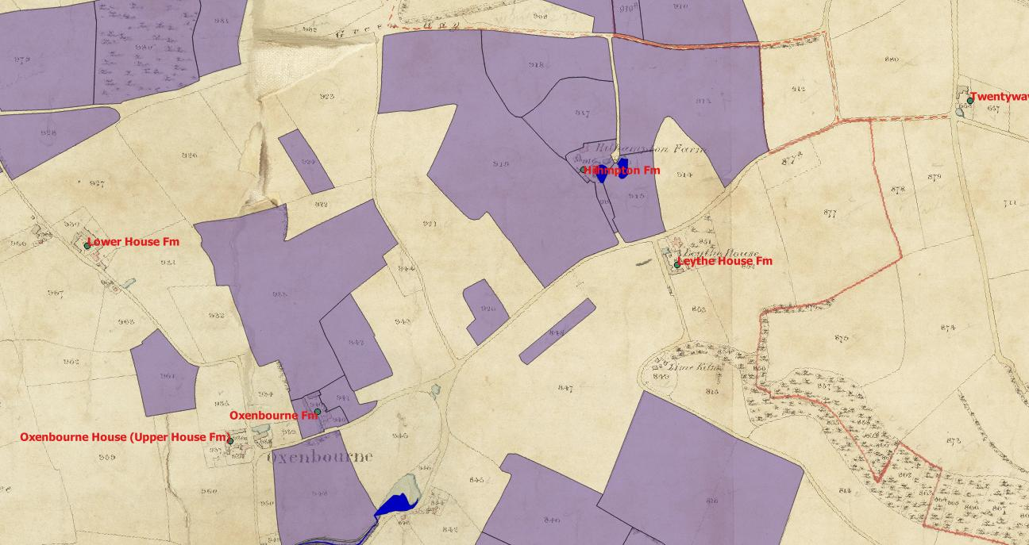
1861 John Christmas, 65, had moved to Oxenbourne Farm. Clarissa Smith, was still his housekeeper and he was described as a farmer of 726 acres employing 12 men and 4 boys. He had a 9 year old farmer’s son, Charley Legg from Colemore, visiting. Harriet Hiscock, former house servant, was a dairy maid, and he had another 15 year old house servant from the village, Elizabeth Gregory. There were three carters from the village also living at Hillhampton.
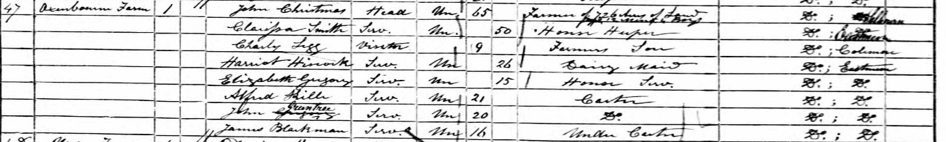
1871 Christmas, based at Oxenbourne Farm, farmed 705 acres employing 11 men and 4 boys. Clarissa Smith was still the housekeeper, and Harriet Hiscock the dairymaid. His 32 year old relative Albert Christmas was a bailiff, living with him. Two carters from the village completed the household of 7.
John Christmas died in 1876.
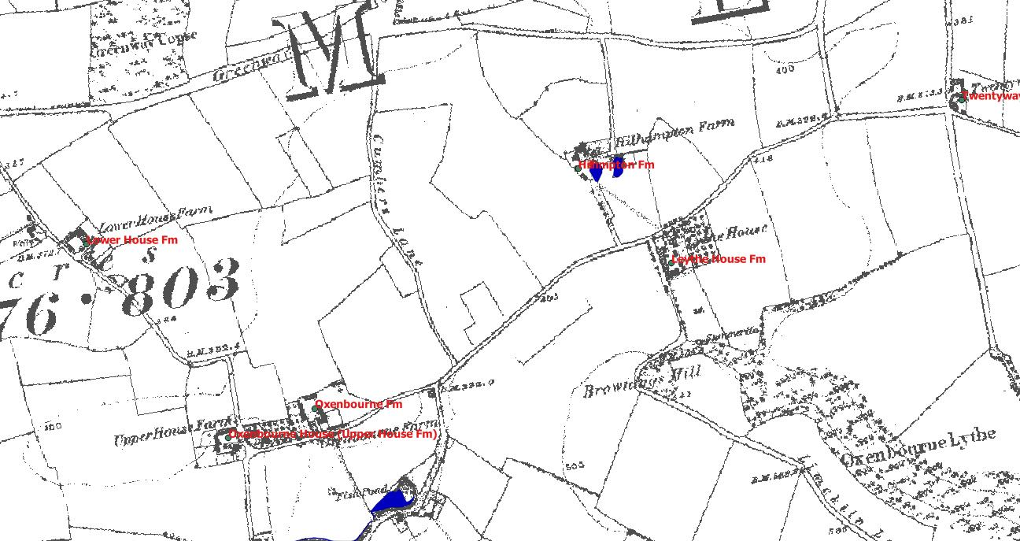
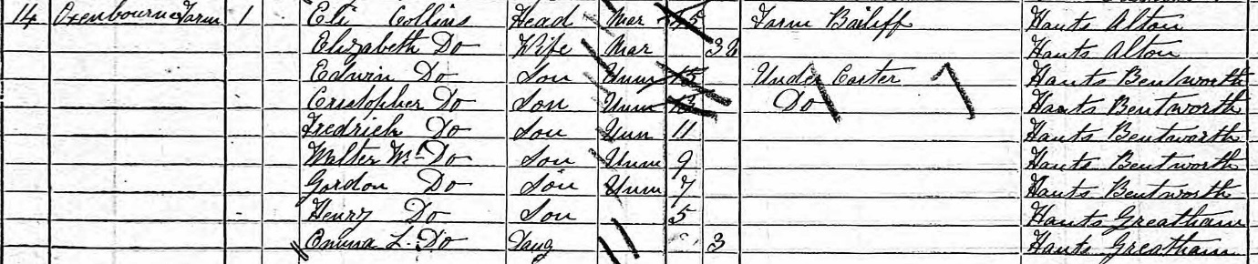
1881 The census showed that the new occupant was 45 year old farm bailiff Eli Collins from Alton, with his wife and 7 children, born in Bentworth or Greatham. The two older sons were under carters. Albert Christmas had moved to Hillhampton, where he described himself as a farmer, and lived with his wife and 3 year old son.
1891 Hillhampton farmhouse was occupied in 1891 by a “farm servant” and his family. It is also unclear which entry applies to the farmhouse. Oxenbourne Farm was occupied by 24 year old Charlotte Berry and 18 year old Richard Berry, both from Weston Patrick, and described as “farmer’s sister” and “farmer’s brother”. Henry Berry, listed in the 1898 directory as farming at Oxenbourne, Hillhampton and Preston, was the farmer in question. He had married William Weeks’ daughter Mary in 1891, when he was 29. He did not live in East Meon in the 1891 census but both he and Mary Weeks were living with Berry’s father, a farmer at Hurstbourne Priors, near Whitchurch in 1891.

In the 1901 census Henry & Mary Berry were living in Oxenbourne, with 83 year old William Weeks, and his daughter Annie in another house in Oxenbourne, and the younger William Weeks in a third house in Oxenbourne, described as a farm bailiff. By 1911 they had moved to Manor Farm Langrish.

Lower Farm (Orchard Farm)
1851 James Deadman, 68, from Hawkley, farmed 70 acres and employed 4 men. He lived with his 66 year old wife Hannah, from Suffolk, 27 year old son Mark, and 25 year old daughter Louisa. They employed one servant, 29 year old Mary Whitehead from Buriton, and had one 16 year old carter from the village as a lodger. Their eldest daughter Maria was married to Robert Green (Rookery Farm). It is not clear if James Deadman and Robert Green farmed together. Robert Green’s mother (Martha Deadman) may have been related to James, but they had different parents.
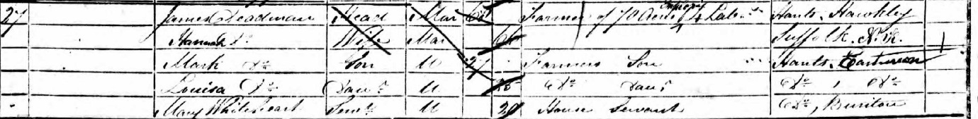
The tithe map showed that James Deadman occupied 110 acres including Lower Farm and Orchard farm. These acres included 83 arable acres, 20 acres of pasture, 4 of hops and 2 acres of woods. There were three other families in Ramsdean called Deadman in 1851. The 1855 Kelly Directory listed Mark Deadman, presumably James’ 27 son, as a farmer in Ramsdean.
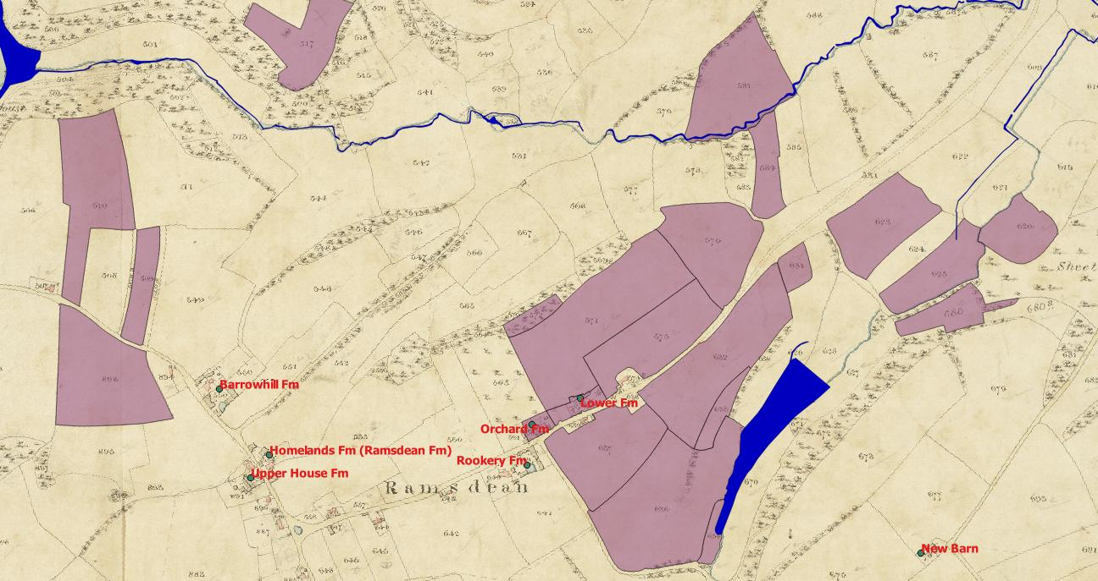
1861 James Deadman had died in 1853 and the farm was taken on by his widow Hannah. She farmed 50 acres, employing 2 men and 3 boys. The address in the 1861 census was Lower Farm. She lived with daughter Louisa, and two grandchildren, Fielder 16 and Jane 14. The former worked as an under carter, the latter as dairy maid and house servant. Their father Stephen Deadman had also died in 1853. The 1865 Harrod’s Directory listed Mrs Hannah Deadman as a farmer in Ramsdean.
1871 Hannah Deadman was 86 and farmed 100 acres employing 4 men and 1 boy. Her 43 year old daughter Louisa lived with her as did her 26 year old grandson Fielder, an agricultural labourer. Another grandson, 20 year old Charles also lived with them. He was the son of Hannah’s oldest son James, who died in 1867. The census address was Ramsdean Road.
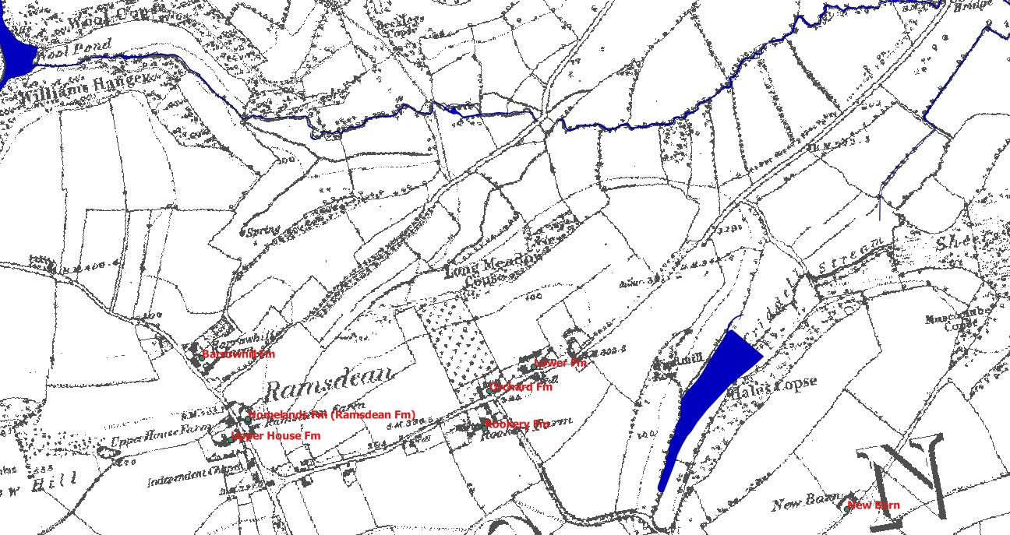
1881 Hannah Deadman died in1872, but she was still listed in the 1875 Directory. Her grandson Charles lived at Cheesecombe Farm, but his occupation was given as a carter. Fielder Deadman was a farmer living at Pidham cottage. Louisa Deadman married Jacob Young, and she lived in Ramsdean in 1881, presumably at Orchard Farm, but this is not clear from the lack of an address in the census.
1891 David Noble, 45 from East Meon, was listed in the 1885 Directory as farming at Orchard farm. In the 1891 census he was listed as a farmer in the hamlet of Ramsdean, living with his 51 year old wife Ann and a 16 year old general servant, Mary Finch from Steep. David Noble was born in the village, and on previous censuses had been listed as a journeyman brewer and as a carrier.

Tegwell (Tigwell) Farm
1851 William Lipscomb was a 31 year old farmer of 423 acres employing 13 men. He shared the house with a 38 year old housekeeper and a 17 year old house servant.
The tithe map showed that the farm house was owned by George Forbes of Bereleigh, and farmed by Charles Elderfield. The tithe map showed this holding was 429 acres, virtually the entire Bereleigh estate. There were 316 arable acres, 56 acres of pasture and 50 acres of woods. The 1855 Harrod’s directory showed Elderfield as a farmer based at Bordean.
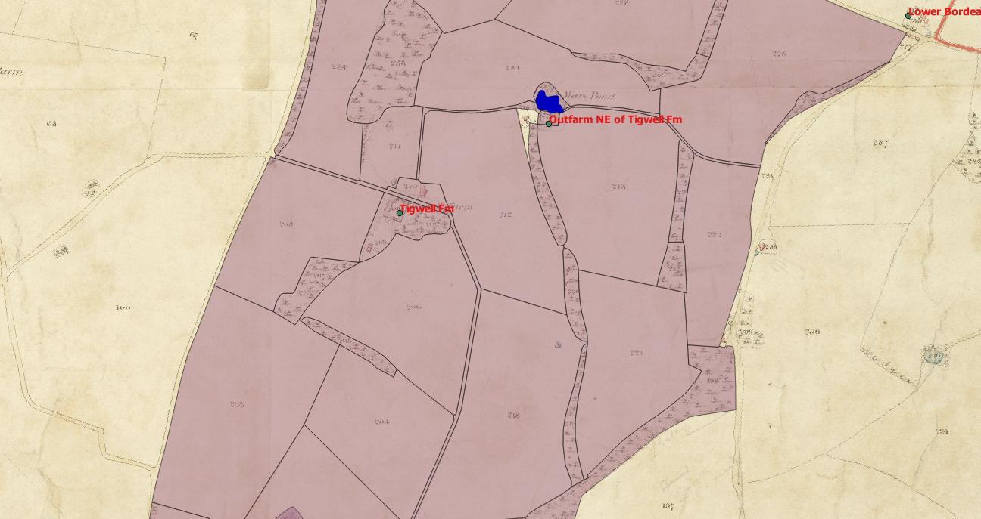
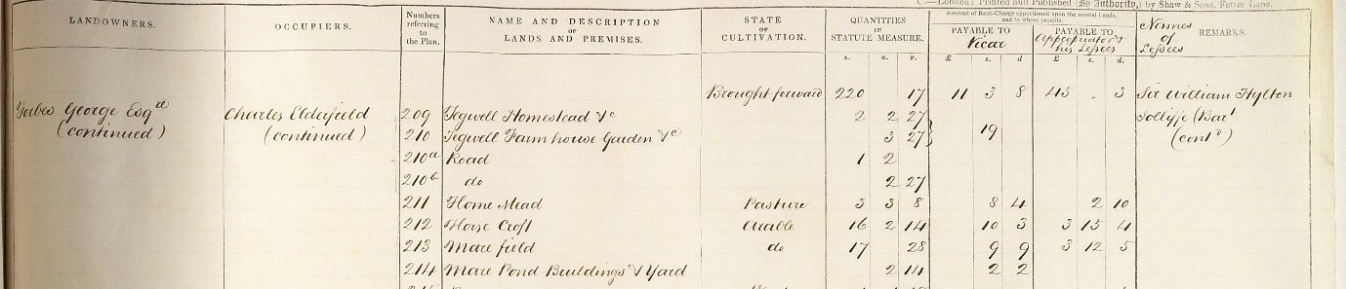
1861, Tigwell was farmed by 51 year old William Mellersh, from Rogate, who lived with his wife and 8 children in the house. He farmed 430 acres, employing 11 men and 3 boys. The two older sons, aged 22 and 19 were described as “farmer’s sons”. They had a 21 year old female relative visiting in 1861. There were also four carters living in the same dwelling, one of whom, 17 year old John Kinshott was from the village. The others were from Priors Dean, Selborne and Binderton, Sussex. Mellersh was listed in the 1865 Harrod’s directory as farming at Tigwell Farm.
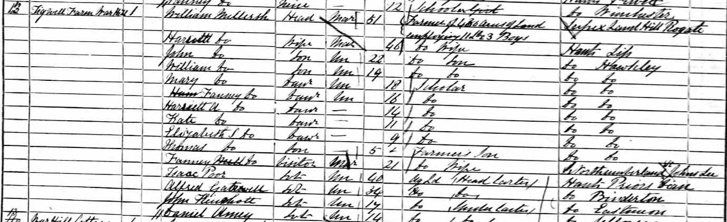
1871 Tigwell was occupied by 59 year old farmer’s widow Harriet Wing from Mildenhall in Suffolk. She was described as a farmer of 315 acres employing 4 men and 2 boys. Her two sons, both in their twenties, and three daughters lived with her, along with a 5 year old grandson.
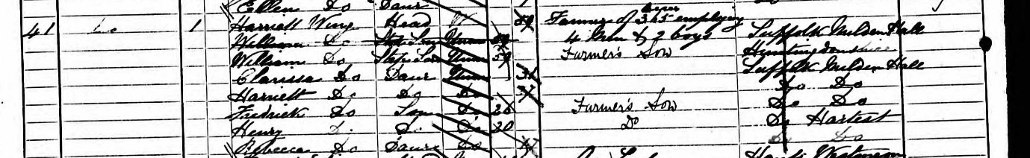
The elder son, Frederick, was listed in the 1875 Harrod’s directory as farming at Tigwell. She had been the second wife of her husband Charles Wing, who had died aged 76 in Suffolk in 1868.
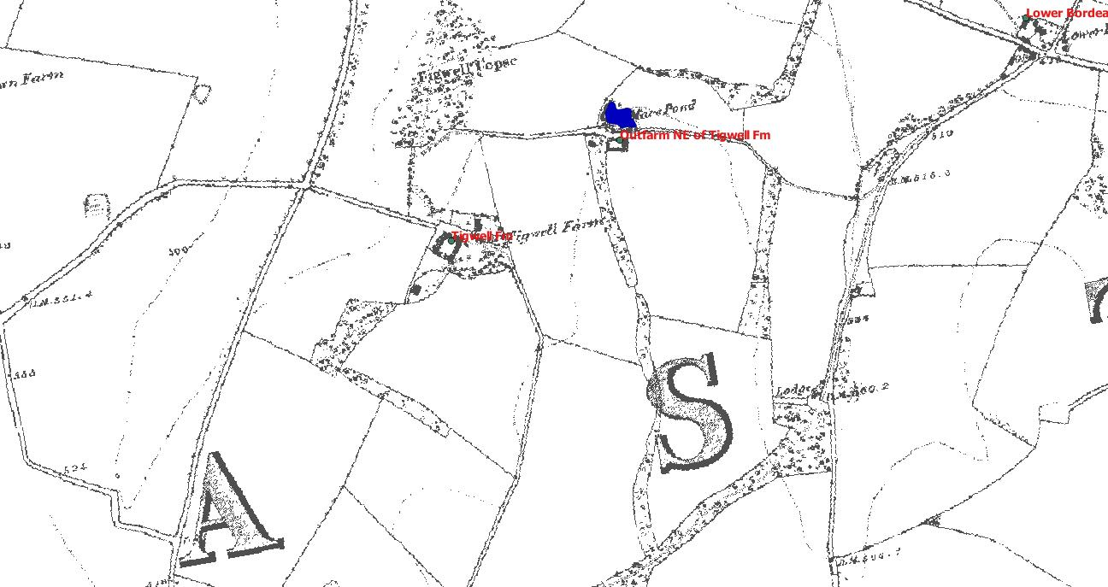
1881 Tigwell was occupied by 45 year old Edward Cunningham, from Hougton in Sussex. He was farm bailiff to Mrs Forbes, farming 328 acres and employing 7 men and 5 boys. He lived with his wife and four children under two. The last two, aged 3 and 1 had been born in East Meon. They had 14 year old Clara Dennis from the village as a general servant. There were two farm cottages at Tigwell in 1881, occupied by labourers James Blackman and Robert Edwards and their families.
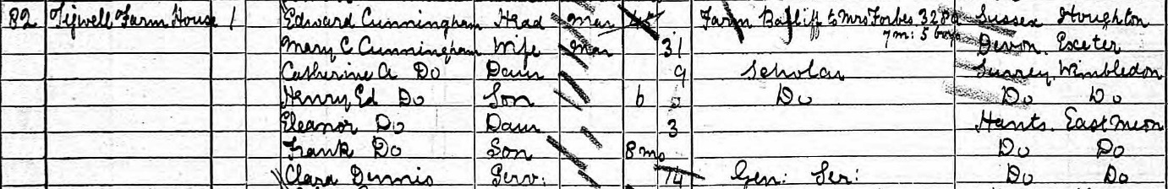
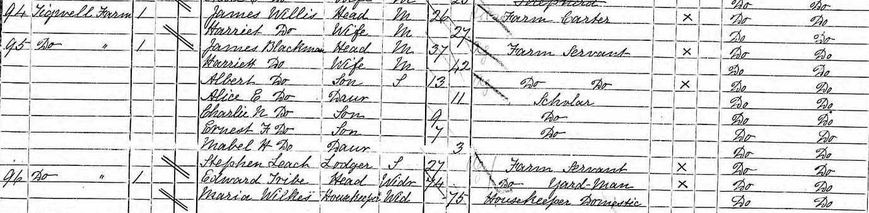
1891 There were three dwellings at Tigwell. The census did not detail which was the farmhouse. James Blackman, 37 year old farm servant, lived in one with his family of 7, so this was probably the farmhouse. The others were occupied by 74 year old yard man Edward Tribe along with two widows in their 70s and a grandchild. The first two were from the village. The other was occupied by 26 year old carter James Willis and his wife, both from East Meon.

Westbury House
1851 Hon Thomas William Gage, 53, was a landed Magistrate and farmer of 1500 acres employing 25 labourers and 10 boys outside.
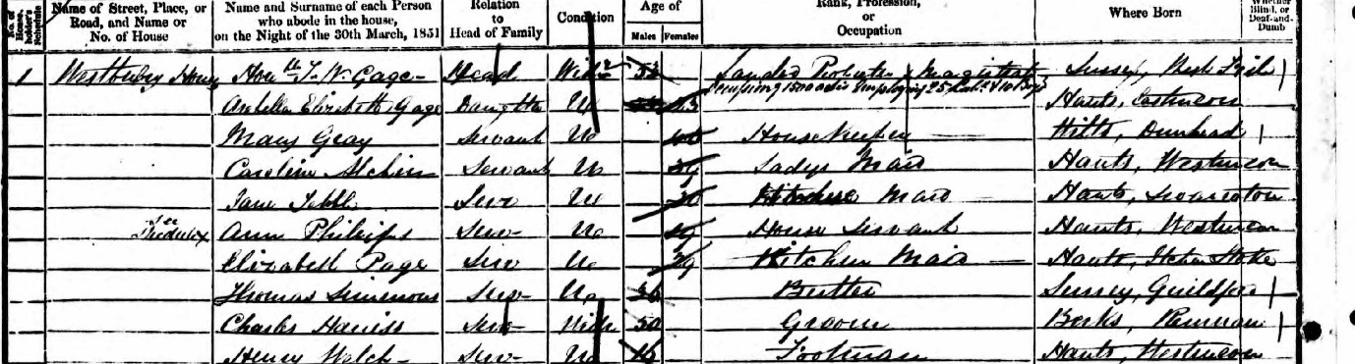
His 23 year old daughter Arabella lived in the house along with 8 servants, none of who were from East Meon. These were: 39 Caroline Archin, ladies maid, 30 year old Jane Tebble, kitchen maid, 19 year old Ann Philips House servant, 29 year old Elizabeth Page, Kitchen maid, 36 year old Thomas Simms, Butler, 50 year old Charles Harris, groom and 16 year old Henry Welch, footman. There were 10 in the household.
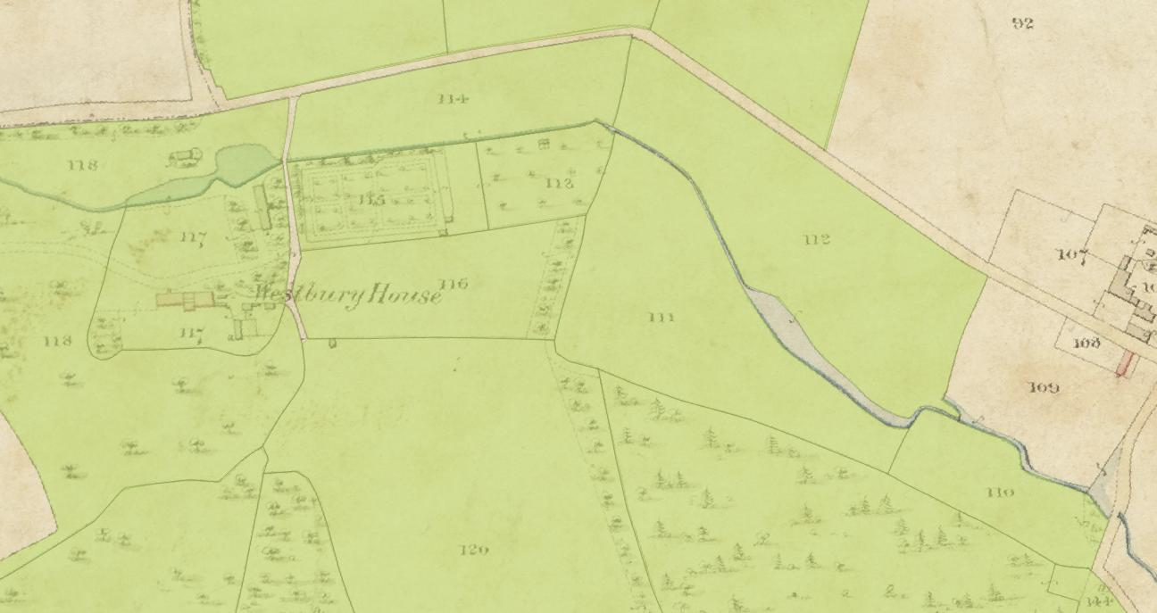
1861 Westbury was rented to Edward Sartoris (46) who was not there on the night of the census. His wife Adelaide, nee Kemble, was described as “landed proprietor’s wife”. Her two children May , 16, and Algernon, 9, lived there. Algernon later married Nellie Grant, the daughter of US President Ulysses Grant. The household included Adelaide’s 12 year old nephew Henry Kemble and her sister May Hames (60). They had another visitor on the night of the census, 37 year old Mary Hogge, a clergyman’s wife.
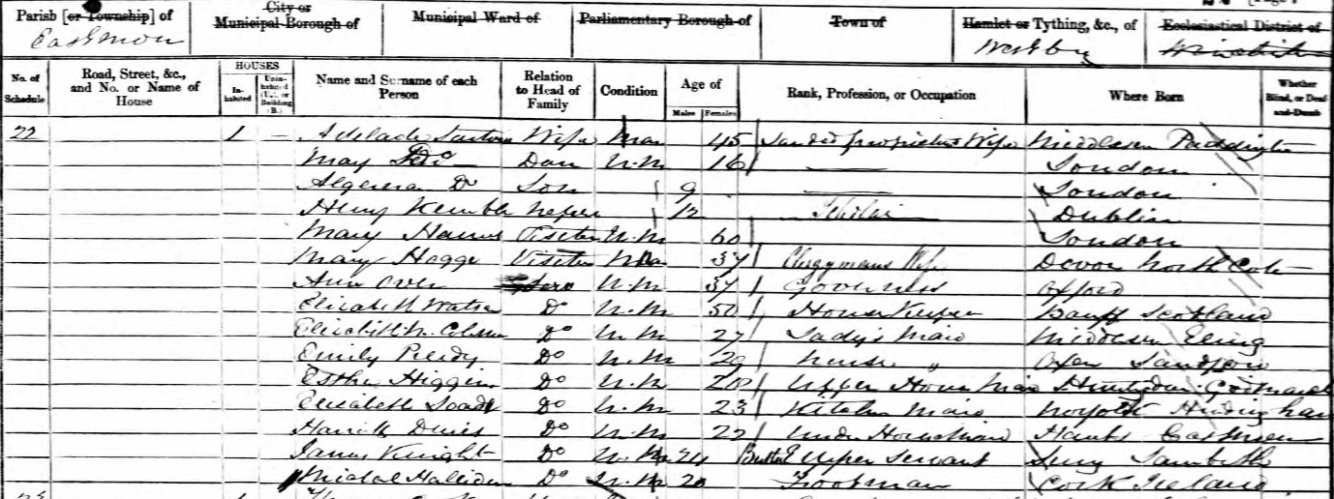
There were nine servants, including 22 year old Harriet Dennis, an under housemaid, from East Meon. None of the other servants were local, and their coachman and two grooms lived in a different part of the house. 10 years later the Sartoris family were living at Warsash, Titchfield, and Edward Sartoris was by that stage MP, having been elected in 1867. Their daughter May lived with them along with a household of 11 servants. None of these had been their servants 10 years before:
1871 John Delaware Lewis had purchased Westbury in 1866. He was MP for Devonport and on the night of the census was in a house Eaton Square’ along with his wife and a household of 9 servants. The house appears to be unoccupied that night.
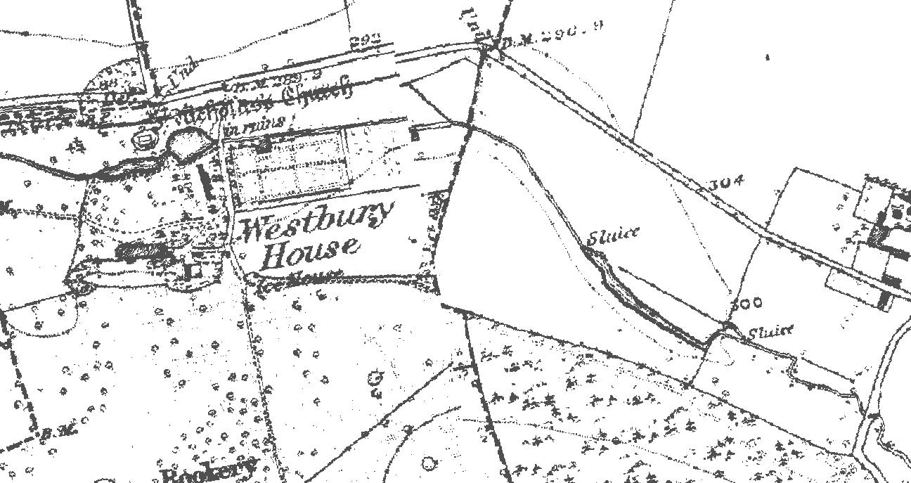
1881 John Delaware Lewis (52) a barrister not in practice and his wife Teresa (45) lived at Westbury. They had a staff of 9 servants, none of whom were from East Meon: footman, 2 pages, cook, 2 housemaids, kitchen maid and ladies maid. The 9th was the sister of one of the maids and was listed as a visitor.
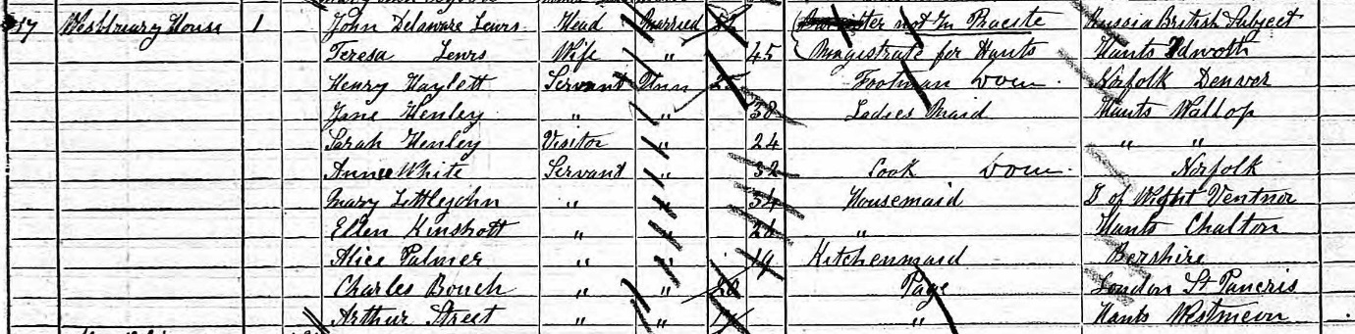
1891 John Delaware Lewis died in 1884. The house was owned by his cousin Herman le Roy-Lewis who had taken on the name Lewis after his cousin’s death. He was “living on his own means” and did not describe himself as a farmer. He lived with his wife and two young daughters. They had a staff of 9 servants, none of whom were from East Meon: butler, 2 footmen, cook, 2 housemaids, kitchen maid and two nursemaids.
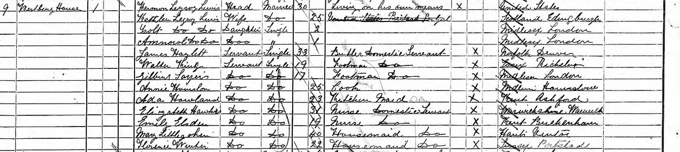

Hop kiln Farm
1851 George Berry was a 39 year old Farmer and limeburner of 40 acres employing 7 men, born in East Meon. His 29 year old wife, Mary Ann, was from Newton Valence, and they had children aged 6,3 and 1 – all born in East Meon.
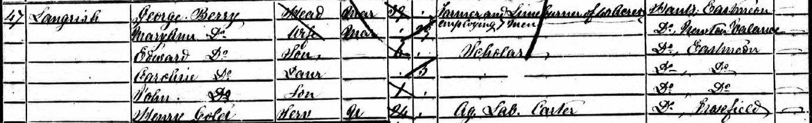
The 1852 Tithe map showed him farming 46 acres and living in a homestead on Langrish Hill. His holdings included the lime kilns on Bordean Hill, so the farm has been named “hop kiln farm” but this name may not have existed. They had a 24 year old male servant from Froxfield in the household.
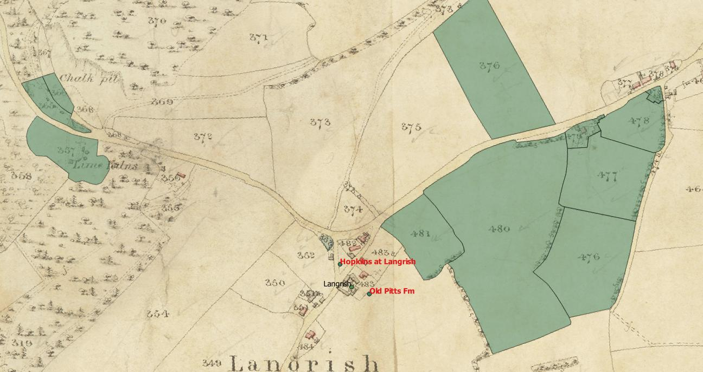
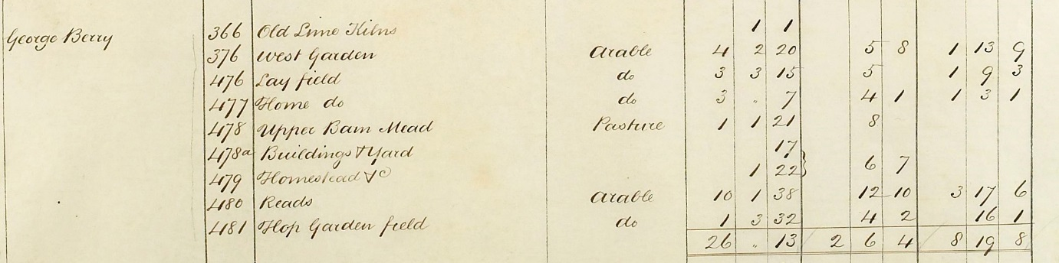
William Berry, a 31 year old brick maker lived next door with his family. It is unclear how they were related. William’s father, 53 year old Edward Berry from East Meon, was a farmer of 100 acres and brick maker employing 7 men living in Stroud. He was listed on the 1852 tithe map at the brick works in Stroud.

The Berry family occupied land either side of Stroud common, some occupied by George, some by William, some by Edward and some by John Berry, who is listed in the 1851 census in Steep as a Farmer of 120 acres employing 3 labourers.
Berry family occupation in 1852 tithe map
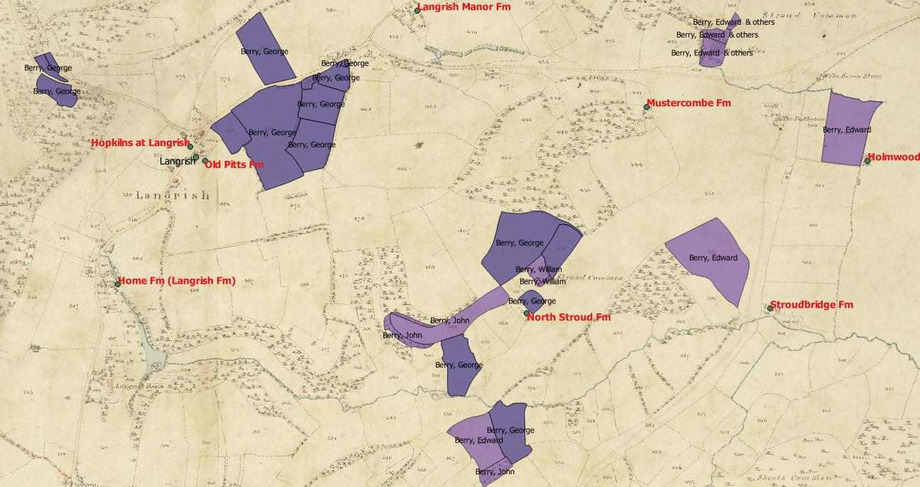
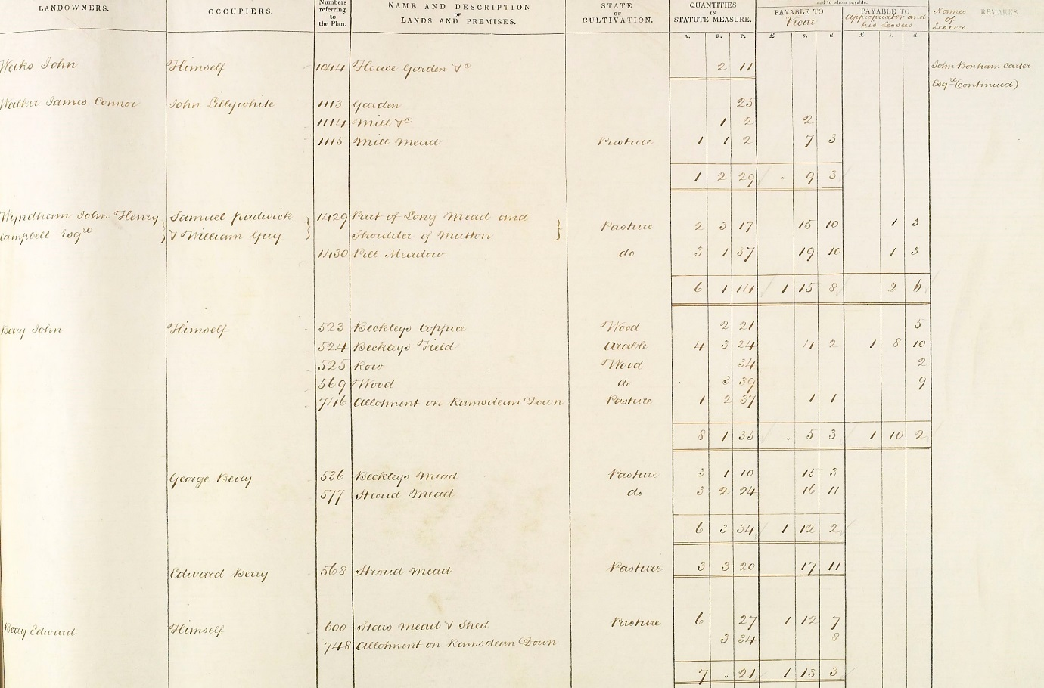
John, Edward and George were probably brothers. Both George Berry and William Berry were listed in the 1855 directory as farmers and brick makers living in Langrish.
1861 George Berry was a 48 year old farmer and Limeburner of 50 acres employing 4 Labourers & 2 boys. He and his wife Mary Ann had 8 children, 6 more born since 1851. They had one 17 year old male servant. 41 year old William Berry was a brick maker also living in Langrish, and he occupied 16 acres. William lived with his wife Emily and their 1 son and 6 daughters. The 1865 directory listed both William and George as farmers, lime burners and brickmakers.
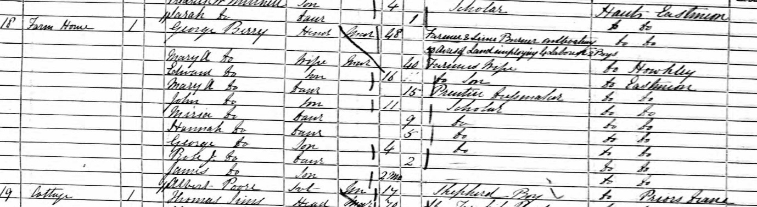
1871 George Berry was a 58 year old farmer and lime burner of 150 acres employing 14 men & 1 boy. His 21 year old son was a wheelwright living at home along with four younger siblings. The two oldest children were no longer living at home. 50 year old William Berry lived in Stroud and farmed 13 acres, He lived with his wife Emily and 5 children under the age of 15. His eldest son, also William, was brick merchant and burner of 25 who lived next door with his wife and two children. The younger William had a live in servant, unlike his parents. The 1875 directory listed both William and George as farmers, lime burners and brickmakers.
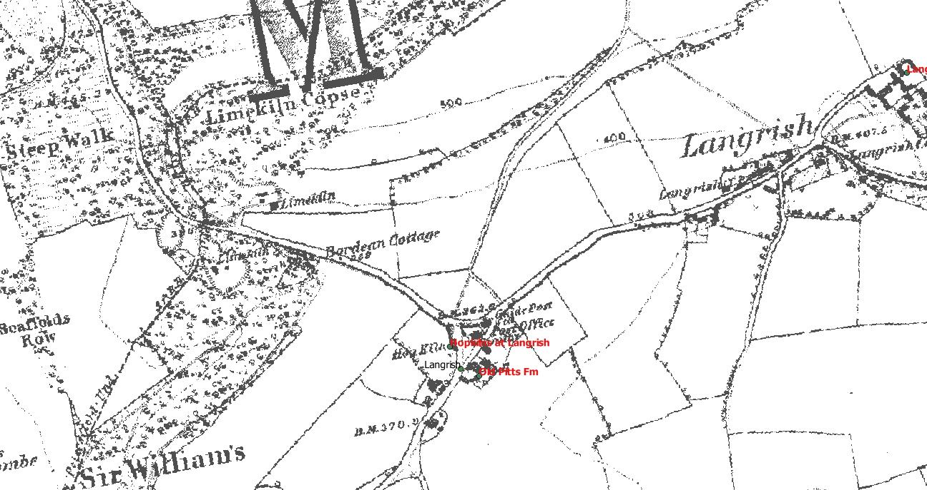
1881 35 year old William Berry lived at Kiln House. He was a brick merchant owning 45 acres and employing 10 men and 2 boys. He lived with his wife Martha and their 5 children. They had a single 14 year old female servant in the house. His widowed mother , 58 year old Emily, lived next door with his two unmarried sisters, aged 21 and 18, and his 16 year old younger brother, a carpenter’s apprentice. The 1880 directory listed William as tile & brick maker and farmer.
1891 William Berry’s widow, 52 year old Martha, lived in Stroud and was listed as “independent”. She lived with her 21 year old daughter and 19 year old son. Her elder son, 22 year old Walter was a lime merchant living elsewhere in the village with his 23 year old wife Jane.

Whitewool Farm
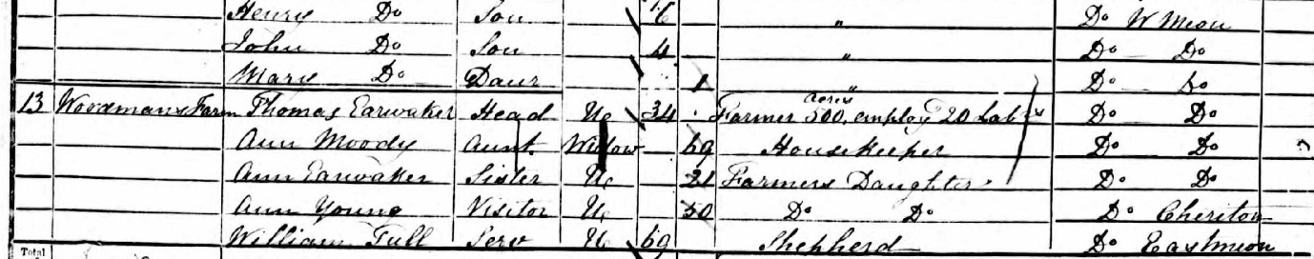
1851 Whitewool Farm is in West Meon, but part of its fields are in East Meon. On the West Meon census, Thomas Earwaker, 34 lived with his 69 year old Aunt Ann Moody and his 21 year old sister Ann. He farmed 500 acres at “Woodman’s Farm” and employed 20 men.
69 year old John Welch farmed 1500 acres at Whitewool farm, employing 28 labourers.
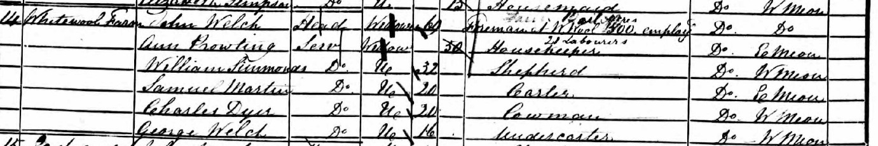
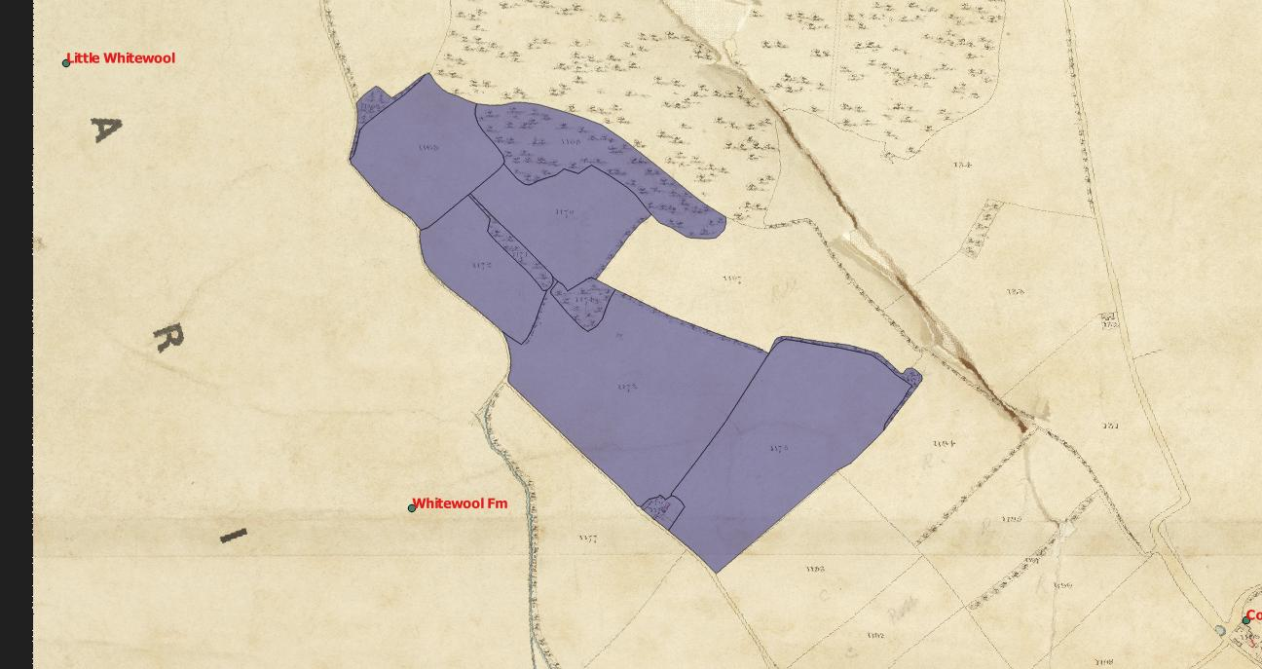
1861 Thomas Earwaker, 45 farmed 600 acres at Whitewool Farm and employed 16 men and 5 boys. He shared a house with a 46 year old Shepherd from west Meon, and Robert Moody, a 32 year old carter from East Meon, who also had has wife Lucy and daughter Emma in the household.
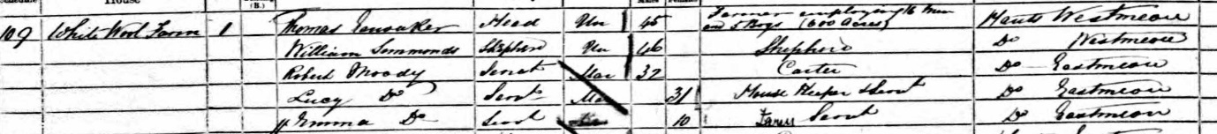
1871 40 year old James Burrough, from Donyatt in Somerset, farmed 546 acres at Whitewool Farm and employed 8 men,6 boys and 4 women. He shared a house with his 46 year old wife Elizabeth. They had one servant, 19 year old Charlotte Leach from East Meon.
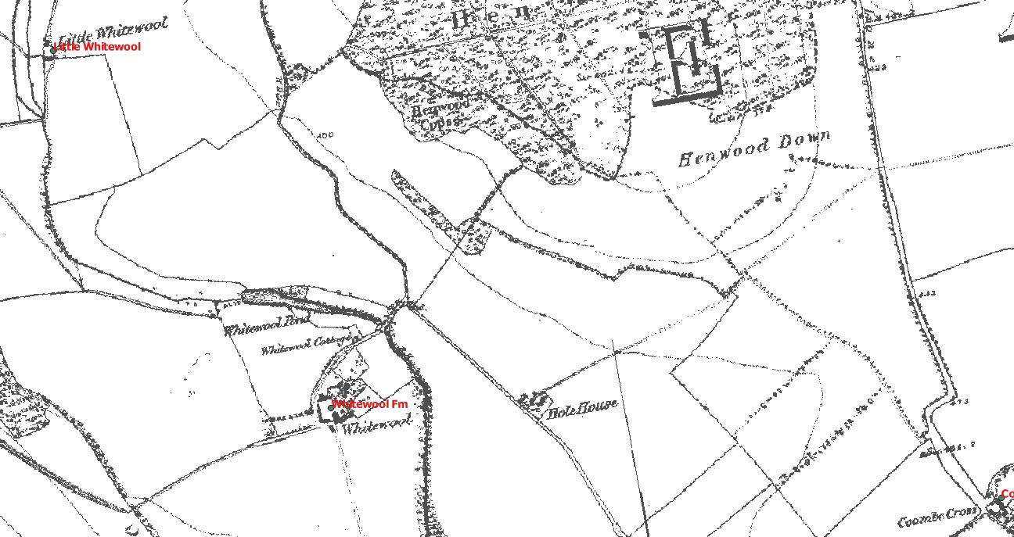
1881 34 year old William Harlock, a retired farmer from Ely lived at Whitewool with his 21 year old brother Arthur, a brewer. There were no details of the farm.
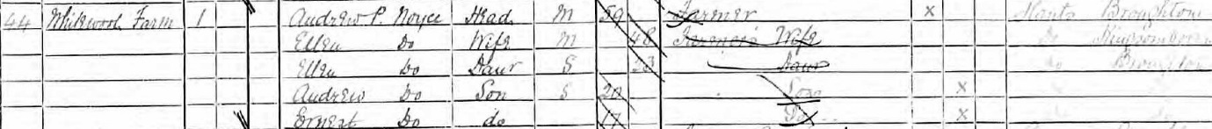
1891 59 year old Andrew Noyce from Broughton and his 48 year old wife Ellen lived at Whitewool, which was in West Meon. They lived with a daughter of 23, also Ellen, and two sons Andrew 20, and Ernest 17.

Barrowhill Farm
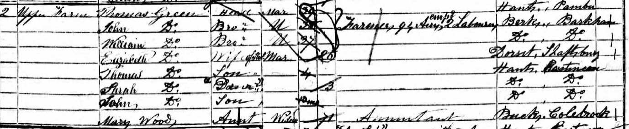
1851 Brothers Thomas, John and William Green farmed 94 acres employing 2 labourers at Upper Farm (no such name exists today , so probably they farmed at Barrowhill Farm, see 1861), Ramsdean. They were originally from Pamber, but the two younger brothers were born in Barkham. A further brother, Henry, was a land surveyor living in the village. Only the eldest brother, Thomas, was married, and his wife Elizabeth and three young children, all of whom were born in East Meon, shared the farmhouse.
The tithe map showed them farming 109 acres, of which 70 were arable, 30 acres were pasture, 5 acres were woods and there were 4 acres of hops.
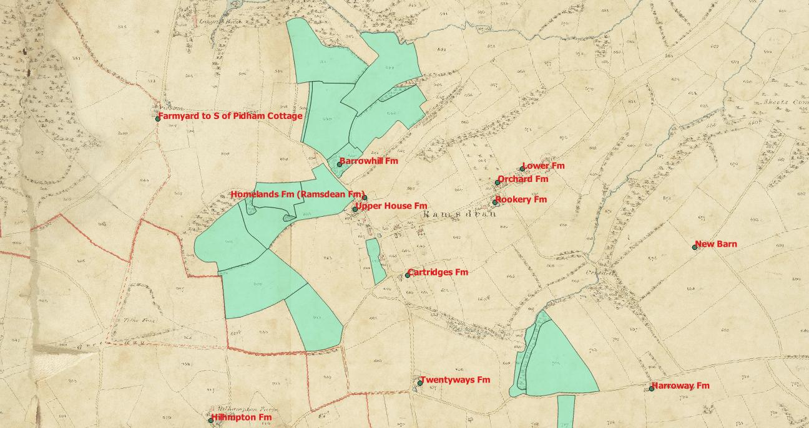
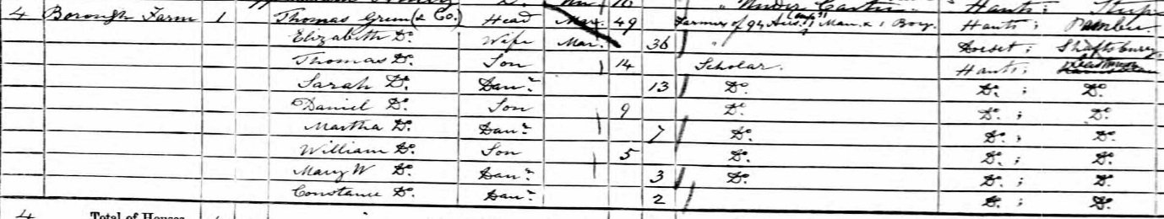
1861 Thomas Green, his two brothers and his family were at Borough Farm (which I assume is Barrowhill Farm, as there is no Borough Farm in Ramsdean), they farmed 94 acres, implying that he had not changed farms, and employed 1 man and one boy. Thomas and his wife had 7 of their children living with them, all born in East Meon. They were to have 2 more children in the next decade. The 1865 Harrod’s directory listed the business as Green, Thomas, William and John, farmers, Ramsdean.
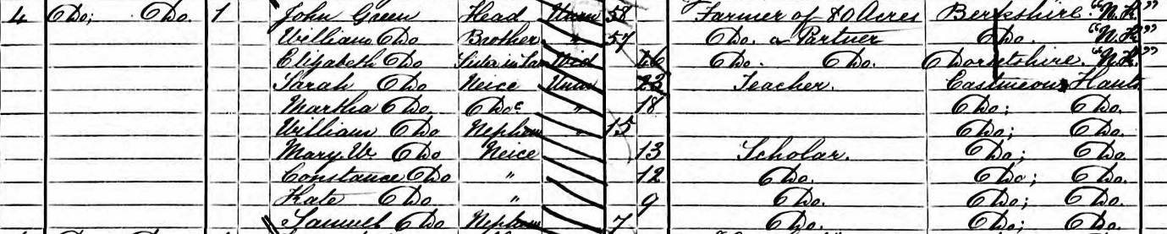
1871 Thomas Green died in 1869, but his wife remained a partner in the farm, headed by younger brother John Green. The farm was 80 acres, so they may have moved farms. 7 of Thomas and Elizabeth’s children still lived with the family. The 1875 directory listed John & William Green as farmers at Burrow (sic) Ramsdean. The 1871 census entry follows that for Richard Green at Ramsdean Farm.

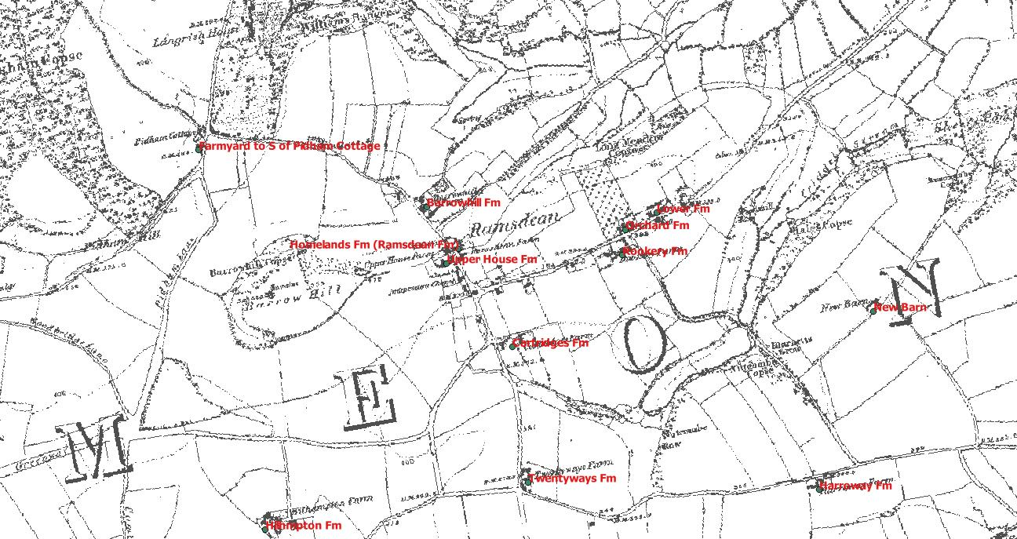
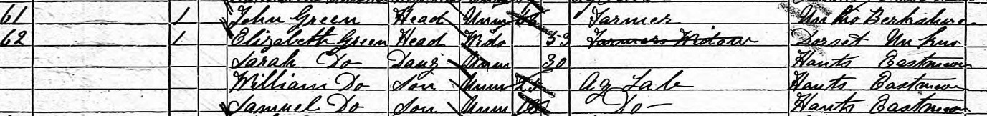
1881 John and Elizabeth Green were at an address given in the census as North Stroud. This means that they had probably still at Barrowhill Farm which is at the end of North Stroud Lane, as are Upper House Farm and Ramsdean Farm. John Green 68, was listed as a Farmer, and his sister in law Elizabeth as a Farmer’s wife. They lived with her 30 year old daughter Sarah, and two sons William, 25 and Samuel, 18, who were both agricultural labourers. The 1880 directory listed John Green as a farmer at Burrow, Ramsdean.
1891 The census does not give addresses, but listed next to Richard Green was 51 year old farm bailiff Horace Wood from Crowhurst, Sussex, and his family. His three children had been born in Staple Cross, and as the youngest was 3, it suggests that they had only recently moved to East Meon. He probably lived at Barrow Hill Farm.

Biden Farm
1851 Thomas Martin, 46, from Bradley, Hants, farmed 220 acres. He employed 6 labourers and was on the Clanfield census.
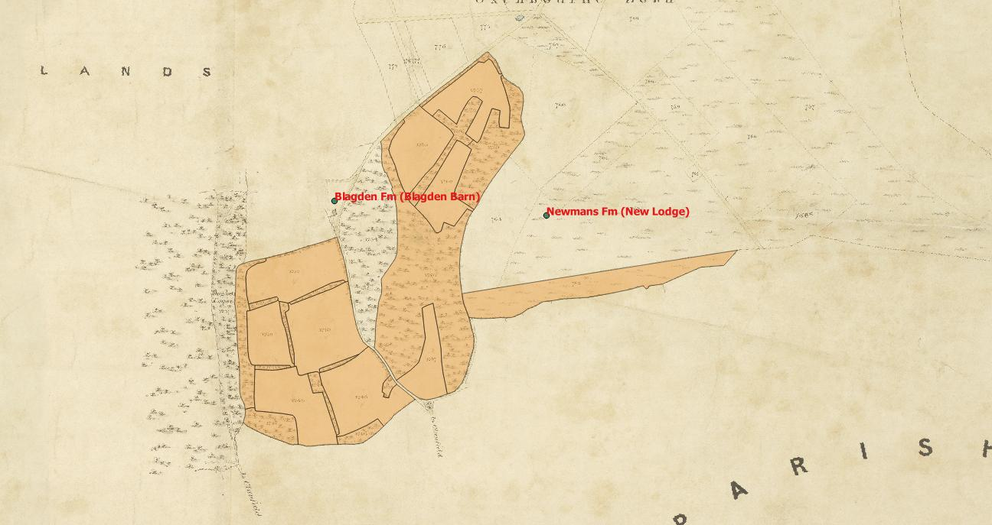
He lived with his 31 year old sister Lavinia. She was a “fundholder” born in Chalton. They had a 16 year old servant, also from Chalton. He farmed 100 acres in East Meon according to the Tithe Map, based at Biden Farm.
Thomas Martin farmed another 272 acres in Clanfield, possibly based at either Upper Farm or Manor Farm.
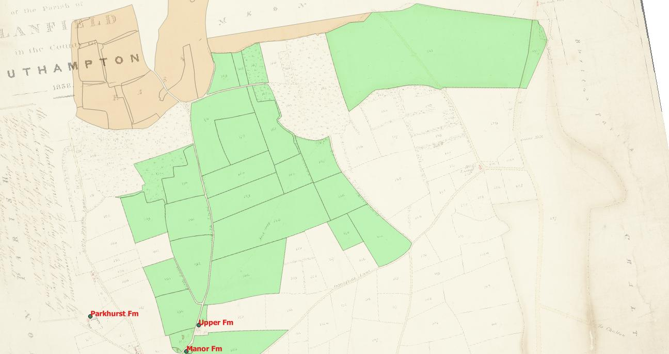
Martin died in 1856. There are no addresses in Clanfield on subsequent censuses, so it is impossible to tell which farmers lived in which farm.
1871
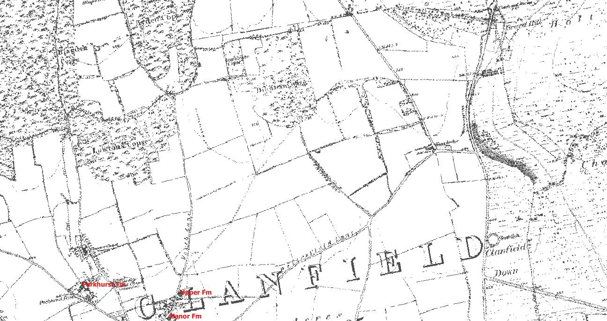

Langrish House (Langrish Farm)
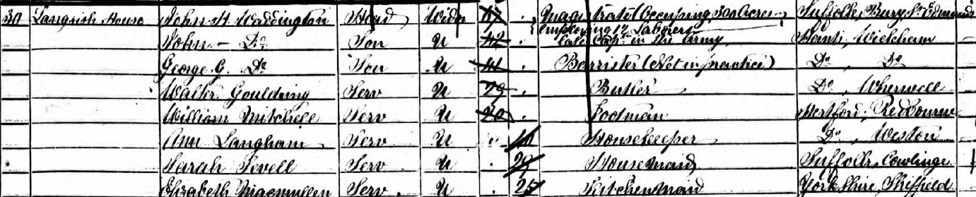
1851 John H Waddington, a 67 year old magistrate occupied 300 acres employing 12 labourers. He had been born in Bury St Edmunds, Suffolk.
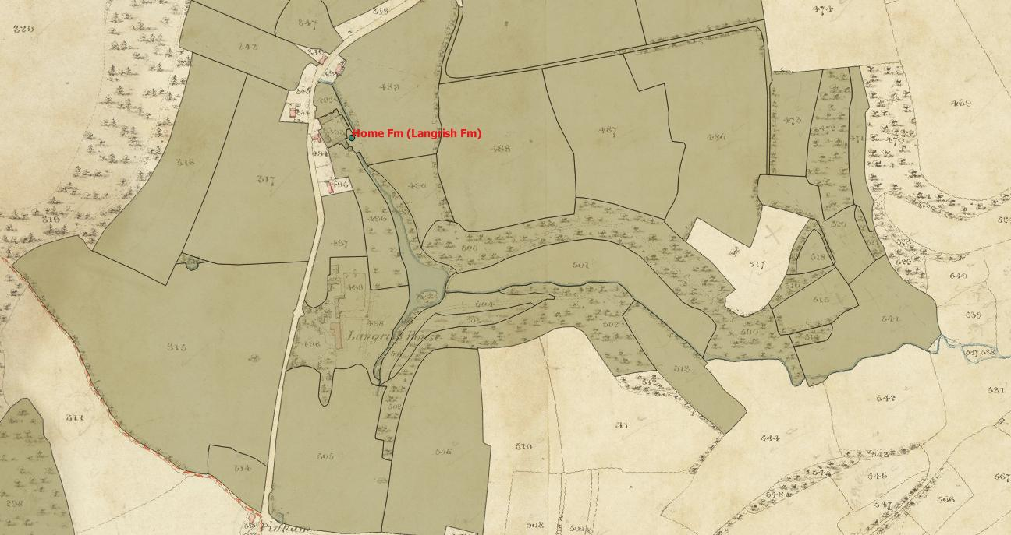
His two sons John, 42, a former captain in the army and George, 41, a barrister not in practice lived with him, both were born in Wickham, but neither appears to have working in 1851. A third son, Thomas Grove, had died in 1846. All four men are buried in East Meon churchyard. They had a domestic staff of five: butler, footman, housekeeper, housemaid and kitchen maid. None of these were from East Meon. Two were from Hertfordshire, one from Suffolk, one from Yorkshire and one from Hampshire. Two grooms and two gardeners lived in the neighbouring cottages. His bailiff, 47 year old William Mitchell from Hertfordshire lived in the Farm House. William’s 20 year old son, also William, was the footman in the main house.
The 1855 O’Kelly directory listed John Hersey Waddington Esq as one of the 7 members of the gentry in the parish of East Meon. His middle name was actually Horsey, his mother’s maiden name.
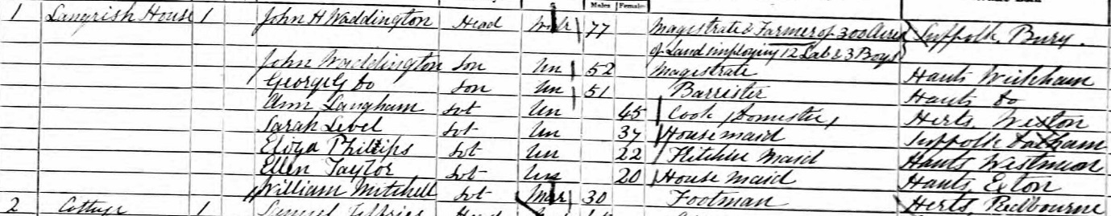
1861, JH Waddington and his two sons still lived at Langrish House. His elder son was described as a magistrate, and the younger one had changed his occupation from “barrister not in practice” to “barrister.”
There was a household staff of five, although only two of these were the same as 10 years previously. William Mitchell was a 30 year old footman, and Ann Langham, also from Hertfordshire, was the housekeeper. Her age had only increased from 40 to 45 in the past decade, and she was possibly Mitchell’s Aunt, and she was from Weston in Hertfordshire, where his sister was also born. There were three housemaids, from Exton, West Meon and Dalham, Suffolk. 37 year old Sarah Level may have been the same person as 29 year old Sarah Sewell from Cowlinge, Suffolk, a village about 5 miles away from Dalham, who was one of the housemaids in 1851. Mitchell’s father was still the estate bailiff, living in what was described as a lower bailiff’s house rather than the farm house, with his wife and daughter. The two same grooms lived in neighbouring cottages, as did the wife and family of the younger William Mitchell. The estate gardener John Warren died in January 1861, but his wife and four children under 10 still lived in one of the cottages.
JH Waddington died in 1863, and George Waddington in 1870
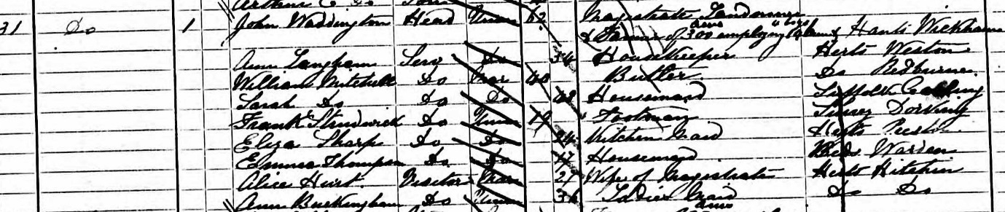
1871 John Waddington, aged 62 lived on his own. 54 year old Ann Langham was still the housekeeper, but William Mitchell, 40, had been promoted to Butler.
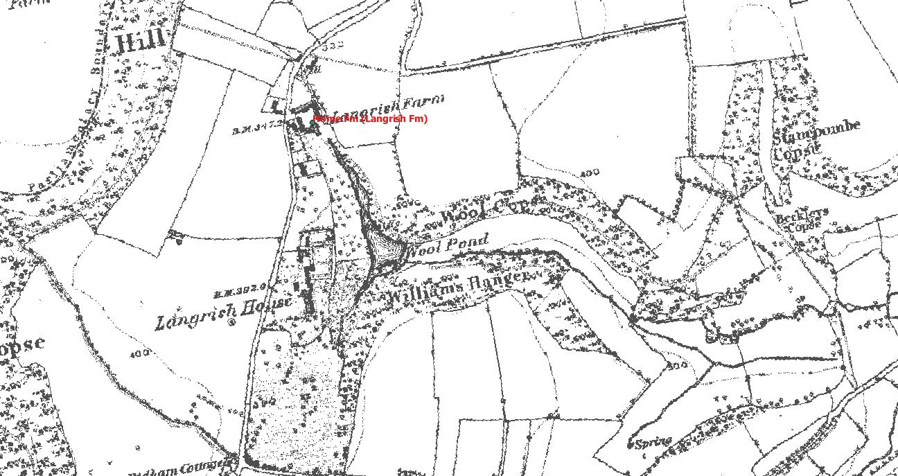
He had married 47 year old Sarah Mitchell, neé Level, after the death of his wife Elizabeth in 1865. His 7 year old daughter Sarah had died in 1867 and his two sons were living with his parents and his sister. The last two were still living in Bailiff’s cottage in 1881 even after the estate had been sold. The two grooms (Henry Willis and Samuel Jeffries) still lived in 1871 in cottages on the estate, although the latter was a “coachman” rather than a groom.
John Waddington died in 1880.
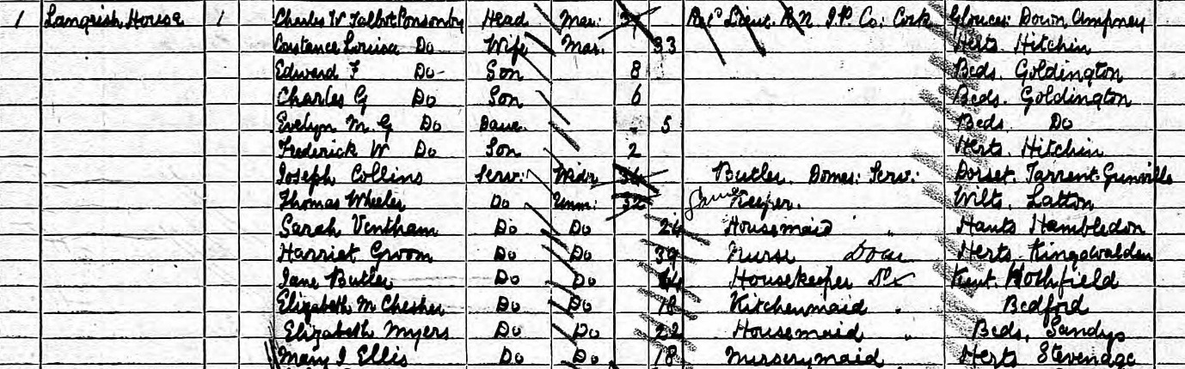
1881 The house was occupied by 37 year old Charles W Talbot Ponsonby, a retired Naval Lieutenant and JP in County Cork. He did not list either farming or landownership in the census. He lived with his wife Constance and four young children. They had a domestic staff of 8 (butler, housekeeper, gamekeeper, Nurse, nursery maid, two housemaids and a kitchen maid) none of whom were from the village. Former bailiff William Mitchell lived in bailiff’s cottage, and new farm bailiff George Douglas, who looked after 500 acres, lived at Home Farm House. There was also a new coachman, John Deakin from Limpsfield, Surrey, whose 15 year old son was the groom.
By 1891 the Talbot Ponsonby family had two further children, and Charles’ occupation was given as “JP living on his own means”. Their domestic staff was still 8 people, but had totally changed. Again, none were from the village. John Deakin was the coachman, and a younger son of his, Charles, was the groom. Former groom, 25 year old John Deakin was living with his parents, and gave his occupation as “discharged soldier”. The Deakins had three other children who had already left home, and four younger children still living at home.

Langrish Farm (Home Farm)
1851 William Mitchell, living in the Farm House, was the 47 year old bailiff from Bourton in Bedfordshire for JH Waddington’s 300 acres, overseeing 12 employees. He lived with his wife and 11 year old daughter. The tithe map shows that Waddington owned 414 acres, and occupied 351 acres. Of these, 198 acres were arable, 74 acres were pasture, 49 acres were woods and there were 2 acres of hops. The rest was rough, roads, homesteads and a 2 acre pond. The 1855 O’Kelly Directory lists William Mitchell as the bailiff to JH Waddington.
1861 Mitchell’s house was described as the Lower Bailiff’s house, and the household included his wife and daughter. The 1861 enumerator was the local grocer Walter Goulding, so it is unclear why the name of the house changed. William Mitchell is listed in the 1865 Harrod’s directory as a farm bailiff.
1871 Mitchell was 67 and still described as the bailiff. His wife was 70 and their unmarried 30 year old daughter still lived with them. The household included two grandsons, aged 14 and 8, both born in East Meon, and whose father was JH Waddington’s butler. The 1875 and 1880 Harrod’s directory both list William Mitchell as the bailiff to JH Waddington
1881 William Mitchell and his daughter Martha still lived in Bailiff’s cottage, but at the age of 77 he was a retired bailiff. In Home Farm House 32 year old George Douglas, from Shinfield, Berkshire was the bailiff for 500 acres. He lived with his wife and two young children, both born in Hurst, Berkshire.
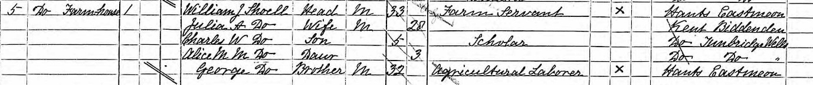
1891 William Shoell, a 33 year old farm servant from East Meon, lived in the Farmhouse, along with his wife and two young children, both of whom were born in Tunbridge Wells. His 32 year old brother George, an agricultural labourer from East Meon, lived with them. Their father was the wheelwright/ carpenter in East Meon.

Lower House Farm (Oxenbourne Farm)
1851 Lower House Farm was occupied by 73 farmer William Weeks, from Steadham, who farmed 550 acres and employed 20 men. The census lists the address as Oxenbourne Road.
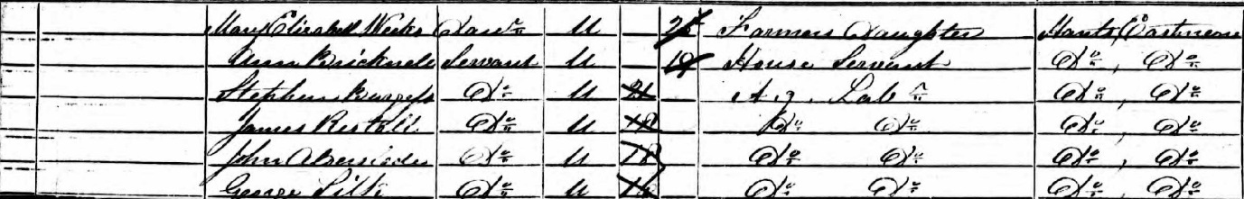
He lived with his 65 year old wife, Catherine, his 33 year old son, also William Weeks, and his daughter 25 year old Mary Elizabeth. Both the children had been baptised in East Meon, and his son was listed as the occupier of the land.
They had one 19 year old house servant, Ann Bricknell living in the house and four young agricultural labourers living in the house – all five of these were from East Meon. 18 year old John Alderslade was a cousin of the Ramsdean farmer. Weeks’ 67 year old brother John lived in the village, listed as a landed proprietor. Weeks’ parents (William and Mary) are both buried in East Meon churchyard as are his sisters Ann (Weeks) and Mary Dowling, brother in law Laurence Dowling, his two nephews and his niece.
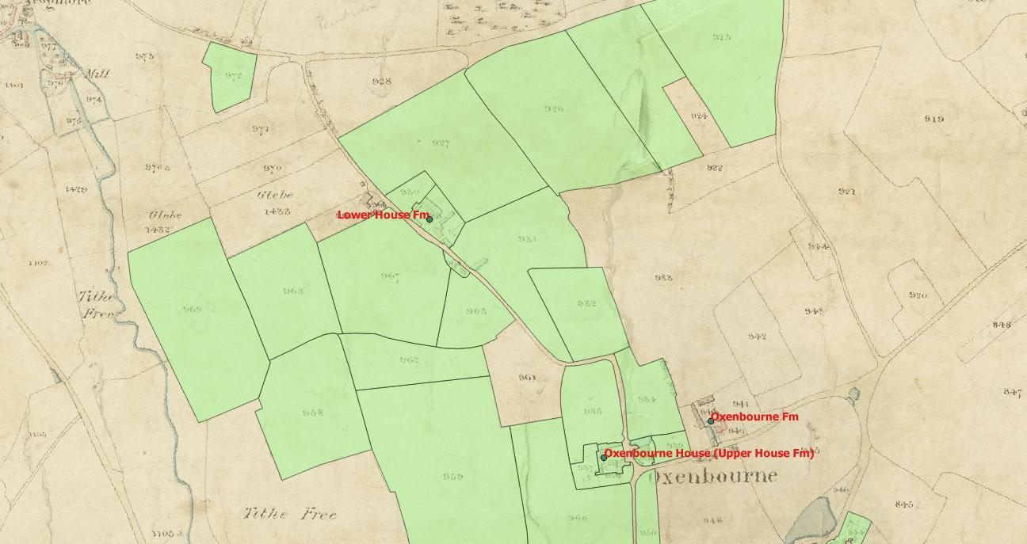
According to the tithe map William Weeks junior occupied 600 acres and the Weeks (father and son) owned 537. Of these, 487 acres were arable, 101 were pasture and 3 were woods. The remaining 9 were cottages, homesteads and 1 acre of limekilns.
The Weeks occupied Lower House Farm, Parsonage, Stony Lands Farm, Upper House Farm and Harvesting Barn. John Christmas was the lessee for all this land and, by acreage, Weeks was the fourth largest farmer in the parish, after Lord Gage, William Ray and James Ray. This excluded the tithe free farms of Park Farm, Court Farm and Lower Farm/ Southfield farm. Weeks paid the second highest general tithe at £92 per year.
William Weeks and his wife Catherine both died in 1860, and his son William had married Ann Stubbs in 1853. Mary Elizabeth Weeks married the miller of Frogmore Mill, John Lillywhite, at the end of 1851.
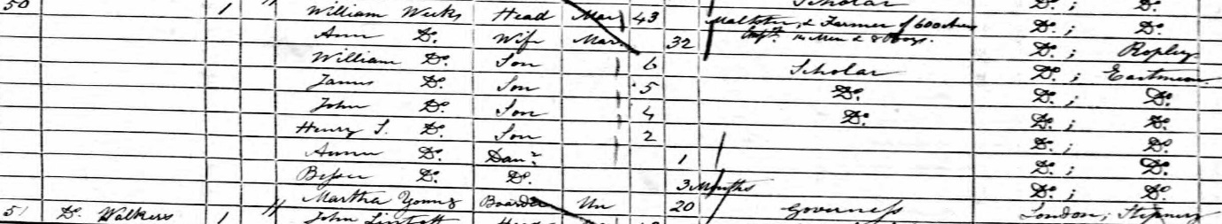
1861 William and Ann Weeks were living with 6 of their children – they would eventually have 11. He was listed as maltster & farmer of 600 acres employing 14 men and 5 boys. They had a 20 year old governess Martha Young, from Stepney, but no other live in servants. His brother in law John Lillywhite lived at Frogmore Mill, married to William’s sister Mary. Lillywhite was listed as a farmer of 100 acres and miller employing 4 men.

1871 William Weeks was living at Lower House, farming 600 acres and employing 13 men and 5 boys. They lived with 4 of their children, all born since 1861.
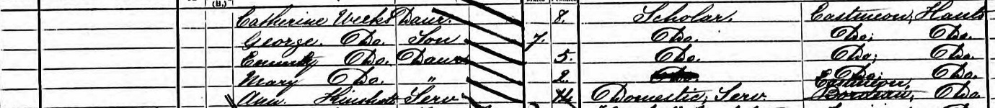
The oldest 6 children were all away in 1871, 13 year old John Weeks was boarding at a school in London, so possibly this applied to the other five children.
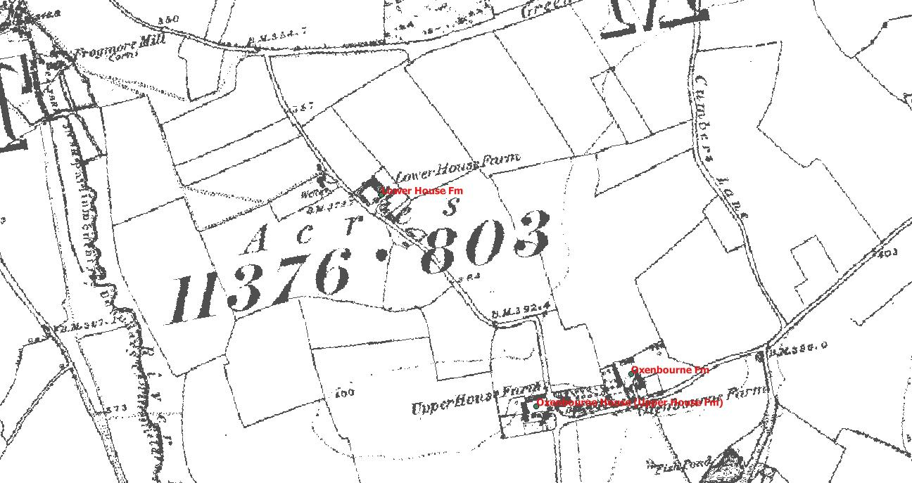
The Weeks had had another child born in 1867 who died two years later. William Weeks employed 14 year old Ann Kinshott for the village as a house servant.

1881, William Weeks was listed at Lower House as a farmer, with his wife Ann as “assistant”. Their 26 year old eldest son William (the fourth eldest son in a row to be so named) had moved back to the farm, and was listed as a farmer. His brother John, 24, was listed as a clerk.
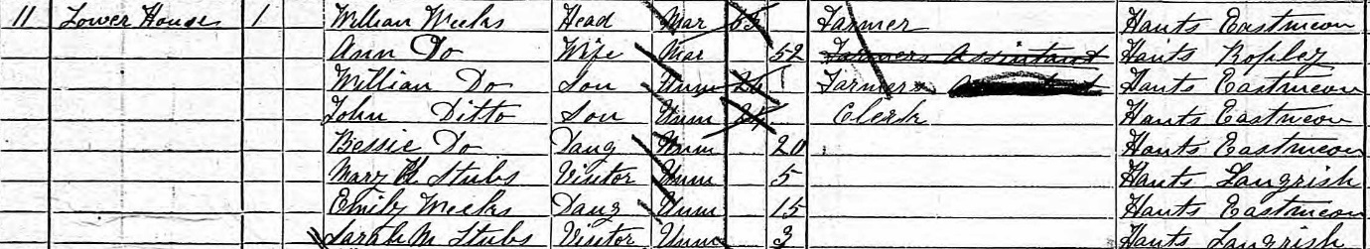
Two younger daughters still lived at home, and they had two five year relations of Ann Weeks (nee Stubbs) staying as visitors. The Weeks’ 21 year old daughter Annie was visiting John Stubbs, Ann’s brother, who farmed 300 acres in Langrish.
1891, William Weeks was listed at Lower Farm as a farmer & maltster. His wife Ann had died in 1889. His daughter Annie was his housekeeper, and his younger daughter 25 year old Emily also lived at home. There were no servants.

Leythe House Farm
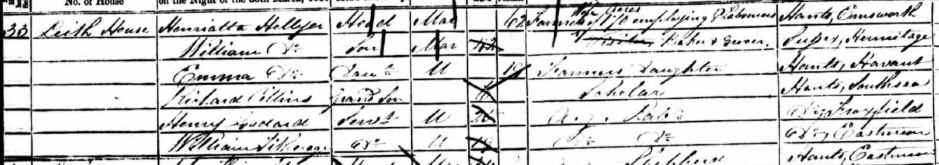
1851 Leith House was occupied by George and Henrietta Hellyer. George was not there on the night of the census, and 62 year old Henrietta was described as a farmer’s wife of 150 acres employing 8 labourers.
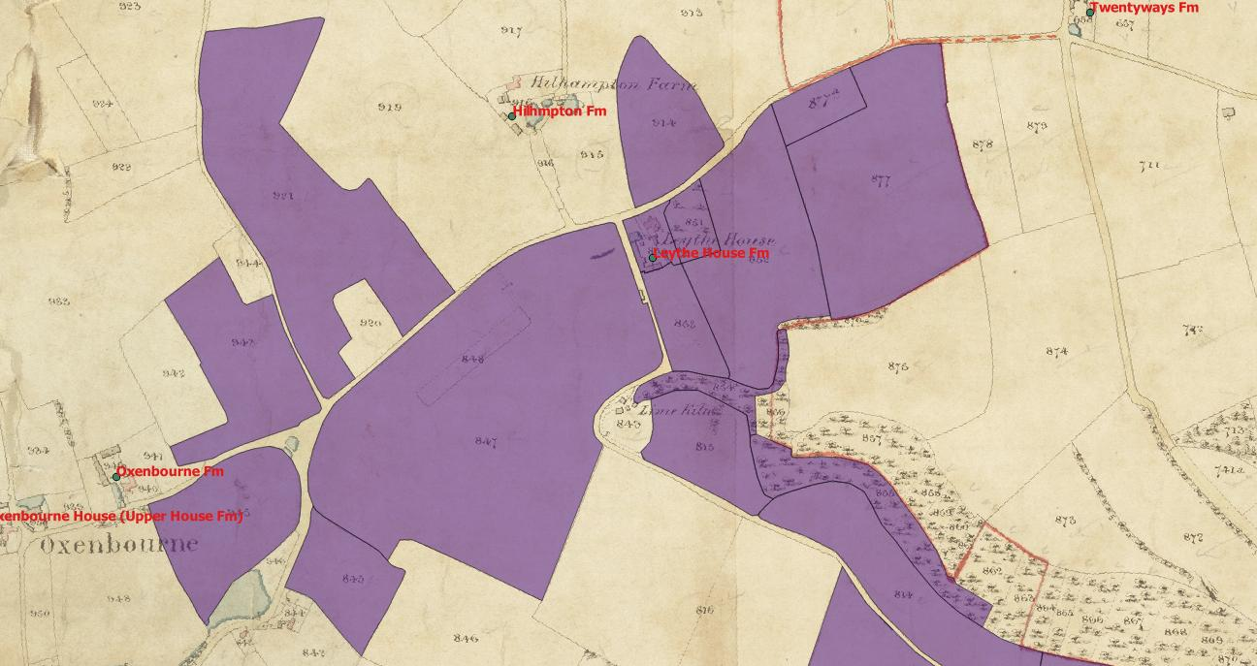
Their 40 year old son William was a baker & grocer, and their 19 year old daughter also lived in the house along with a 6 year old grandson. Two agricultural labourers also lived with them, a 25 year old from Froxfield and 18 year old William Titheridge from the village. The tithe map showed that Hellyer owned and occupied 227 acres, of which 180 acres were arable, 42 pasture and 6 acres of woods/orchard. He was simply listed a as farmer in the 1855 O’Kelly’s Directory.
1861 47 year old master mariner John Smire from Portsmouth lived in Leith House with his 45 year old wife Jane.
1871 27 year old carter George Carpenter from Froxfield lived in Leythe House with his 26 year old wife Elizabeth and their daughter born in 1871. Elizabeth (nee Knight) had been born at Leith yard, where her father was a shepherd. She was listed in the census as being in charge of Leythe House.

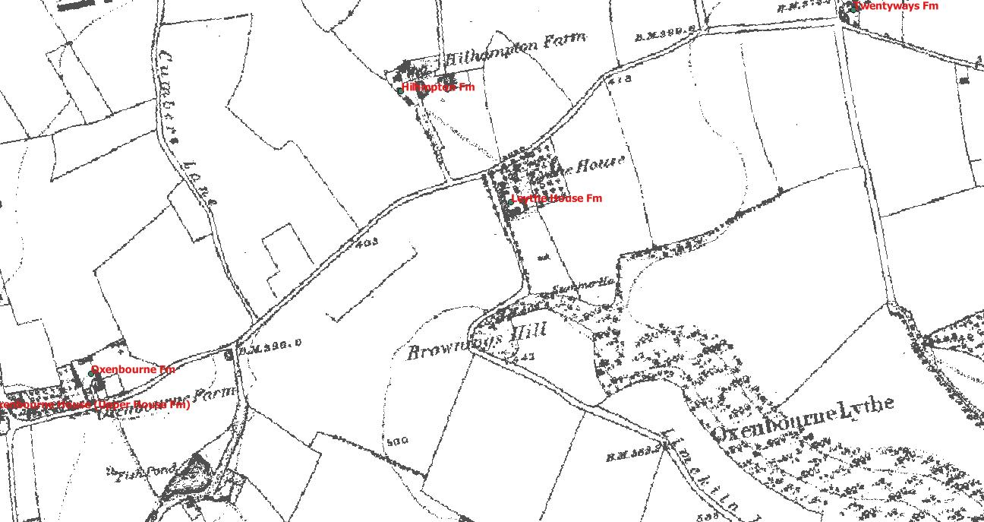
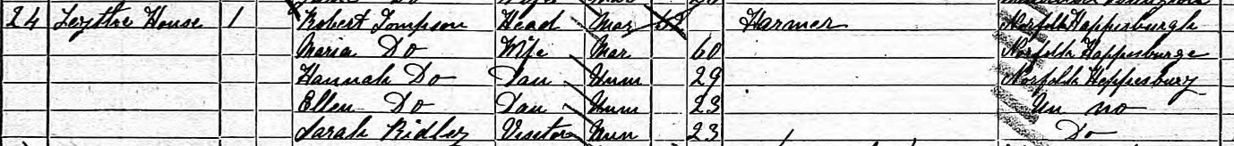
1881 Robert Thomson, a 62 year old farmer from Happisburgh, Norfolk, lived at Leythe House with his 60 year old wife Maria and his two daughters, aged 29 and 23. They had a 23 year old friend visiting and one servant, 17 year old Ann Eames from the village. The 1880 Harrod’s directory listed Robert Thompson (sic) as a farmer at Lythe Farm.
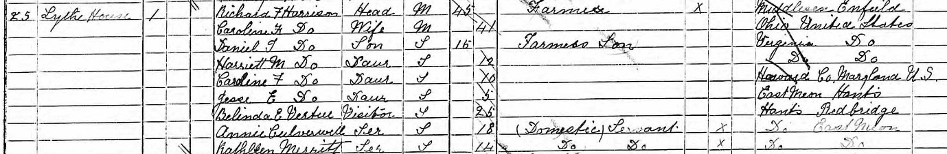
1891 45 year old Richard Harrison, from Enfield, Middlesex, was the farmer at Lythe House. He lived with his 41 year old wife Caroline, who has been born in the USA, as had their three oldest children. The fourth child, aged 5, was born in 1885 in East Meon, so the family had been in the house for at least six years. They had two domestic servants, 18 year old Annie Culverwell and 14 year old Kathleen Merritt, both from East Meon.

Riplington Farm
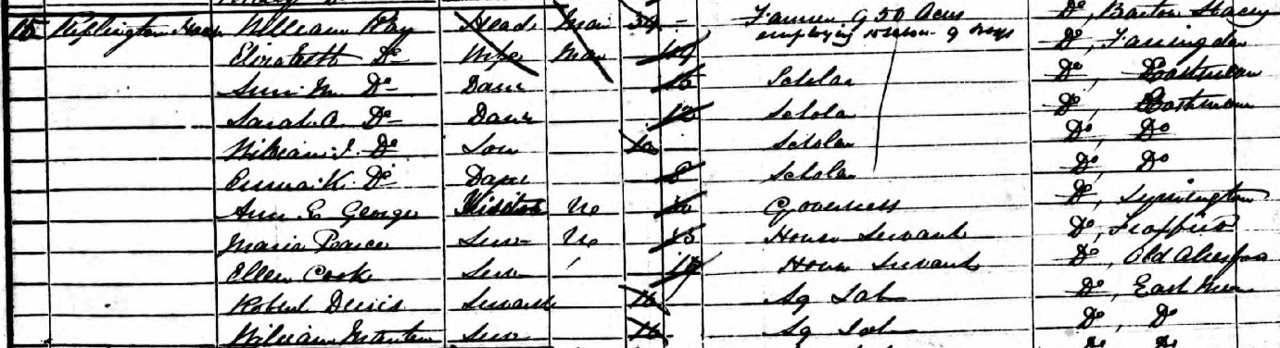
1851 William Ray, 39, was a farmer of 950 acres employing 15 labourers and 9 boys. With his 49 year old wife, Elizabeth. She was a widow when they married, having previously been married to (I think) William Pink, the brother of George Pink, the surgeon. Her maiden name would have been Kersley.
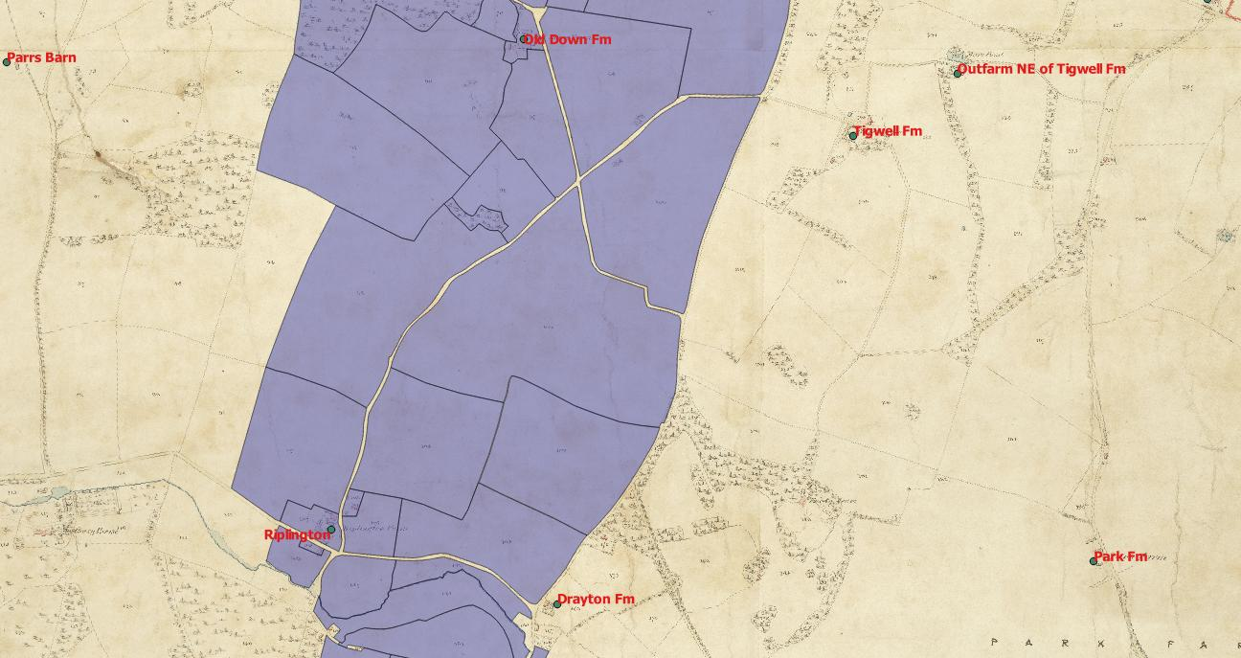
They had 4 children, all four of whom were born in East Meon. 16 year old Ann Maria, 12 year old Sarah Olive, 10 year old William and 8 year old Emma were looked after by a governess. House servants 14 year old Maria Pearce and 14 year old Ellen Cook, neither of whom was from East Meon, made up the domestic household of 9. Two young 16 year old boys from East Meon were listed as living in the house as agricultural labourers. The parents of Robert Dennis lived in #1 Lower cottage along with his three younger siblings. One (married) older son also lived in a cottage at Riplington, but the other three older siblings were not living in East Meon. William Martin had been baptised in the village church along with two younger siblings, but the family no longer lived in East Meon in 1851.
The tithe map showed him as the occupier of 965 acres, all of which was owned by Lord Gage, and the latter was also the lessee. This land was 787 acres of arable, 78 acres of pasture, 64 acres of woodland and 28 acres of Down. The latter was called “HenWood” and lead into the actual 148 acre wood. It was one of the only three plots classified as “Down”. All the rest of the Downs were classified as “pasture”.
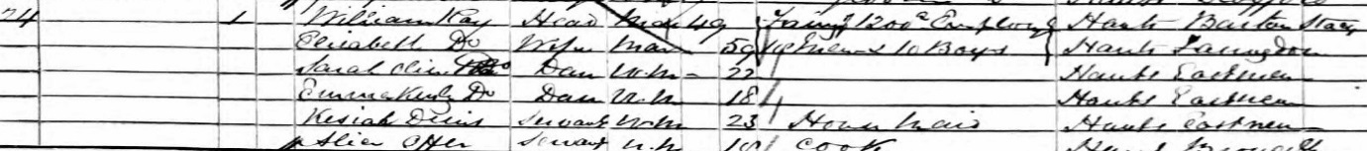
1861 William Ray farmed 1,200 acres employing 14 labourers and 10 boys. His wife and two younger daughters were still at home. There were two house servants, 23 year old Keziah Dennis was the first cousin of Robert Dennis, and her parents also lived in Riplington along with 5 younger siblings. The other house servant was 18 year old Alice Otter, who was from Broughton. The household was 6 people.

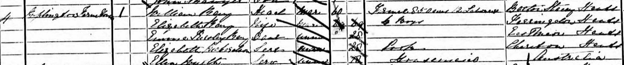
1871 William Ray, 60, was the enumerator for the census. He farmed 850 acres, employing 12 labourers and 6 boys. His wife and younger daughter, 28, lived in the house along with two servants completing a household of 5: 20 year old Elizabeth Richardson was the cook and 18 year old Ella Wyatt was the housemaid. Neither came from the village.

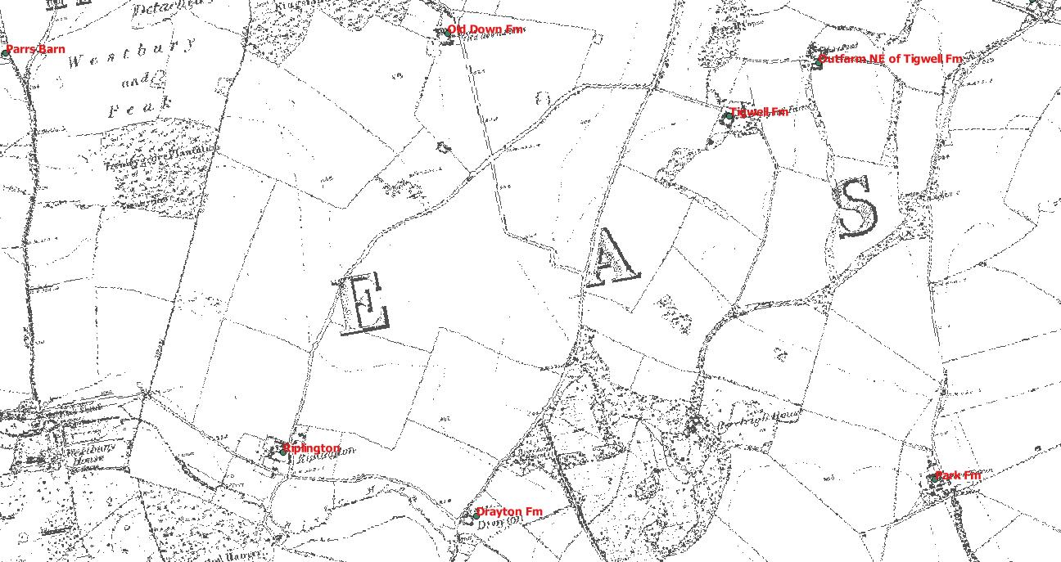
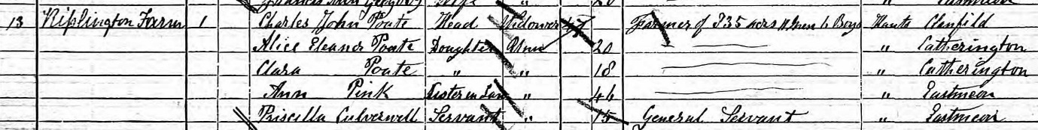
1881 William Ray died in 1872. The farmer was 47 year old Charles John Poate who farmed 835 acres employing 11 men and 6 boys. The 1875 Harrod’s Directory lists Charles Poate as the farmer at Peak Farm.
Poate’s wife Eleanor died in 1864, possibly in childbirth of their younger daughter who was 18 in 1881, so born in 1863 or 1864. Eleanor had been the second daughter of George Pink, William Ray’s brother in law. Eleanor was not on the census, but her younger sister Ann was, and she lived at Riplington in 1881 along with her brother in law. Poate’s two daughters, 18 year old Clara and 20 year old Clara also lived at Riplington. They had one servant, 15 year Priscilla Culverwell, whose widowed mother lived in the village along with four younger siblings. Her parents and their 5 (out of an eventual 7) children were listed on the 1871 census at Combe, and her paternal grandparents were listed on both the 1851 and 1861 censuses in the village.
1891 The Poates had moved by 1991, and it is difficult to tell from the census who lived in the Farmhouse. There were three dwellings at the farm, and four others at Riplington. The hamlet supported 43 people, of whom 22 were children. There were 11 men who were either listed as farm servants or farm labourers. In 1881 there had been 26 people, 6 of whom were children and 10 labourers The Farmhouse was probably occupied by 32 year old John Pile, from East Meon, listed as a farm servant. According to the 1898 Harrod’s Directory, Isaac Wren was the farmer at Riplington. He had moved down in 1893 from Cumbria (see Cumbrian Migration). The rent was £0.25 (5 shillings) per acre.

Old Down Farm
Although listed as a farm, the census never showed an occupant who listed his profession as “farmer”.
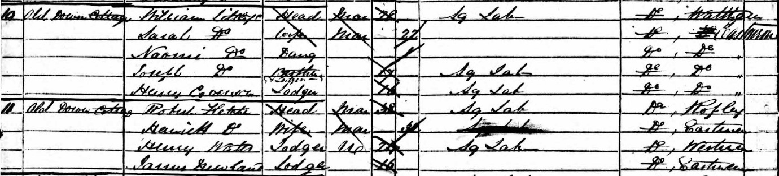
1851, the two dwellings were occupied by Agricultural labourers. 28 year old William Littlefield, his wife Sarah and their two children were in one cottage. They also had 16 year labourer Henry Coverson sharing their cottage. In the other dwelling were 38 year old labourer Robert Fletcher and his wife Harriett. They had a further two labourers, 24 year old Henry Watts and 16 year old James Newland living with them. All five men gave their occupation as agricultural labourers.
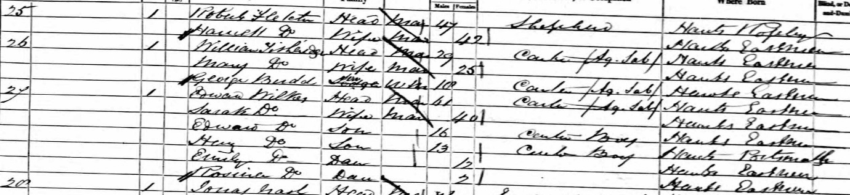
1861, census enumerator William Ray (from Riplington) no longer gave the addresses of the houses on his return. Based on the 1871 return, it appears that the two dwellings were occupied by 29 year old carter William Titheridge and his 25 year old wife Mary, both from the village. They had 18 year old George Budd, from the village, as their lodger. The other dwelling was occupied by 47 year old shepherd Robert Fletcher, from Ropley, and his wife Harriet, from East Meon. The working population was three men, and there were no children. It is possible that 61 year old carter Edward Wilks and his family of 5 also lived at Old Down as they were the next house on the census, but this house could equally have been at Peak Farm, as was the following entry for Jonas Nash, the former bailiff.
1871, there were three dwellings at Old Down. 37 year old carter William Titheridge and his 34 year old wife Mary, both from the village, occupied one with their four children under 10 and Titheridge’s 17 year old brother Frank, another carter. In the second dwelling was 57 year old shepherd Robert Fletcher and his wife Harriet. The third dwelling housed 28 year old labourer James Read and his 33 year old wife Ann (from the village), and they had another labourer 21 year old William King as their lodger. The working population of the farm was five men.
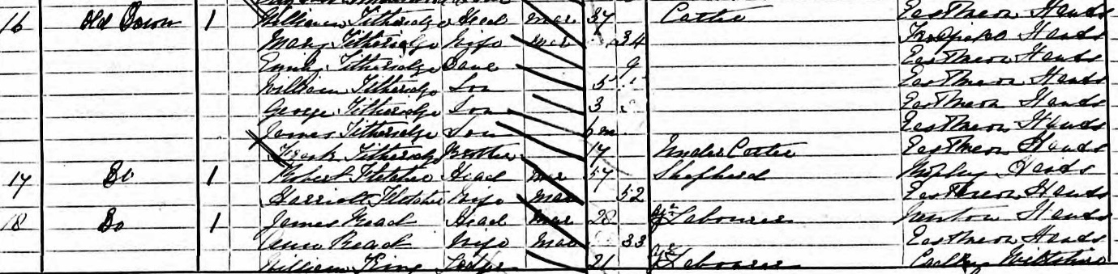
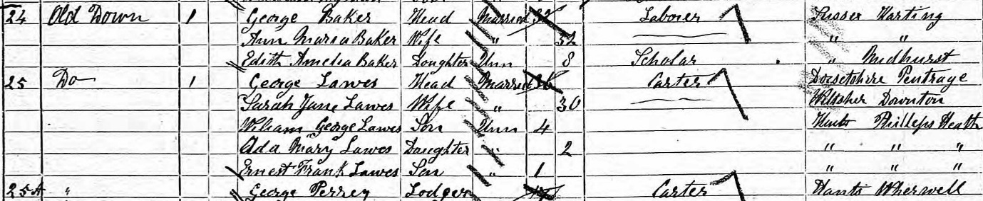
1881 there were four dwellings at Old Down, of which one was unoccupied. The Titheridges and their 6 children occupied one of the dwellings. The two oldest sons, aged 15 and 13, were listed as carters like their father. 32 year old labourer George Baker, from Harting, Sussex with his wife and daughter Sussex occupied one of the dwellings. The third was occupied by 36 year old carter George Lawes, from Pentrage, Dorset and his wife Sarah and three children under 5. He had a 17 year old carter, George Perrey from Wherwell, as his lodger. The working population was six men, and there were 7 children aged 10 or under.
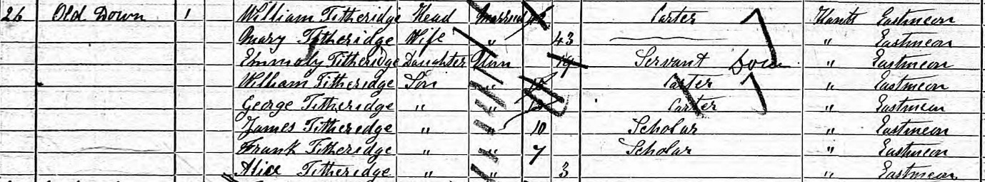
1891 there were again three dwellings. William Titheridge still lived in one with his wife. Three of their sons, aged 22, 20 and 17 were living at home and occupied as carter like their father. Their youngest child, a 13 year old daughter also lived at home. Their eldest son was a labourer at Peak Farm, as was William’s brother. 38 year old shepherd Joseph Harnsworth from Wooton St Lawrence, Hampshire, lived in one of the dwellings with his wife Mary Ann and two young children. The third dwelling was occupied by 57 year old labourer James Mould from Tisbury, Wiltshire along with his wife Adelaide. They had two lodgers, one a carter, the other an agricultural labourer. One was from Cheriton, the other from Ropley. The working population of the farm was 8 men.
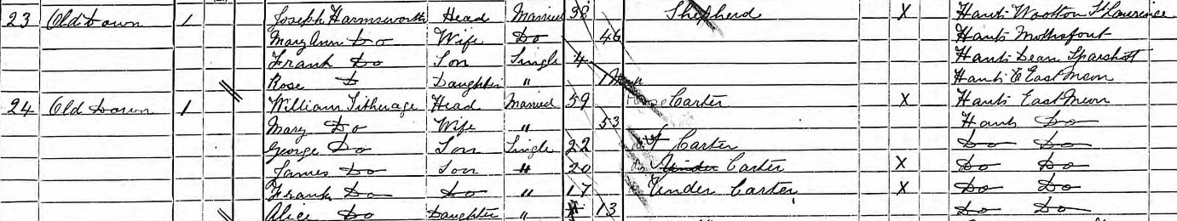

Peake (Peak) Farm (part of Riplington)
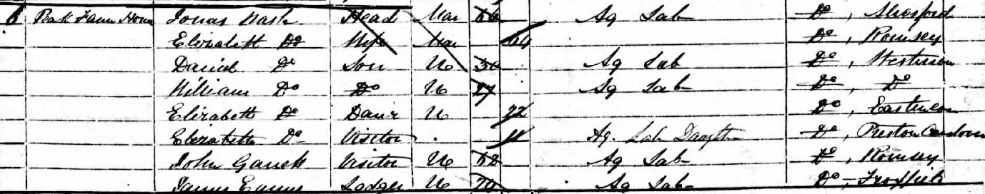
1851 Occupied by 66 year old Agricultural Labourer Jonas Nash, who in the 1861 census was listed as “former bailiff”. His 64 year old wife Elizabeth, son David, 30, son William 27 and daughter Elizabeth, 22, also lived at Peak Farm House. The latter was the only one baptised in East Meon, although her father was listed as “George” not Jonas. There was another Elizabeth Nash, 11, listed as a visitor. There were 5 other agricultural labourers listed as either visitors or lodgers. Only 20 year old George Beckingham was from East Meon. His widowed mother was listed as a pauper in the village, living in Crop Lane with his two younger brothers. His eldest brother lived in Drayton with his wife and 4 children. The other four labourers at Peak were from Romsey, Froxfield, Hamford and Privett.
1861 Peak Farm House was not listed but Jonas Nash is listed just after the workers at Old Down. The following two homes were presumably the cottages at Peak, but there are no addresses. The inhabitants were 35 year old Shepherd/ agricultural labourer John Littlefield, from East Meon, and his family and 25 year old carter / agricultural labourer James Tobury, from Privett, with his family.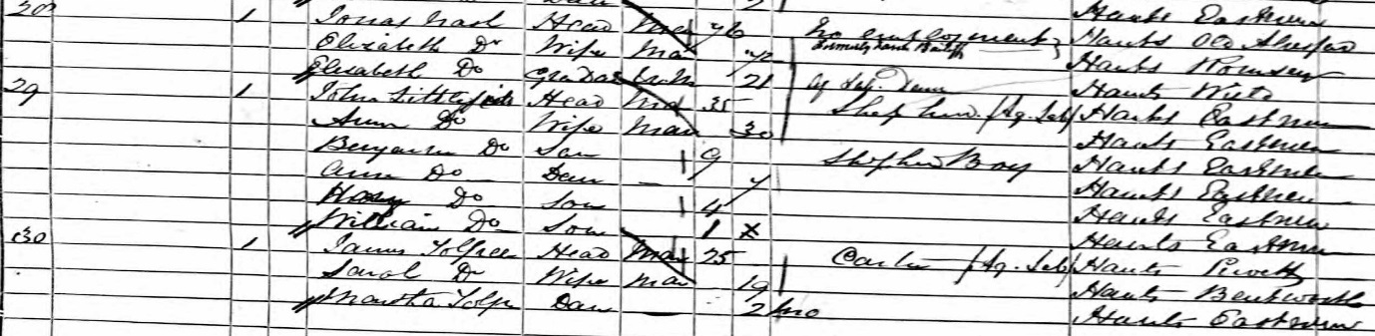
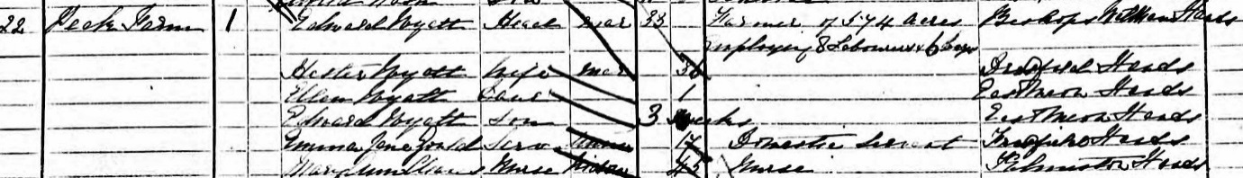
1871 33 year old Edward Wyatt, from Bishop’s Sutton, was listed as a farmer of 574 acres, employing 8 labourers and 6 boys. His 36 year old wife Hester and two young children lived at the Farm House, along with a 17 year old domestic servant and a 45 year old nurse. Neither servant was from East Meon. The 1875 Harrod’s Directory list Edward Wyatt as the farmer at Peak Farm.
1881 Peak Farm House was occupied by 46 year old Edward Jarrett, a farm bailiff from North Waltham. He farmed 570 acres and employed 8 labourers and 7 boys. His 43 year old wife, simply listed as “Mrs Edward Jarrett” and 17 year old son James also lived in the house. There were no servants, but also listed at “Peak” was 62 year old cater George Munday, his 52 year old wife Jane, and 6 children and two spouses of these children. One listed his employment as “gardener” and both women were domestic servants.

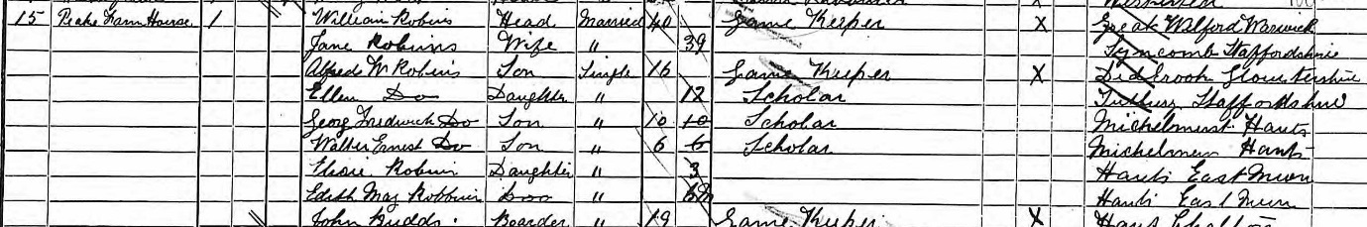
1891 William Robbins, a 40 year old gamekeeper from Warwickshire was living at Peak Farm House with his family. He and his wife had six children, of whom were born in East Meon. The other three cottages at Peak were lived in by 74 year old labourer George Mundy, from Alresford, 57 year old labourer Charles Titheridge from the village, and his 25 year old nephew William Titheridge, whose parents lived at Old Down. All three were accompanied by their families, and the settlement was home to 23 people, of whom 9 were gamekeepers or labourers.

Stroudbridge (Farm) (Dean’s Farm, Buriton)
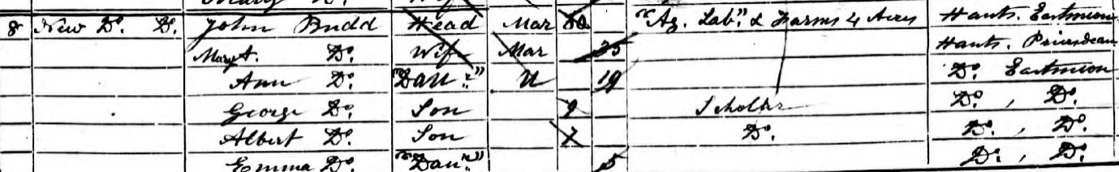
1851 The only farmer at Stroudbridge in the 1851 census was 60 year old John Budd, from East Meon, and his 35 year old second wife Mary Ann. He lived in the “new house” next to Stroud Bridge and was a farmer of 4 acres.
They had 6 children, one of whom was listed at a house servant.
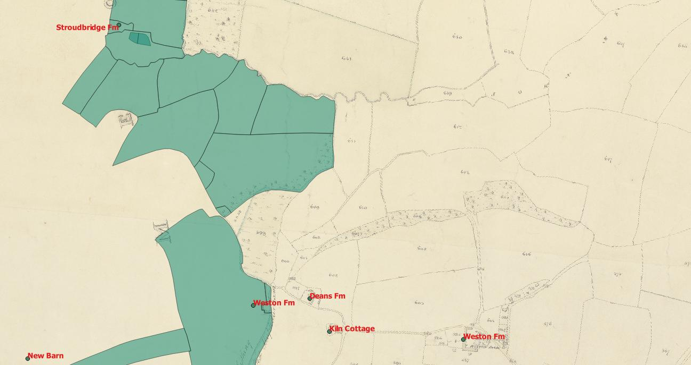
Henry Dean farmed 150 acres on the tithe map, but was on the 1851 census in Buriton as a farmer of 100 acres employing 4 men. He lived at “Weston Homestead” according to the Buriton tithe map, and farmed another 30 acres in Buriton. The farm he lived at is named “Dean’s Farm”.

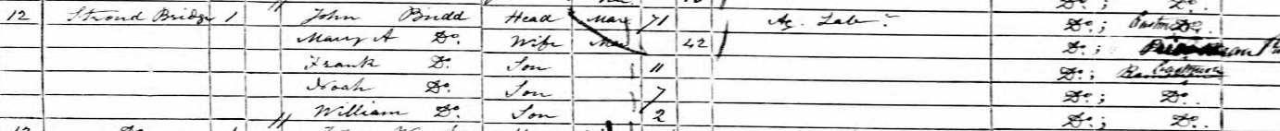
1861 John Budd was no longer listed as a farmer. He was a 71 year old agricultural labourer, and Mary Ann was 42. Their three youngest children still lived with them.
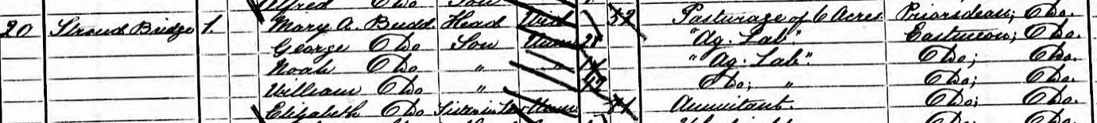
1871 John Budd died in early 1871, so Mary Ann lived with her two younger sons. An elder son, George, 28, had moved back in. Mary Ann’s sister in law Elizabeth Budd had also moved in. Mary Ann has a pasturage of 6 acres.
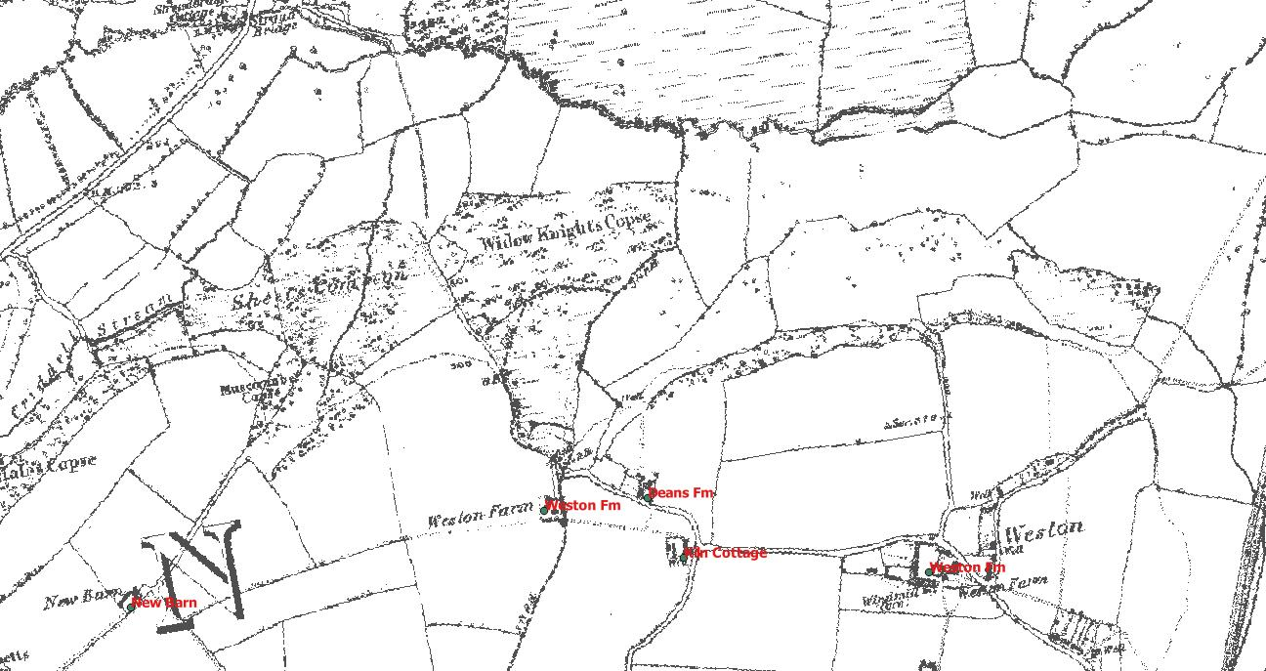
1881 Mary Ann Budd, 62, had married Nicholas Pink, 64 in Petersfield in 1879. He was listed as a dairy farmer.
1891 Mary Ann Pink, again a widow after the death of her second husband, was a 72 year old cowkeeper, and she had 14 year old Rebecca Knight from Stroud as an indoor servant. Her son Francis Budd was a general labourer living next door. George Francis Budd was listed as a cowkeeper at Stroudbridge in the 1898 directory.

Coombe Cross
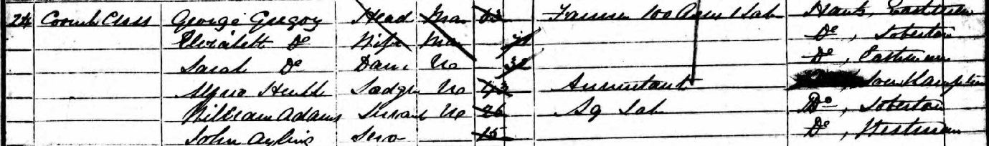
1851 George Gregory, 63 was a farmer of 100 acres, employing 1 labourer. His 71 year old second wife Elizabeth also lived at Coombe Cross, along with their 32 year old daughter Sarah, who had no listed employment. There were three lodgers: 43 year old accountant Alfred Heuble, and two agricultural labourers, 26 year old William Adams and 15 year old John Ayling. Neither was from East Meon. None of George Gregory’s 4 other children lived in the parish, and only one of his 5 brothers. Several nephews did live in the parish. He had described himself in the church register for the birth of his five children as labourer, shop keeper, and finally as “shopkeeper and farmer”.

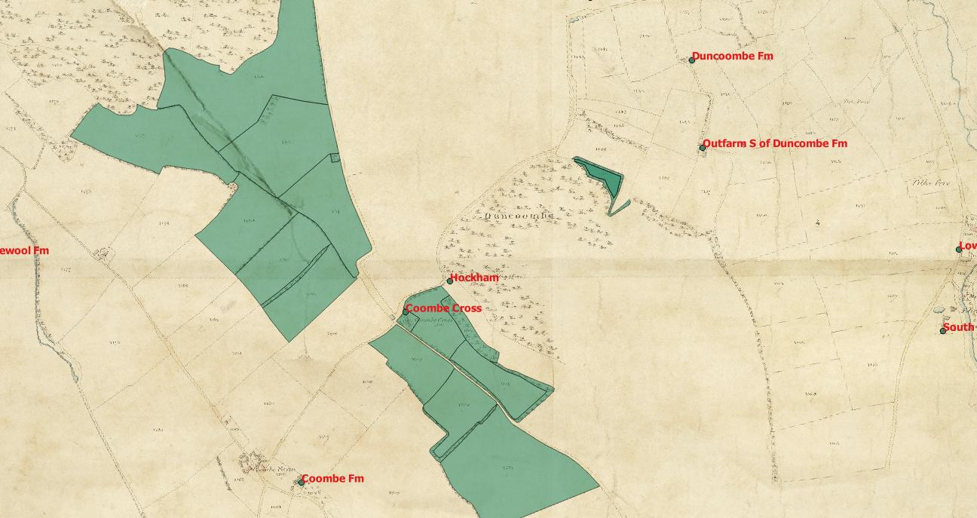
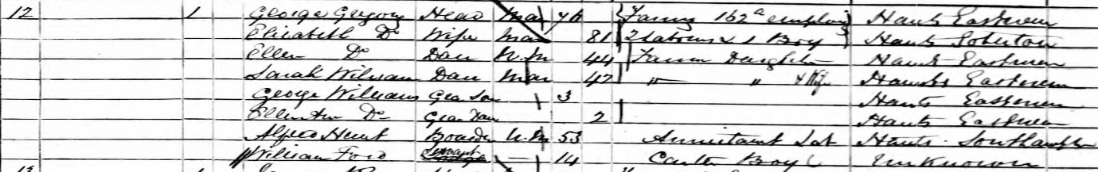
1861 George Gregory, 76, was a farmer of 162 acres, employing 2 labourers and 1 boy. His 81 year old wife Elizabeth was one of 7 80 year olds in the parish. Their daughter Sarah had married in 1854, and by 1861 had two young children, but no husband on the day of the census. Another daughter, 44 year old Ellen, had moved back into the house, and both women were listed as “farmer’s daughter”. There were two other members of the household, a 53 year old annuitant labourer and a 14 year old carter, neither from East Meon.
1871 Elizabeth Gregory died in 1863. Thomas Lilywhite, 48 from Twyford lived at Combe Cross. He was a working bailiff. He lived with his wife Charlotte and daughter Mary Ann. They had a farm servant also living in the household.

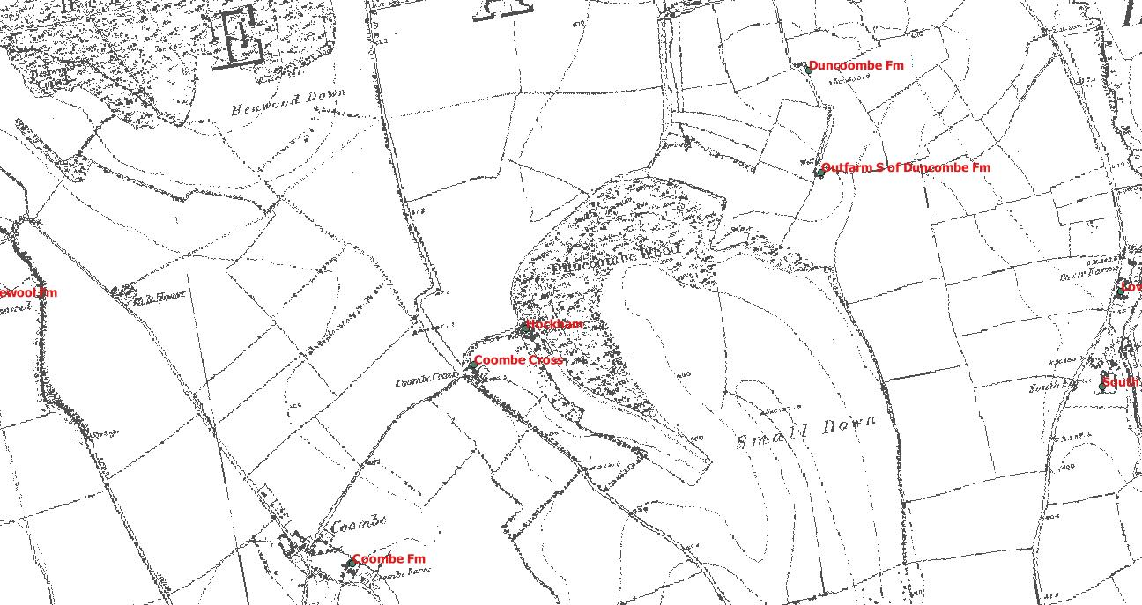
1881 Thomas Lillywhite, 58 described himself simply as “farmer” and lived with his wife Charlotte (58). He had lived next door to his father Thomas Lillywhite in 1861, describing himself as agricultural labourer/ carter. 2 agricultural labourer brothers from the village, 18 year Henry and 16 year old George Rutter completed the household. His brother, Charles, farmed at Coombe.
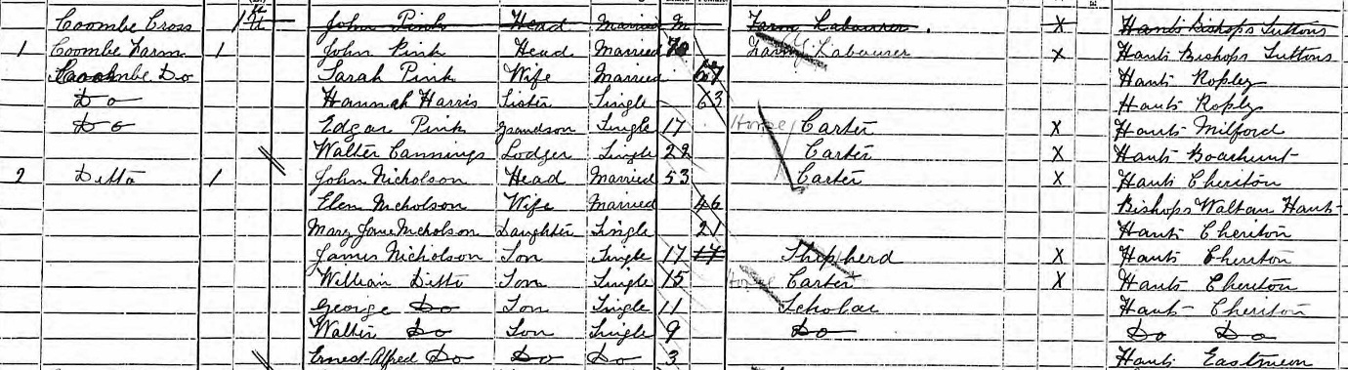
1891 Cross Farm Coombe was two dwellings in 1891. One was occupied by 70 year old labourer John Pink and his family. His grandson, aged 17, was a carter, and there was another 22 year old carter who lodged with them. The other dwelling was occupied by 53 year old shepherd John Nicholson from Cheriton and his family, which comprised his wife, 21 year old daughter and five sons. The two oldest, aged 17 and 15, worked as shepherd and carter respectively.

Court Farm (tithe Free)
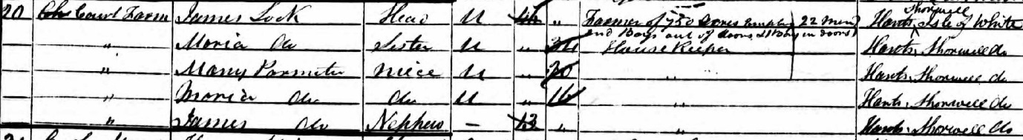
1851 James Lock, 44, farmed 750 acres, employing 22 men & boys out of doors and 1 in doors. He had been born on Shorwell in the Isle of Wight, and lived with his 34 year old (unmarried) sister Maria as his housekeeper, and three orphaned teenage nieces/nephews, children of his sister Sarah and William Parmiter.
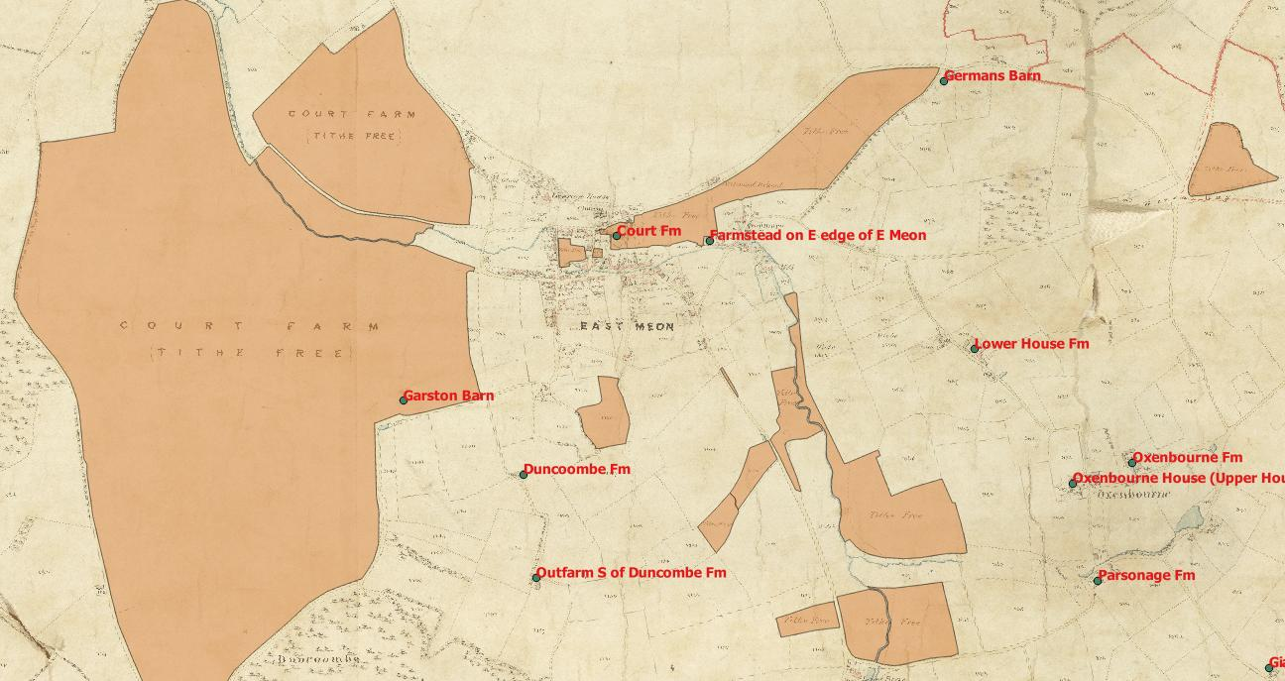
There were no servants in 1851. Sarah Parmiter had died in 1846 (buried in East Meon Church), and her husband in 1844. James’ father (also James Lock), was a farmer from St Nicholas, IOW. He died in East Meon in 1854, aged 79.
1861 Lock farmed 766 acres and employed 12 men and 8 boys, and his household included his two sisters, his mother in law (with the same surname), one of his nieces from 1851,another 9 year old niece born in Southsea, whose mother (Lock’s third sister) had died in child birth. There was also a housemaid (15 year old Mary Grant from East Meon, who was the oldest of a family of 13). Her parents and 7 of her siblings lived in Fish Ponds cottages, Oxenbourne.
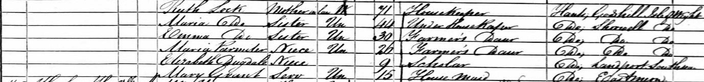
The entry for Court Farm was the 141st house in the East Meon tithing out of 142.
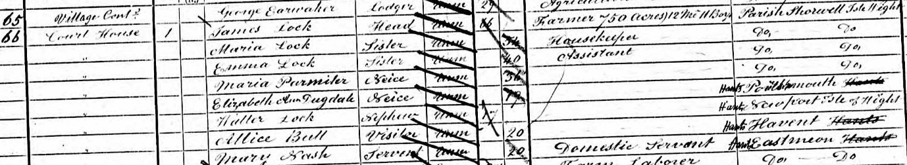
1871 James Lock (66) farmed 750 acres, employing 12 men and 11 boys. His sister Maria (54) was his housekeeper, and another sister Emma (40) was the assistant housekeeper. His nieces Maria Parmiter (36) and Elizabeth Dugdale (19), and his nephew Walter Lock (17) all lived in the house, as did Alice Bull (20) a visitor. There was one house servant, 20 year old Mary Nash from East Meon. There were 8 in the household.

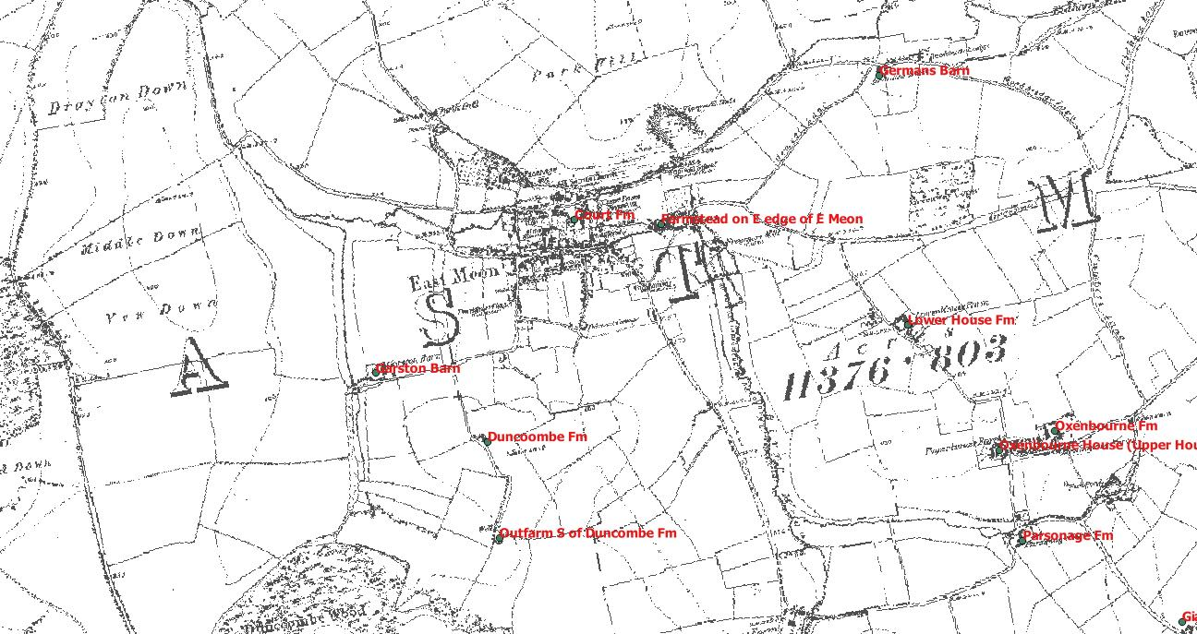
1881 James Lock, 76 had retired. His niece Maria (Padwick), 25, was his housekeeper, and her sister Edith, 23, was visiting. These were two of the Padwicks’ 11 children. Ellen Chivers, 19, was the housemaid. She was 6th of 7th children, her parents lived in Halley St, in the village.
James Lock died in 1885, leaving £316 in his will. Probate was granted to William Weeks and Lock’s brother John, a draper in Newport, IOW. When John died in 1908 he left £10,570.

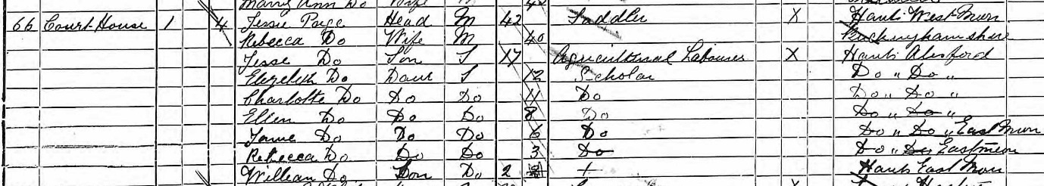
1891 Jesse Paige, a 42 year old saddler lived in the court house with his family. There was no farmer at Court Farm.

Coombe Farm
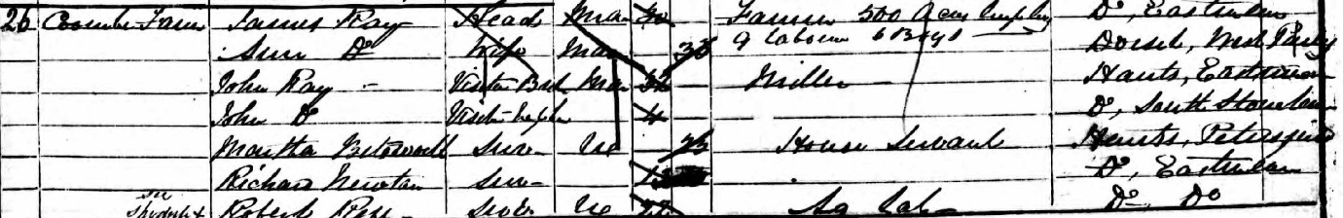
1851 30 year old James Ray farmed 500 acres employing 9 labourers and 6 boys. He was baptised in East Meon as was his 32 year old brother John Ray, a miller, who was visiting at the time of the census, along with his 4 year old son (also John). There is no evidence that they were related to William Ray of Riplington , who was listed as being from East Meon, but was not baptised in the church. Mrs Ann Ray, 33, lived at Coombe Farm, but they had no children. They had four servants: 25 year old Martha Betsworth from Petersfield, 16 year old Richard Oakshott from Clanfield. Both 22 year old Robert Ress, and 13 year old Richard Newton were from East Meon. Newton’s parents and 8 of his 10 siblings lived in the village.

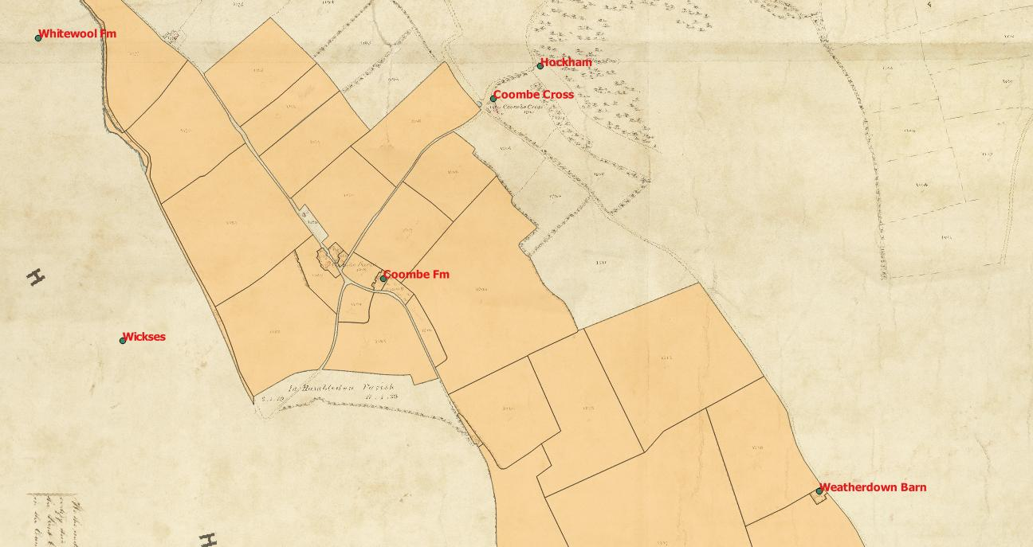
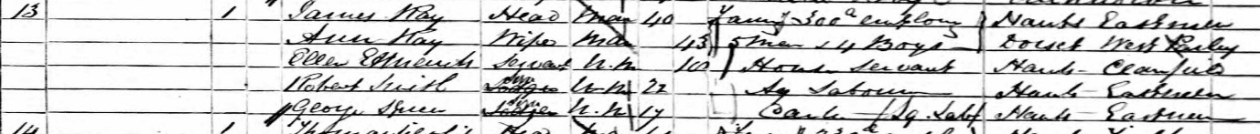
1861 James Ray, 40, farmed 300 acres, employing 5 labourers and 3 boys. Mrs Ann Ray was 43. They had an 18 year old house servant from Clanfield. Two agricultural labourers from East Meon, 22 year old Robert Smith and 17 year old George Spiers, also lived at Coombe Farm. Spiers’ parents lived in the village with 2 of their 7 other children. Robert Smith’s mother Maria had died in 1838, presumably in childbirth. His father lived in Temple Road in the village with his second wife and a grandchild.

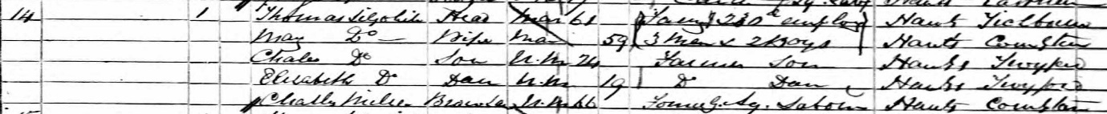
61 year old Thomas Lillywhite also was listed at Coombe as a farmer of 230 acres employing 3 men and two boys. His wife, Mary, 59, son Charles, 24 and daughter Elizabeth, 19, lived at the same address along with brother in law, 66 year old Charles Miller, a former agricultural labourer, who completed the household. There is no clear relationship with the miller John Lilywhite at Frogmore Mill who was 45 in 1861, so unlikely to have been Thomas Lillywhite’s son. John was from Ropley, and Thomas from Titchborne.
1871 Thomas Lillywhite was 71 and farmed 390 acres employing 6 labourers and 2 boys. His wife Mary was 69. There was no one else in their household, listed by enumerator William Ray simply as “Coombe”.
35 year old George Atkins was a farmer of 526 acres, employing 11 labourers and 5 boys. He lived with his 35 year old wife Lucy and they had one 17 year old house servant from Hayling Island. ( See Duncoombe Farm for more on Atkins family).

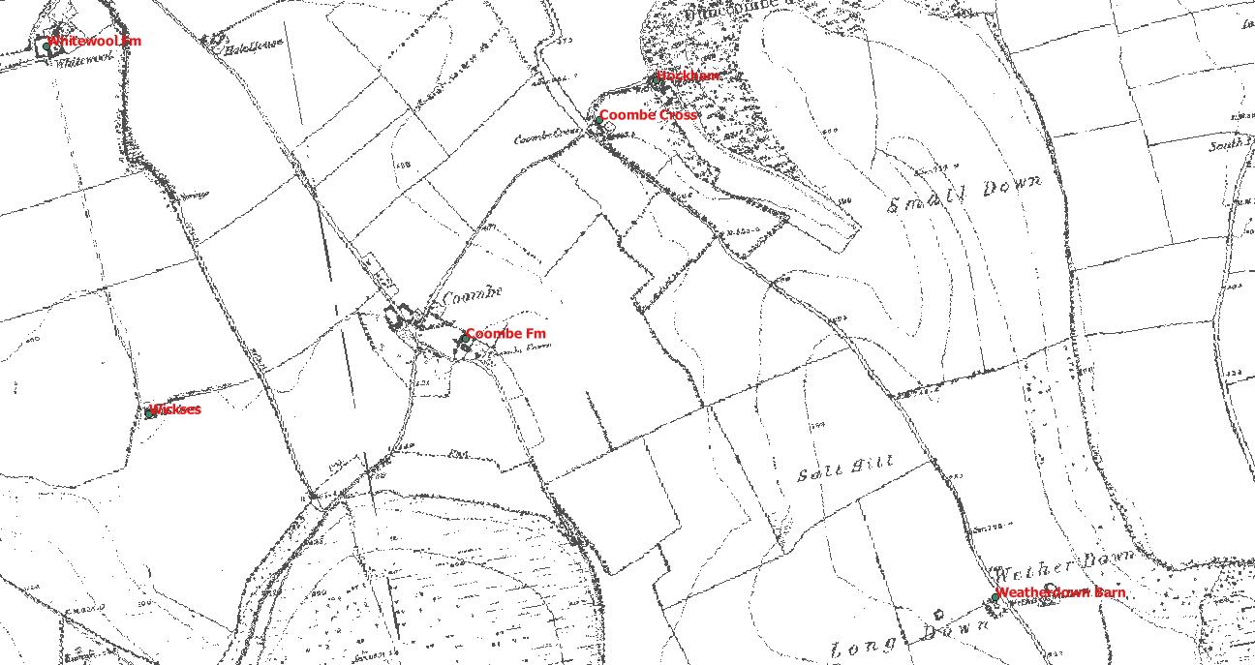
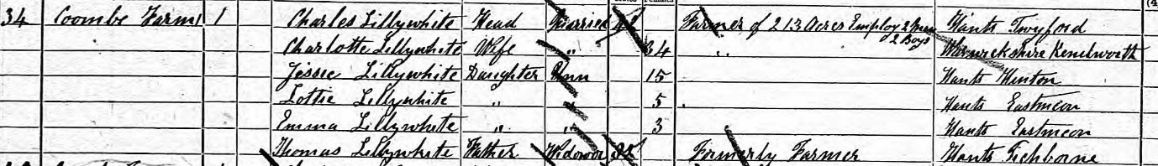
1881; 42 year old Charles Lillywhite farmed 213 acres, employing 2 men and 2 boys. He lived with his 34 year old wife and three daughters, aged 15, 5 and 3. His 82 year old father Thomas Lillywhite, a former farmer, completed the household.
50 year old Andrew Noyce, from Broughton, farmed 900 acres, employing 8 men and 4 boys. He lived with his 389 year old wife Ellen, and three children, aged 13, 10 and 7. The 1880 Harrod’s directory listed Andrew Noyce as the farmer at Coomb Farm.
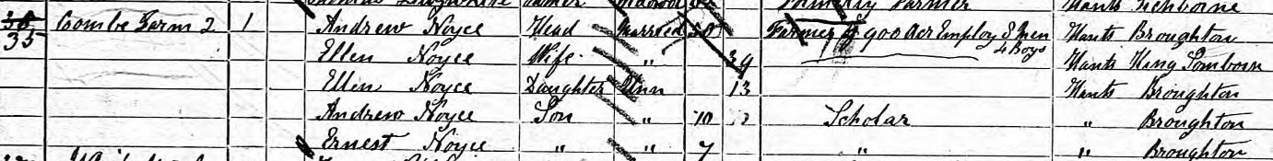
1891 Edward Jackson, a 38 year old farmer born in London, was the farmer at Coombe Farm. He lived with his wife and three young children. Andrew Noyce lived at Whitewool Farm in 1891, which was part of West Meon. The 1898 Harrod’s directory listed Noyce Brothers as the farmers at Coomb Farm.
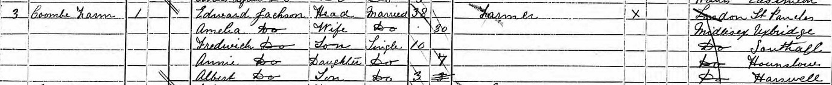

Duncoombe Farm
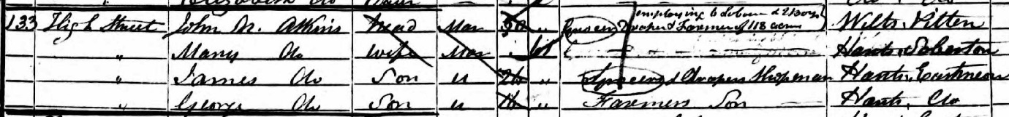
1851 John Nathaniel Atkins lived at Glenthorne House, and was listed as a draper and farmer of 118 acres employing 6 labourers and 2 boys.
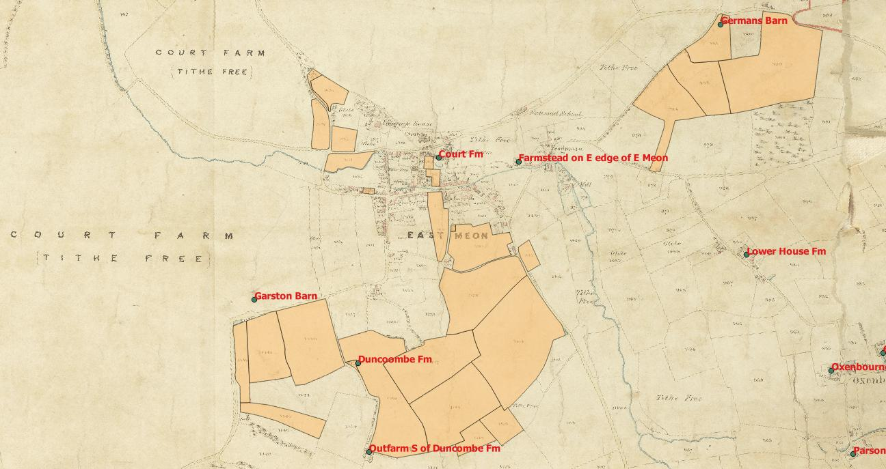
He did not live at Duncoombe Farm, but these were the acres that he owned. He was aged 53 and was from Pilton in Wiltshire, and lived with his 61 year old wife Ann. Their 16 year old son George Atkins was listed as a farmer’s son, but his 26 year old brother James was listed as a draper’s son and shopman. His 17 year old son Clement was an apprentice miller in 1851 to John Lillywhite, the Miller at Frogmore Mill. His widowed 31 year old daughter Eliza Barnard lived in Cross St with 2 of her three children. Her husband, James Barnard, had died a few years previously.

1861 John Nathaniel Atkins was still living at Glenthorne with his wife Ann. He was 63 and listed as a grocer. His son George Atkins was the eldest surviving son at home as his brother James had died in 1853. George was listed as a farmer of 260 acres employing 7 men and 3 boys.
It is unclear where the extra 150 acres was. Atkins’ daughter Eliza (Barnard) was living at 5 High Street along with her daughter Eliza who was listed as 9, but was born in 1847 according to the church records, and was the illegitimate daughter of James Lock of Court Farm. Atkins’ 17 year old grandson James was also living at Glenthorne, and was described as a shopboy. Clement Atkins, the youngest son, was the miller at South Mill, listed next to South Farm of Samuel Padwick.
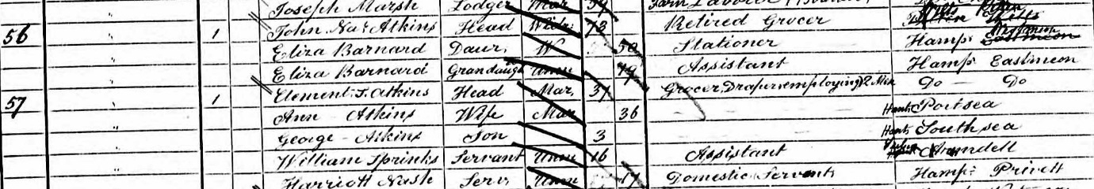
1871 John Nathaniel Atkins, 73, had retired, and lived in the village with his daughter Eliza, a stationer, and granddaughter Eliza, her assistant. His wife had died aged 79 in 1868. His son Clement had taken over the shop and was listed as a grocer & draper employing 2 men.

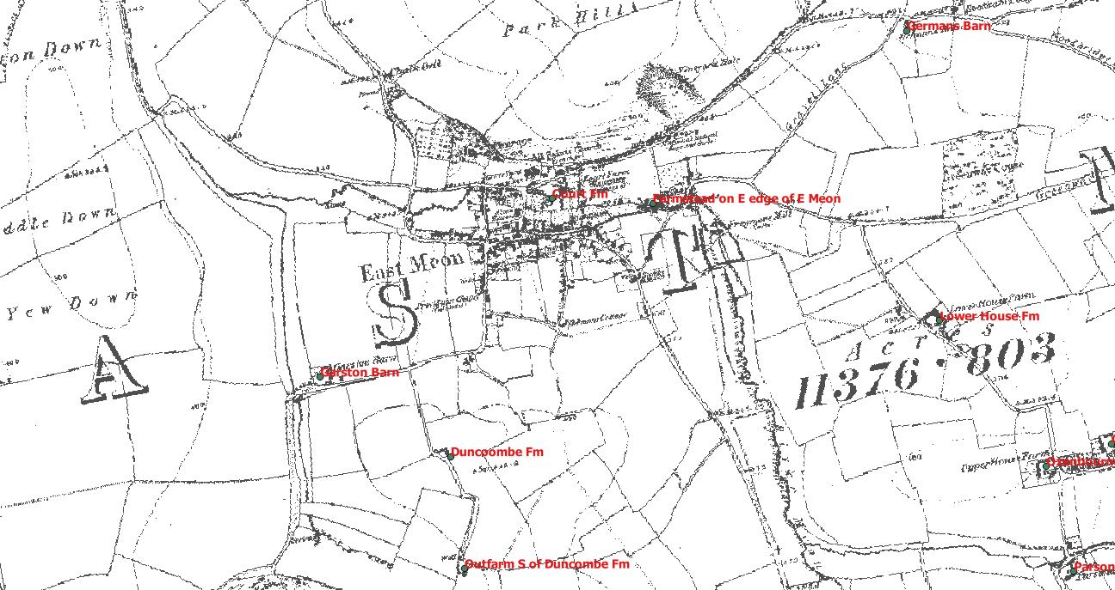
The two households are listed next to each other in the census, so presumably lived next door. 35 year old George Atkins lived at Coombe Farm and was a farmer of 526 acres, employing 11 labourers and 5 boys. He lived with his 35 year old wife Lucy and they had one 17 year old house servant from Hayling Island.
1881 George Atkins had moved to farm in Up Marden, Sussex, and farmed 660 acres employing 7 men and 5 boys. His brother Clement lived at the village post office in East Meon with his family describing himself as a grocer and draper and his sister Eliza lived in the village working as a bookseller, with her daughter as her assistant. Duncoombe Farm was occupied by 35 year old James Blackman, a carter born in East Meon and his family.
This was the first time the census had listed a Farm at Duncoombe (although the enumerator spelt it as Duncombe).
1891 43 year old carter George Norman, born in East Meon, lived at Duncoombe with his wife and two children. All four were born in East Meon. It was not listed as a farm.

Bordean Farm
There were two farms at Bordean, Upper Bordean and Lower Bordean.
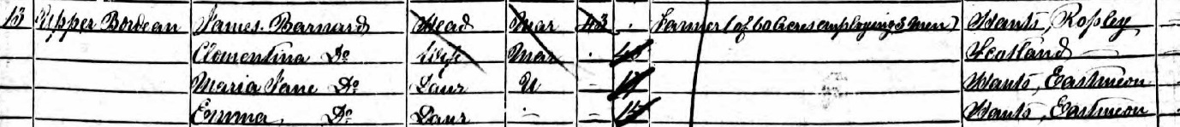
1851 43 year old James Barnard, born in Ropley, farmed 60 acres employing 3 men at Upper Bordean. He lived with his second wife Clementina (née Shand) and three daughters aged from 2 to 17, all of whom were born in East Meon. He was listed as a “gent” on the birth registry. His first wife (Martha Maria, nee Kemp, was the daughter of the local vicar) had died in 1841. They had had six children, of whom two had died in early childhood. The two older sons (James Kemp, born 1832 and William born 1838) were on the 1841 census, whereas the two daughters (Maria Jane b 1834 and Emma b 1836) were only on the 1851 census.
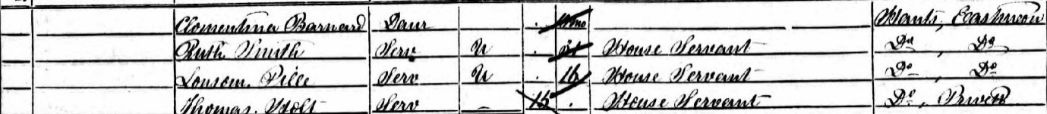
They had three house servants, 31 year old Ruth Smith from East Meon, 16 year old Louisa Pink from East Meon, and a 15 year old boy from Privett.
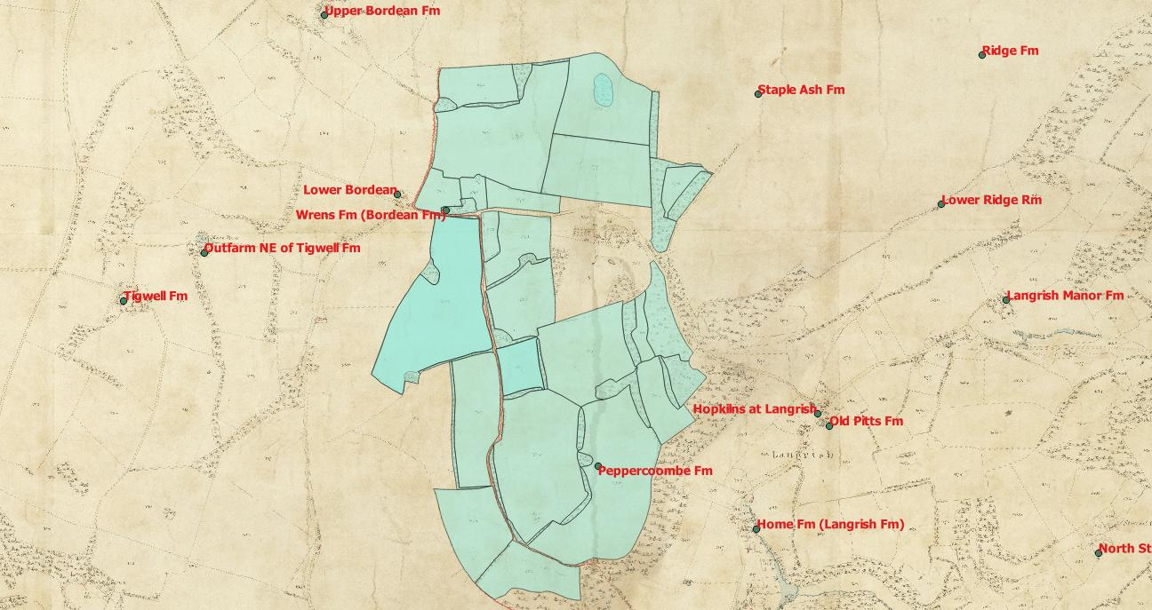
The tithe map did not show James Barnard as occupying any land, but he was the owner of 360 acres, all of which were occupied by Henry Barnard. They included 314 arable acres, 13 acres of pasture and 21 acres of woods, and included the homesteads of both Little Bordean and Upper Bordean. The 349 acres at Bordean was occupied by “the executors of John Wake”.
1861 James Barnard was a retired 51 year old farmer, living with his wife, youngest daughter (also Clementina) and son Gordon born since the previous census at Upper Bordean Farm. They had a 35 year old housekeeper, Phoebe Smith, from East Meon and a 15 year old “footboy” from West Meon. Phoebe Smith was also on the 1841 census.
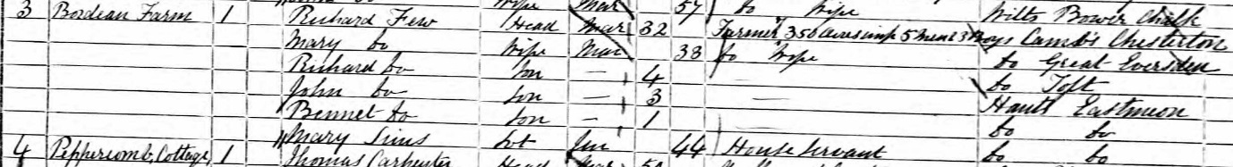
Richard Few, 32, from Chesterton in Cambridge was a farmer of 350 acres living at Bordean Farm. He employed 5 men and 3 boys. His wife was also from Cambridgeshire, as was their four year old son. Their two younger sons, aged 3 and 1 had both been born in East Meon. They employed a 44 year old servant, Mary Simms, from the village.
1871 John Charman, a 45 farmer from Bradford Purcell in Dorset, farmed 750 acres at Bordean, employing 16 men, 6 women and 6 boys. He lived with his 34 year old wife Eliza, from Tasmania and they had one 16 year old house servant from Andover. He was listed as a farmer in the 1875 directory, farming at Bordean Farm.
This census no longer gives full descriptions of the houses, but it is probably that Bordean Farmhouse was let out to 42 year Major Daniel Baly and his wife Juliana, who occupied what was clearly a sizeable house in Bordean with their two children, and fellow Army officer 29 year old Richard St Viel. Another guest was 25 year old Fanny Wishart, and there were two domestic servants, 18 year old Eliza Carter from East Meon and 17 year old Sarah Ayling from Privett.
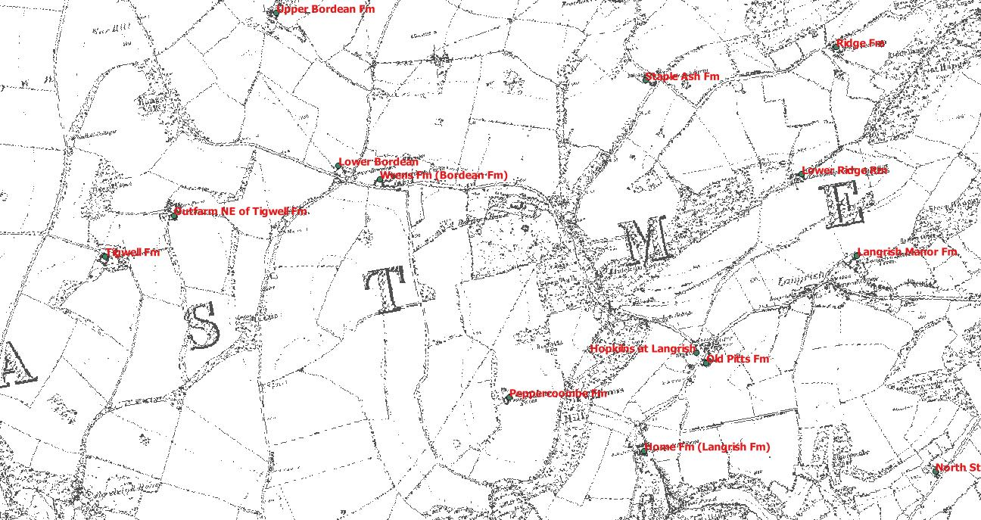
1881 John Sanderson, a 27 year old from Skelling in Cumberland, was bailiff for Sir William Nicholson, living in Bordean Farm house on his own. He looked after 660 acres and 20 labourers.
Stephen Holt, a 63 year old labourer from Privett lived in a separate dwelling in the Farmhouse with his wife.
Arthur Wilcoxon, a 47 year old gentleman from London lived in Upper Bordean Farmhouse with his wife Fanny, née Barnard.

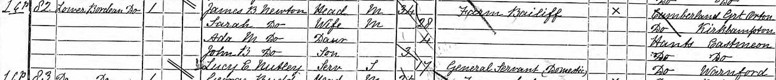
1891 James Newton, a 34 year old bailiff from Great Orton in Cumberland, was bailiff for Sir William Nicholson. He lived in Lower Bordean Farmhouse with his 28 year old wife, also from Cumberland, and their two young children. They employed one 17 year old general servant from Warnford.
The 1898 Harrod’s directory listed Thomas Edwin Rose as bailiff to Sir William Nicholson, living at Lower Bordean Farm, and Thomas Studdy, his land agent, living at Upper Bordean.

Rothercoombe Farm
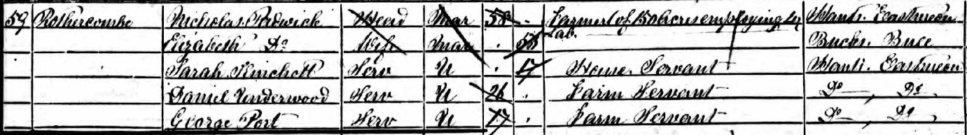
1851 58 year old Nicholas Padwick farmed 150 acres employing 4 men. He had been born in East Meon, as was his father William, the eldest of Nicholas Padwick’s four sons (and three daughters). His first cousin Samuel Padwick farmed Lower Farm. Nicholas’s brother John Lypscomb Padwick (c1795 – 1813) suggests that his mother Mary’s maiden name may have been Lypscomb. Nicholas’s wife, 55 year old Elizabeth, was from Buckinghamshire. They employed 17 year old Sarah Kinshot from East Meon as a house servant, and two Farm Servants lived in- 26 year old Daniel Underwood and 17 year old George Port, both from East Meon.
The Tithe map showed that Nicholas Padwick occupied 124.5 acres, owned by Sir William Joliffe.
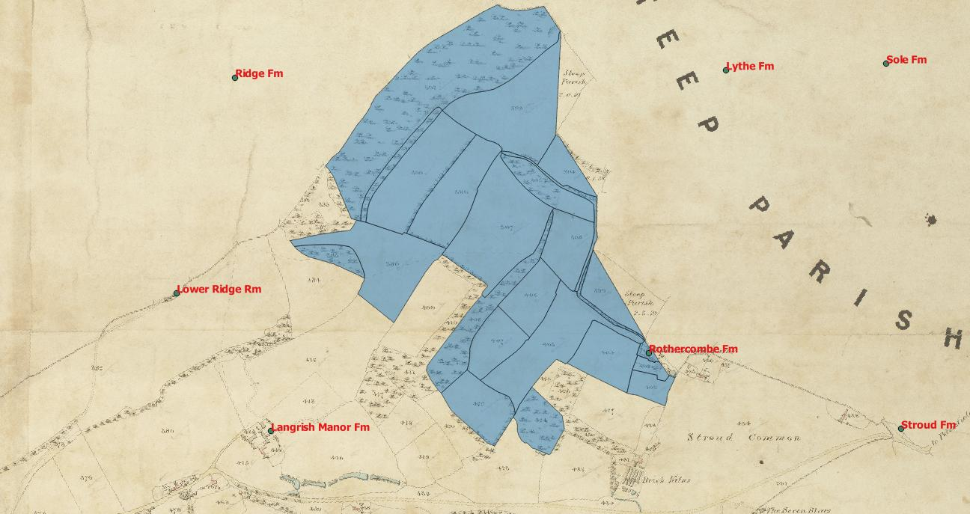
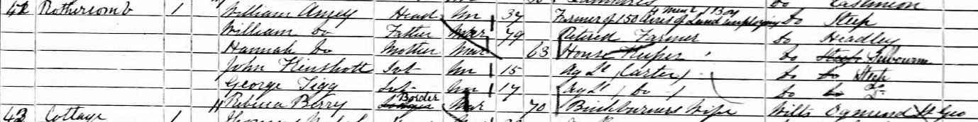
1861 the farm had passed to 37 year old William Amey from Steep, who was listed as farming 150 acres, and employing 4 men and 1 boy. He lived with his parents, 79 year old William and 63 year old Hannah. His 16 year old son, also William, lived with neighbouring farmer Richard Green and was employed as a carter. Amey’s household also included 15 year old Joh Kinshott from Steep, and agricultural labourer/carter, 17 year old George Sigg from Steep (agricultural labourer) and 70 year old Rebecca Berry, described as a brickburner’s wife. She was widow of Edward Berry, a brick burner and farmer who in 1851 had employed 6 men in Stroud.

1871 William Amey farmed 152 acres employing 5 men and 3 boys.
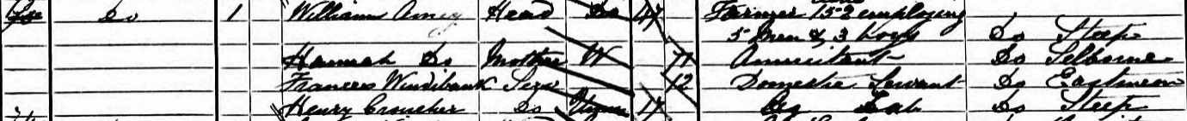
His mother, 77 was his housekeeper, and his household included 12 year old Frances Windybank from East Meon as a domestic servant and 17 year old Henry Croucher from Steep as an agricultural labourer.
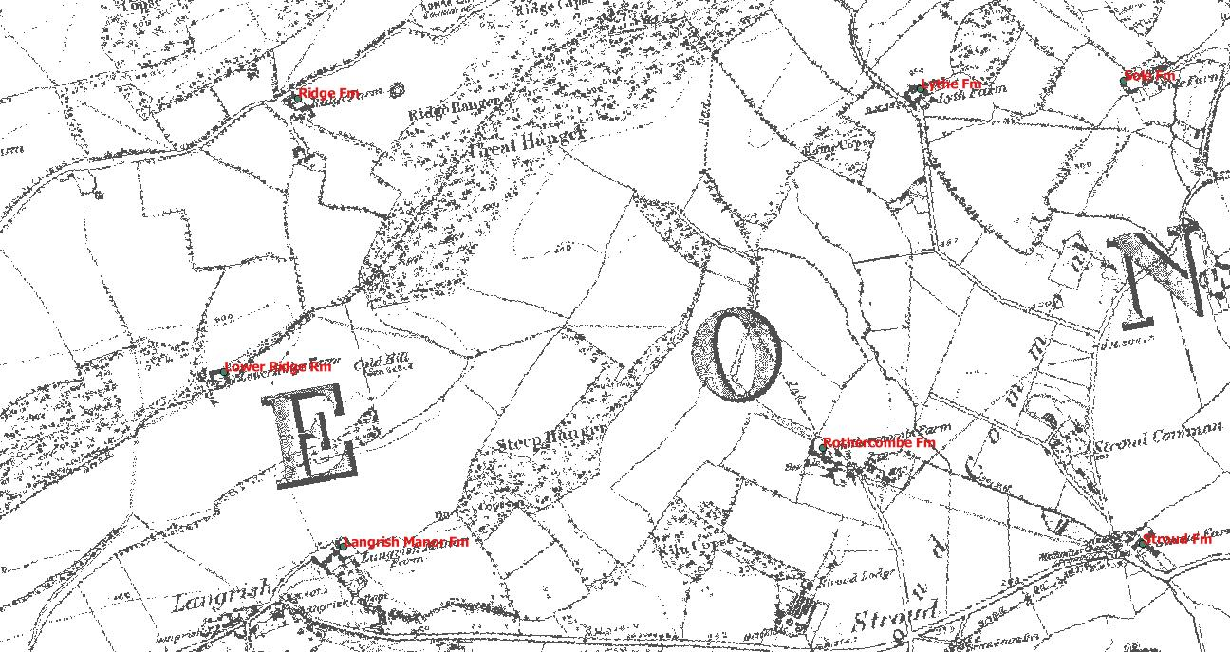

1881 Amey’s farm had grown to 180 acres, and he again employed 4 men and 1 boy. He lived with 25 year old Mary Cooper, from Hambledon, who was his housekeeper.
1891 Farmers were no longer providing their acreage or employment numbers. William Amey was 66, and his housekeeper was 43 year old Sarah Green from East Meon. She was the daughter of Thomas Green, who had farmed at Barrow Hill Farm (Upper Farm).

Upper House Farm
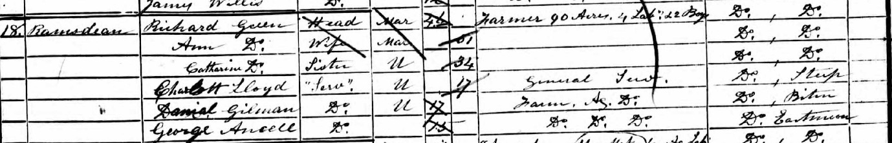
1851 Richard Green, 46, from East Meon was listed in the census as farming 90 acres, and employing 4 labourers and 2 boys. He lived with his wife Ann, and his 34 year old sister Catherine.
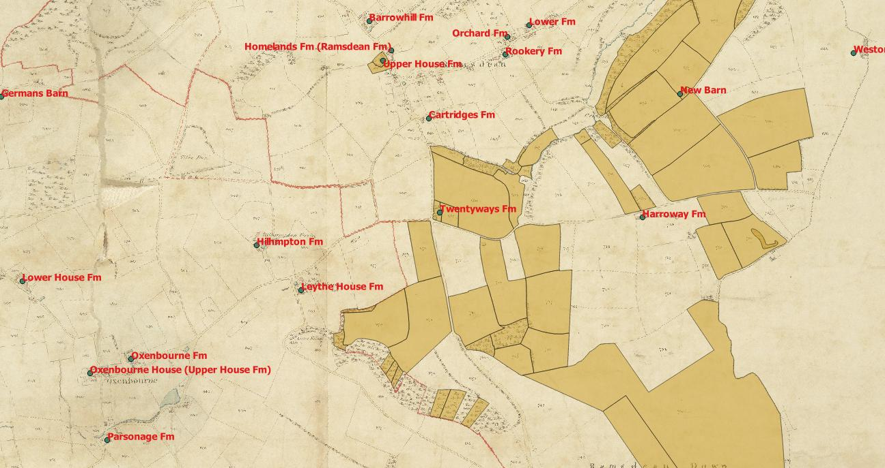
Neither Richard nor Catherine was baptised in East Meon church, and they may have been non-conformists. The tithe map showed him farming 335 acres, 192 of which were arable, 120 were pasture and 24 were woods. They had one servant, a 17 year old from Steep, and two agricultural labourers lived in the property. In 1851 he was probably at Upper House Farm.

1861 Richard Green, 56, lived at “Ramsdean Farm” , but as Manning’s Farm was occupied by Henry Vokes in 1861, I assume that Richard Green continued to live at Upper House Farm, which is opposite Manning’s Farm. He farmed 200 acres. He was listed as a farmer and grocer. He employed 4 boys and possible 8 labourers, although the census is very smudged. He lived with his wife Ann, his 16 year old niece Wilhelmina Nicholas as a helper, and another niece, 11 year old Martha, the daughter of his brother Robert. They also employed a 17 year old nursery maid from Hawkley, and had two labourers living with them. The younger, 16 year old William Amey from Steep was probably the son of the eponymous Rothercombe farmer.
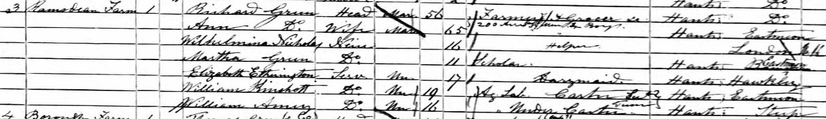
1871 Richard Green farmed 300 acres and employed 8 labourers and 3 boys. Ann Green had died in 1868, and he lived with his 24 year old niece Sarah Nicholas as a helper. He also had 16 year old Anne Waite from Steep as a house servant, and had two agricultural labourers from East Meon living in the house. The 1865 Directory had listed him as farmer, grocer and land surveyor at Ramsdean Farm. He was no longer a grocer as well in the 1875 directory.
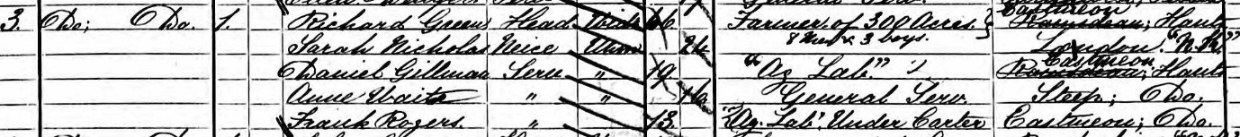
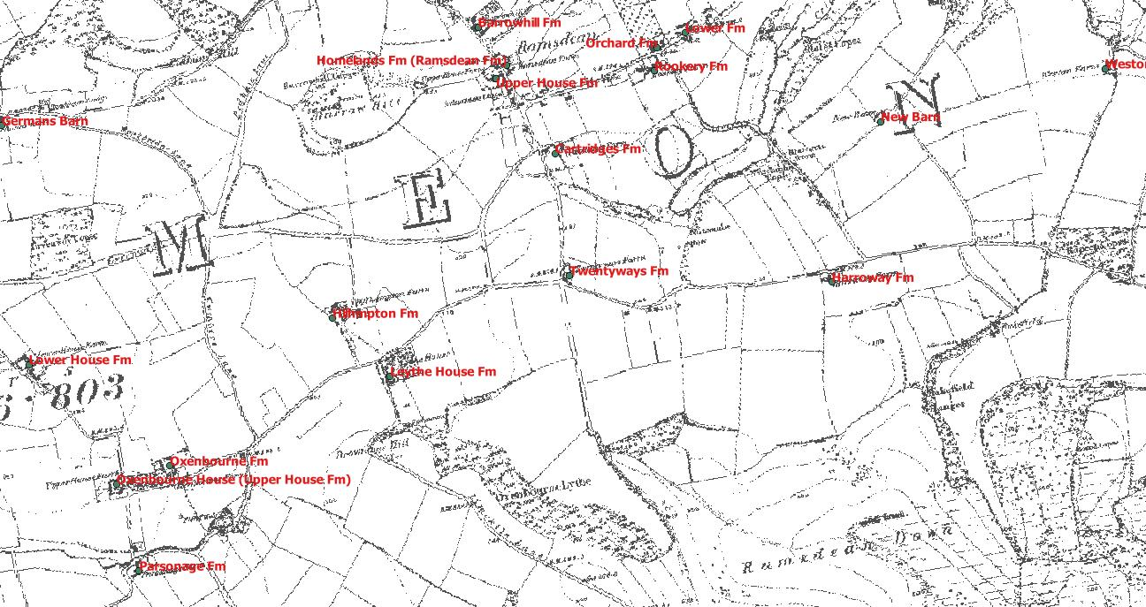
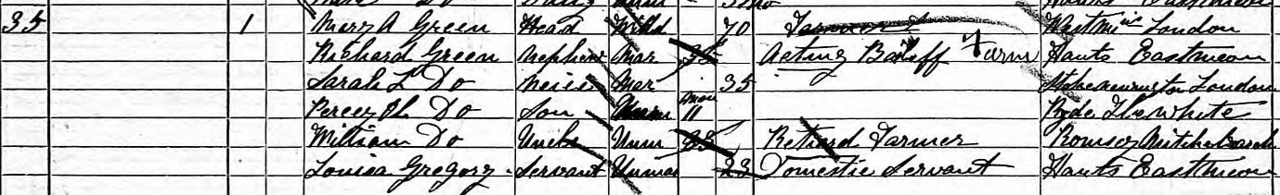
1881 Richard Green died in 1880. His farm was taken on by Mary Green (nee Pagnall, who had married him in 1871), his 70 year old widow, listed as a farmer. Richard Green’s nephew, 35 year old Richard was listed as the farm bailiff, along with his 35 year old wife Sarah, from Stokenchurch and their one year old son Percy. Richard’s brother, 83 old William Green, a retired farmer lived with them. They had one domestic servant, 23 year old Louisa Gregory from the village. The 1880 Directory was published before the older Richard Green died, and he was listed as farmer and land surveyor, as he had been in 1875.
1891 Richard Green, 44, farmed in Ramsdean. He lived with his 44 year old wife Sarah, and their three children, the youngest two of whom were born in East Meon. The farm next door was farmed by his sister in law, 48 year old widow Mary A Green, who lived with her son John 18, daughter Sarah 15 and nephew Richard. She was the widow of George Green, Richard’s older brother.

Rookery Farm
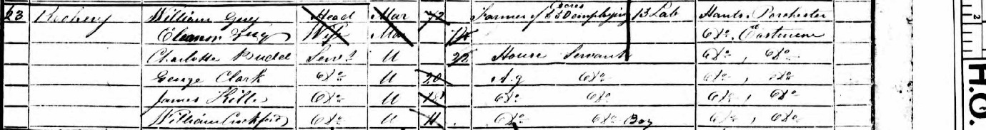
1851 72 year old William Guy from Porchester farmed 630 acres from Rookery Farm, employing 13 labourers. He was the brother in law of Samuel Padwick, and they farmed as “Padwick & Guy”. He was not listed on the tithe map as the holding was tithe free. He lived with his wife Eleanor, née Padwick, and they had four house servants from East Meon, three men and one woman.

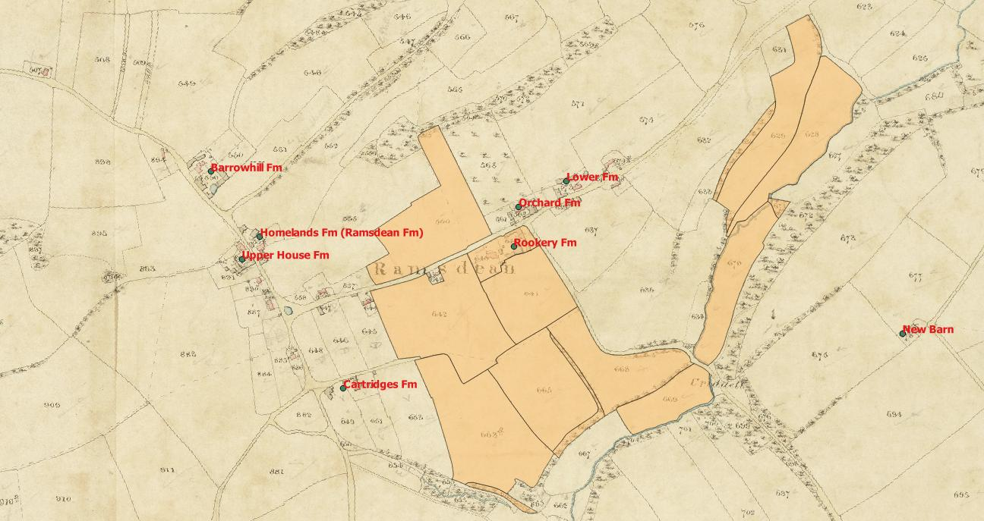
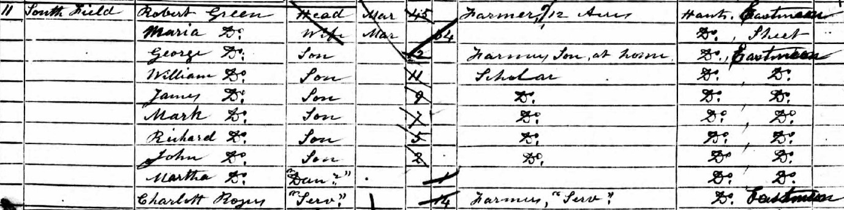
1861 Robert Green, 50, farmed 63 acres at Rook Farm, employing 5 men and three boys. In 1851 he had been listed at “South Field”.
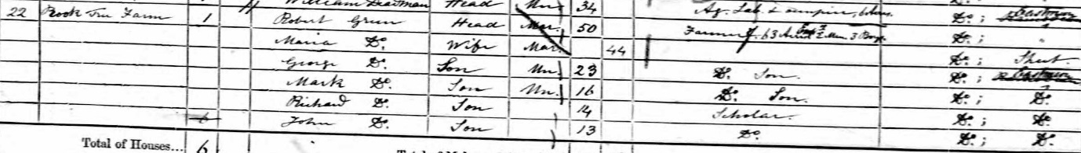
He and his wife Maria had seven children at home, of which the two oldest sons, 23 year old George and 16 year old Mark were listed as farmer’s sons in the census.
1871 Robert Green died in 1868, so his widow 56 year old Maria took on the farm. The census showed the address as Ramsdean, and she farmed 100 acres employing 1 man and 1 boy. She had six of her children living with her, including three sons in their 20s who were listed as “farmer’s sons”.
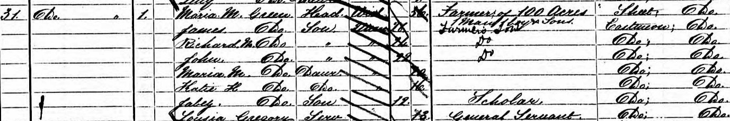
Robert and Maria’s second son, William, 31, had set up home with his wife Harriet, from Hawkley. The census showed him living next door to his mother (presumably at either Orchard Farm or Lower Farm), farming 25 acres and employing 1 man and 1 boy. The address is shown as Ramsdean Road. They lived with their six children, the youngest five of whom had been born in East Meon.
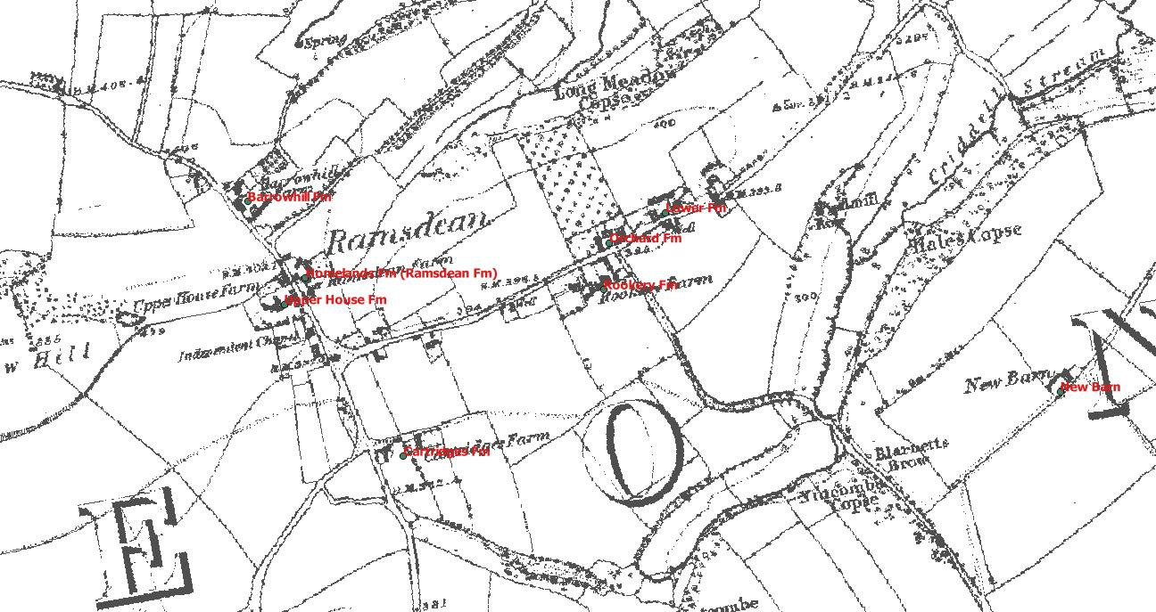
1881 Maria Green, 64, lived at Rook Farm with her son John as assistant farmer. She had 26 year old daughter Kate living with her and her 11 year old grandson Robert, born in Steep.
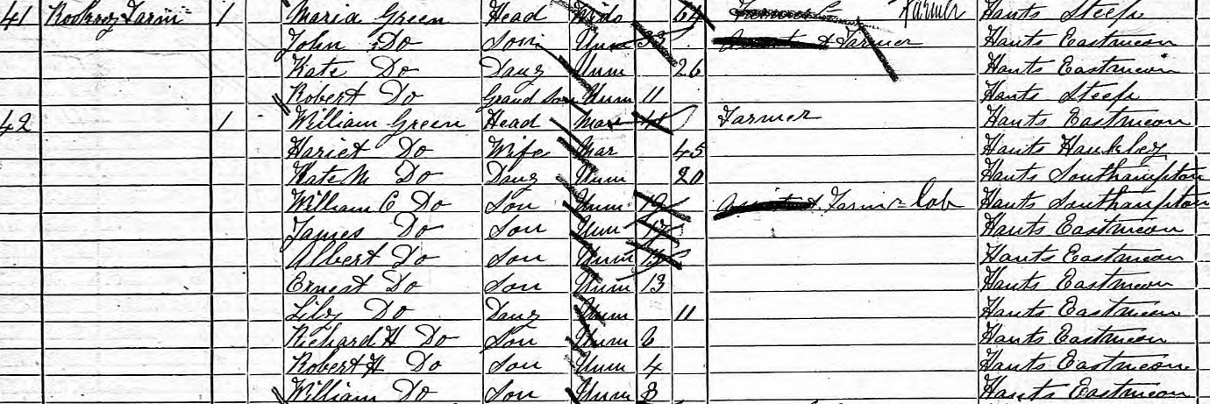
The other half of Rookery Farm was lived in by her 41 year old son William, listed as a farmer, with his 45 year old wife Harriet, and their 9 children. His 19 year old son William, was listed as a farm labourer, but other sons aged 17, 15 and 13 were not. A 62 year old labourer, William Crockford, also lived at Rookery Farm along with his 15 and 8 year old daughters.
The 1880 directory listed Mrs M Green as a farmer at Rook Tree Farm, Langrish.
1891 Maria Green’s 42 year old son John was lodging with Louisa Young, whose husband had died. Both were listed as farmers. John Green was listed in the 1898 directory as the farmer at Rookery Farm.

South Field (Rookery Farm)
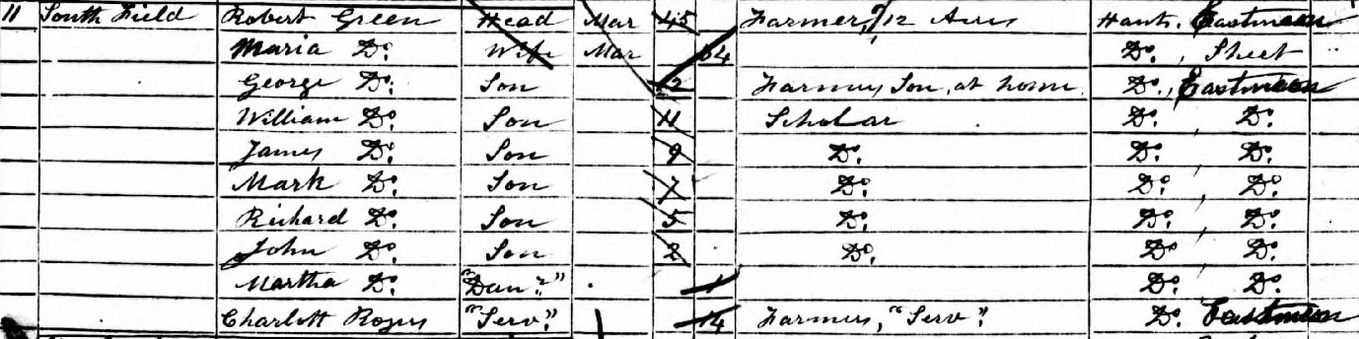
1851 Robert Green, a 45 year old farmer from East Meon was listed as farming 12 acres at “South Field”. He lived with his wife Maria (nee Deadman) from Sheet, and 7 children under the age of 12. He was Richard Green’s brother, but it is not clear if they farmed together or not. By the time of the Tithe map he was living at Rookery Farm, and farming 56 acres. Of these, 31 acres were arable, 22 were pasture and there were 2 acres of woods. As he moved into Rook(ery) Farm by 1861, this maybe meant he was living at Lower Farm, which is next door to Rookery Farm.

South Field is a mystery. Mary Ann Green lived in South Field House in 1881, and there is a field in the tithe map called “South Field Barn Piece”, but there is no reference to South Field or SouthField on either the tithe map or the first three ordnance survey maps.
Robert Green’s wife Maria Deadman was from Sheet. Her father, James Deadman, farmed at Lower Farm and was from Hawkley.

Lower Farm & Fairfield Farm (South Farm) (Tithe Free)
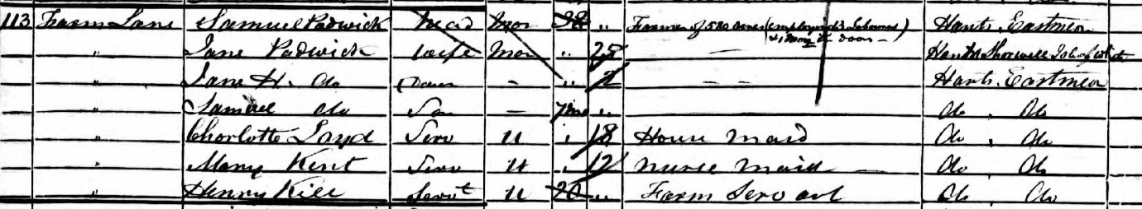
1851 (just called Farm Lane) 38 year old Samuel Padwick, farmed 580 acres, and employed 13 labourers and 12 boys. He was born in East Meon in 1813. His wife Jane, nee Lock, was 25, and was sister of James Lock of Court Farm. Their two children were 2 year old Jane & 1 year old Samuel.
They would eventually have 11 children. They had two house maids, 18 year old Charlotte Lloyd and 12 year old Mary Kent, both of whom were born in East Meon. Mary was the eldest of 10 children (9 girls) and whose parents lived in Sheep Wash, Oxenbourne. They had five other children living with them in 1851. Live in Farm Servant Henry Kille, 20, was also born in the village. He was the second child (of 6) of James Kille, the third of the Kille brothers, who lived in Cross Street. There were 7 people in the household.
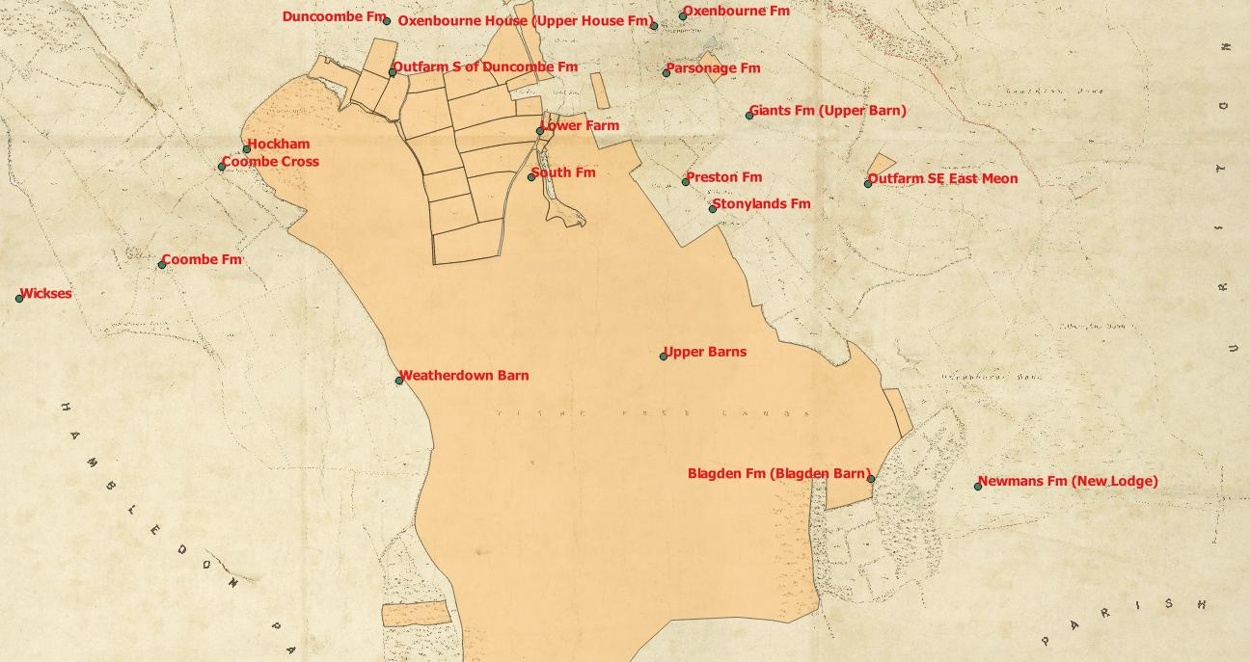
Lower Farm is identified on the Tithe map and tithes were paid on the farmhouse, occupied by Samuel Padwick. Fairfield Farm is identified on the map, but as it was tithe free the farmhouse is not identified on the tithe map. The tithe map does not name South Farm, nor does it differentiate between the tithe free farms. Fairfield Farm was 884 acres, Hiden Farm 227, and “Church Farm” was 205. There is no other record on the census of Church Farm, although there is a Church Farmhouse in the village today. It is unclear where the boundaries of Hiden, Fairfield, Church, Park and Court farm were.
In the 1855 O’Kelly directory of Hampshire listed “Padwick and Guy, farmers” confirming that they farmed together.
South Farm had three entries in 1851 George Noble a 45 year old shepherd from Catherington and his family, Henry Crockford a 67 year old agricultural labourer from Westbourne, Sussex and his family, and George Porter a 35 year old labourer from East Meon and his family.
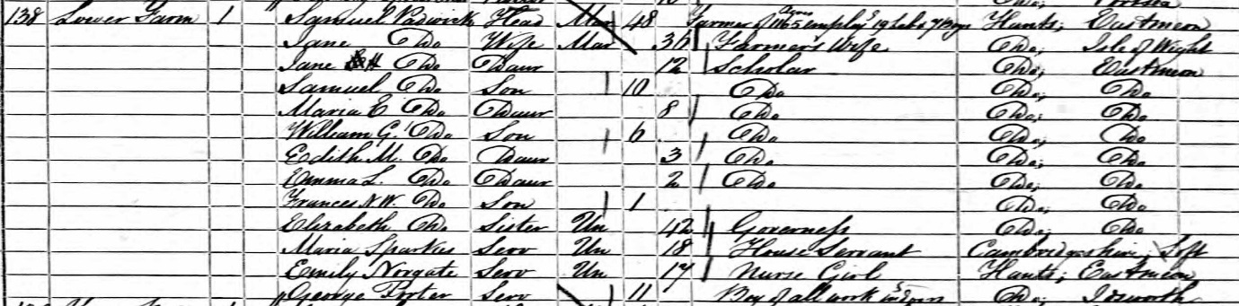
1861 Living at South Farm, Samuel Padwick farmed 1,165 acres and employed 19 labourers and 7 boys. He had 7 children, and his 42 year old sister Elizabeth was their governess. They had 18 year old Maria Sparkes (from Cambridgeshire) as house servant and 17 year old Emily Norgate from East Meon as Nurse girl. She was 7th of 10 children, whose parents lived at Spring Head, East Meon with 2 of these children. 11 year old George Porter from Idsworth was a “boy of all work” and completed the 13 person household. There was an unrelated boy of the same name and age already in the village.

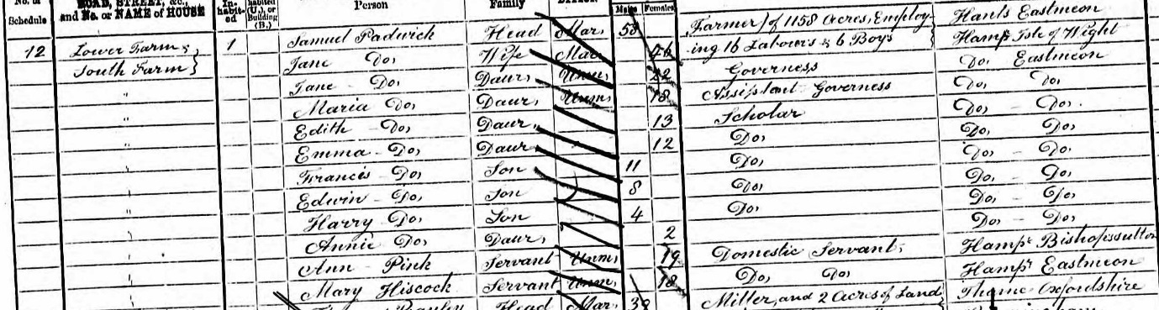
1871 Samuel Padwick farmed 1,158 acres and employed 16 labourers and 6 boys. The address was given as a combination of Lower Farm and South Farm. His wife and 8 of his children still lived on the farm. His eldest two daughters are listed as Governess and Assistant Governess. They had two live in servants, 19 year old Ann Pink from Bishops Sutton and 18 year old Mary Hiscock from East Meon. There were 12 in the household.
Samuel Padwick’s brother William, aged 49, his sister in law Charlotte, 45, and his sister Elizabeth, 52, all lived at South Farm House. William Padwick was a retired farmer. This was the first time that this building was explicitly mentioned in the census.
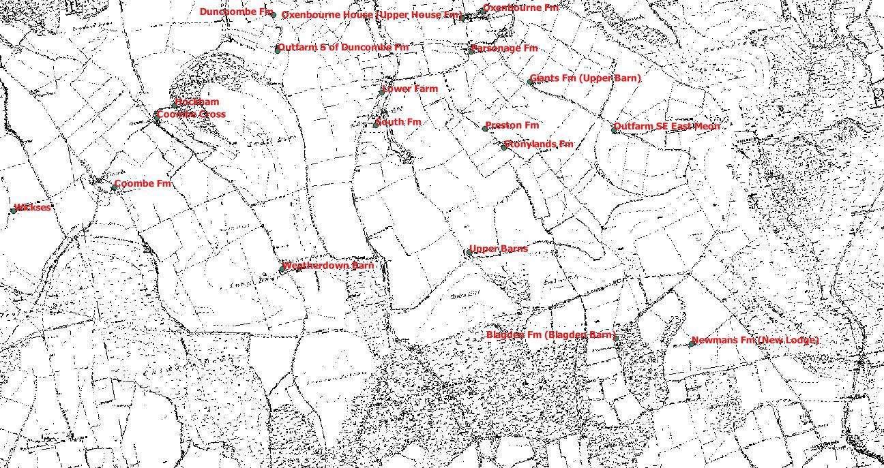

1881 The name changed to Fairfield Farm. Samuel Padwick had died in 1878 (leaving £4,000 in his will), and his widow Jane farmed 881 acres, employing 7 men and 4 boys. Her 30 year old son Samuel was described as “employed on the farm” and 2 other sons and daughters still lived at the farm. The youngest was 12. They employed 16 year old Louisa Porter from East Meon as a general servant. Her parents lived with her five younger siblings at Lower Bordean. She was not related to George Porter. Household was back down to 7.
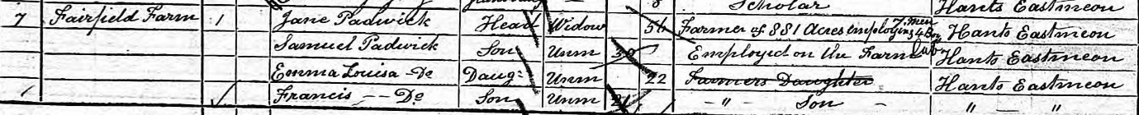

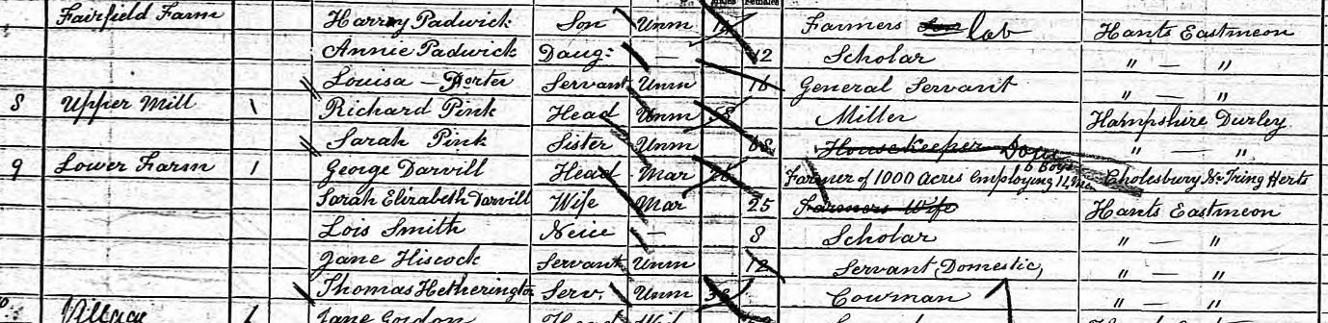
Separately in 1881, George Darvill lived at Lower Farm. He farmed 1000 acres, employing 14 men and 6 boys. Darvill had married Elizabeth Smith, daughter of Henry Smith, the East Meon baker.
1891. Darvill’s wife died in 1888, and George Darvill was listed as a farmer at South Farm in the census. Samuel Padwick, 40, was listed as a retired farmer living at the same address.

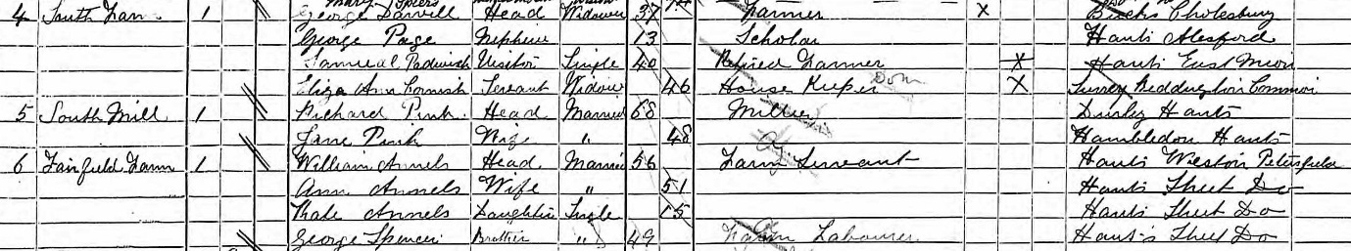
The 1898 Harrod’s directory showed Darvill as the farmer at Court Farm. The household also comprised Darvill’s 13 year old nephew, and a 46 year old housekeeper, Eliza Ann Cornish, from Surrey. There were no other Padwick relations in the village. Fairfield Farm was occupied by 56 year old William Annels, a “farm servant” from Petersfield.

Acres
East Meon 11,376
Buriton 6,435
Clanfield 1,403
Petersfield 237
Steep 2,657
Froxfield 4,908
Privet 1,278
Meonstoke 2,055
Exton 3,566
West Meon 3,773
Hambledon 9,040

